GRADUATE RECORD EXAMINATIONS®

Mathematical Conventions

Copyright © 2010 by Educational Testing Service. All rights reserved. ETS, the ETS logo, GRADUATE RECORD EXAMINATIONS, and GRE are registered trademarks of Educational Testing Service (ETS) in the United States and other countries.

This is the accessible electronic format (Word) edition of Mathematical Conventions. A downloadable large print (PDF) version, as well as a Large Print Figure supplement is available from the GRE® website. Other downloadable practice and test familiarization materials in large print and accessible electronic formats are also available. A tactile figure supplement for Mathematical Conventions, along with additional accessible practice and test familiarization materials in other formats, is available from E T S Disability Services Monday to Friday 8:30 a m to 5 p m New York time, at 1-6 0 9-7 7 1-7 7 8 0, or 1-8 6 6-3 8 7-8 6 0 2 (toll free for test takers in the United States, U S Territories and Canada), or via email at stassd@ets.org.

The mathematical content covered in this edition of Mathematical Conventions is the same as the content covered in the standard edition of Mathematical Conventions. However, there are differences in the presentation of some of the material. These differences are the result of adaptations made for presentation of the material in accessible formats. There are also slight differences between the various accessible formats, also as a result of specific adaptations made for each format.

Information for screen reader users:
This document has been created to be accessible to individuals who use screen readers. You may wish to consult the manual or help system for your screen reader to learn how best to take advantage of the features implemented in this document. Please consult the separate document, GRE Screen Reader Instructions.doc, for important details.

Figures
This document includes figures. In accessible electronic format (Word) editions, figures appear on screen. Following each figure on screen is text describing that figure. Readers using visual presentations of the figures may choose to skip parts of the text describing the figure that begin with “Begin skippable description of …” and end with “End …”

Mathematical Equations and Expressions
This document includes mathematical equations and expressions. Some of the mathematical equations and expressions are presented as graphics. In cases where a mathematical equation or expression is presented as a graphic, a verbal presentation is also given and the verbal presentation comes directly after the graphic presentation. The verbal presentation is in green font to assist readers in telling the two presentation modes apart. Readers using audio alone can safely ignore the graphical presentations, and readers using visual presentations may ignore the verbal presentations.

Overview

Note: Some of the mathematical conventions discussed in this document are conventions used in print editions of tests and practice material. Braille editions use the Nemeth Code of Mathematics and Science Notation.

The mathematical symbols and terminology used in the Quantitative Reasoning measure of the test are conventional at the high school level, and most of these appear in the Math Review. Whenever nonstandard or special notation or terminology is used in a test question, it is explicitly introduced in the question. However, there are some assumptions about numbers and geometric figures that are particular to the test. These assumptions appear in the test at the beginning of the Quantitative Reasoning sections, and they are elaborated below.

Also, some notation and terminology, while standard at the high school level in many countries, may be different from those used in other countries or from those used at higher or lower levels of mathematics. Such notation and terminology are clarified below. Because it is impossible to ascertain which notation and terminology should be clarified for an individual test taker, more material than necessary may be included.

Finally, there are some guidelines for how certain information given in test questions should be interpreted and used in the context of answering the questions—information such as certain words, phrases, quantities, mathematical expressions, and displays of data. These guidelines appear at the end.

Numbers and quantities

1. All numbers used in the test questions are real numbers. In particular, integers and both rational and irrational numbers are to be considered, but imaginary numbers are not. This is the main assumption regarding numbers. Also, all quantities are real numbers, although quantities may involve units of measurement.

2. Numbers are expressed in base 10 unless otherwise noted, using the 10 digits 0 through 9 and a period to the right of the ones digit, or units digit, for the decimal point. Also, in numbers that are 1,000 or greater, commas are used to separate groups of three digits to the left of the decimal point.

3. When a positive integer is described by the number of its digits, for example, a two digit integer, the digits that are counted include the ones digit and all the digits further to the left, where the left most digit is not 0. For example, 5,000 is a four digit integer, whereas 031 is not considered to be a three digit integer.

4. Some other conventions involving numbers:
one billion means 1 , 0 0 0 , 0 0 0 , 0 0 0, or 10 to the ninth power (not 10 to the twelfth power, as in some countries);
one dozen means 12;
the Greek letter pi represents the ratio of the circumference of a circle to its diameter and is approximately 3.14.

5. When a positive number is to be rounded to a certain decimal place and the number is halfway between the two nearest possibilities, the number should be rounded to the greater possibility.

Example: 23.5 rounded to the nearest integer is 24, and 123.985 rounded to the nearest 0.01 is 123.99.

When the number to be rounded is negative, the number should be rounded to the lesser possibility.

Example: negative 36.5 rounded to the nearest integer is negative 37.

6. Repeating decimals are sometimes written with a bar over the digits that repeat, as in 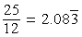 25 over 12 = the decimal 2.083, with a bar over the digit 3 and 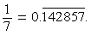 1 seventh = the decimal 0.142857, with a bar over the digits 1, 4, 2, 8, 5, and 7.

7. If r, s, and t are integers and rs = t, then r and s are factors, or divisors, of t; also, t is a multiple of r (and of s) and t is divisible by r (and by s). The factors of an integer include positive and negative integers.

Example 1: negative 7 is a factor of 35.
Example 2: 8 is a factor of negative 40.
Example 3: The integer 4 has six factors: negative 4, negative 2, negative 1, 1, 2, and 4.

The terms factor, divisor, and divisible are used only when r, s, and t are integers. However, the term multiple can be used with any real numbers s and t provided r is an integer.

Example 1: 1.2 is a multiple of 0.4.
Example 2: negative 2 pi is a multiple of pi.

8. The least common multiple of two nonzero integers a and b is the least positive integer that is a multiple of both a and b. The greatest common divisor (or greatest common factor) of a and b is the greatest positive integer that is a divisor of both a and b.

9. When an integer n is divided by a nonzero integer d resulting in a quotient q with remainder r, then n = qd + r, where 0 is less than or equal to r, which is less than the absolute value of d. Furthermore, r = 0 if and only if n is a multiple of d.

Example 1: When 20 is divided by 7, the quotient is 2 and the remainder is 6.
Example 2: When 21 is divided by 7, the quotient is 3 and the remainder is 0.
Example 3: When negative 17 is divided by 7, the quotient is negative 3 and the remainder is 4.

10. A prime number is an integer greater than 1 that has only two positive divisors: 1 and itself. The first five prime numbers are 2, 3, 5, 7, and 11. A composite number is an integer greater than 1 that is not a prime number. The first five composite numbers are 4, 6, 8, 9, and 10.

11. Odd and even integers are not necessarily positive.

Example 1: negative 7 is odd,
Example 2: negative 18 and 0 are even.

12. The integer 0 is neither positive nor negative.

Mathematical expressions, symbols, and variables

1. As is common in algebra, italic letters like x are used to denote numbers, constants, and variables. Letters are also used to label various objects, such as line l, point P, function f, set S, list T, event E, random variable X, Brand X, City Y, and Company Z. The meaning of a letter is determined by the context.

2. When numbers, constants, or variables are given, their possible values are all real numbers unless otherwise restricted. It is common to restrict the possible values in various ways. Here are three examples.

Example 1: n is a nonzero integer.
Example 2: 1 is less than or equal to x, which is less than pi
Example 3: T is the tens digits of a two digit positive integer, so T is an integer from 1 to 9.

3. Standard mathematical symbols at the high school level are used. These include the standard symbols for the arithmetic operations of addition, subtraction, multiplication and division, though multiplication is usually denoted by juxtaposition, often with parentheses, for example, 2y and open parenthesis, 3, close parenthesis, open parenthesis, 4.5, close parenthesis, and division is usually denoted with a horizontal fraction bar, for example, the expression w over 3, written with a horizontal fraction bar. Sometimes mixed numbers, or mixed fractions, are used, like 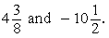 4 and 3 eighths and negative 10 and one half. (The mixed number 4 and 3 eighths is equal to the fraction 35 over 8 and the mixed number 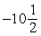 negative 10 and one half is equal to the fraction 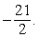 negative 21 over 2). Exponents are also used, for example,
2 to the tenth power = 1,024, 10 to the power negative 2 = 1 over 100, and x to the power 0 = 1 for all nonzero numbers x.

4. Mathematical expressions are to be interpreted with respect to order of operations, which establishes which operations are performed before others in an expression. The order is as follows: parentheses; exponentiation; negation; multiplication and division (from left to right); addition and subtraction (from left to right).

Example 1: The value of the expression 1 plus 2 times 4 is 9, because the expression is evaluated by first multiplying 2 and 4 and then adding 1 to the result.
Example 2: negative 3 squared, without parenthesis means “the negative of ‘3 squared’ ” because exponentiation takes precedence over negation. Therefore, negative 3 squared, without parenthesis = negative 9, but negative 3 squared, with parenthesis around negative 3 = 9 because parentheses take precedence over exponentiation.

5. Here are nine examples of other standard symbols with their meanings:
Note: In these nine examples the symbols are in mathematical expressions given as graphics. Since the meaning of each is given directly after the graphic, a “green font” verbal description of these expressions is not included.
Example 1: x is less than or equal to y
Example 2: x is not equal to y
Example 3: x is approximately equal to y
Example 4: the absolute value of x
Example 5: the nonnegative square root of x, where x is greater than or equal to 0
Example 6: the nonpositive square root of x, where x is greater than or equal to 0
Example 7: n factorial, which is the product of all positive integers less than or equal to n, where n is any positive integer and, as a special definition, 0 factorial = 1.
Example 8: lines k and m are parallel
Example 9: lines k and m are perpendicular

6. Because all numbers are assumed to be real, some expressions are not defined. Here are three examples:

Example 1: For every number x, the expression x over 0 is not defined.
Example 2: If x is less than 0, then the positive square root of x is not defined.
Example 3: 0 to the power 0 is not defined.

7. Sometimes special symbols or notation are introduced in a question. Here are two examples:
Example 1: The operation denoted by a diamond symbol is defined for all integers r and s by 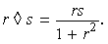r followed by the diamond symbol followed by s is equal to the fraction with numerator rs, and denominator 1 +, r squared.
Example 2: The operation denoted by a box symbol is defined for all nonzero numbers x by 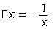 the box symbol followed by x is equal to the negative of the fraction 1 over x.

8. Sometimes juxtaposition of letters does not denote multiplication, as in “consider a three digit integer denoted by BCD, where B, C, and D are digits”. Whether or not juxtaposition of letters denotes multiplication depends on the context in which the juxtaposition occurs.

9. Standard function notation is used in the test, as shown in the following three examples.

Example 1: The function g is defined for all
x greater than or equal to 0 by g of, x = 2x, +, the positive square root of x.

Example 2: If the domain of a function f is not given explicitly, it is assumed to be the set of all real numbers x for which f of, x is a real number.
Example 3: If f and g are two functions, then the composition of g with f is denoted by g of, f of, x.

Geometry

1. In questions involving geometry, the conventions of plane (or Euclidean) geometry are followed, including the assumption that the sum of the measures of the interior angles of a triangle is 180 degrees.

2. Lines are assumed to be “straight” lines that extend in both directions without end.

3. Angle measures are in degrees and are assumed to be positive and less than or equal to 360 degrees.

4. When a square, circle, polygon, or other closed geometric figure is described in words but not shown, the object is assumed to enclose a convex region. It is also assumed that such a closed geometric figure is not just a single point or a line segment. For example, a description of a quadrilateral cannot refer to any of the four sided geometric figures in Conventions Figure 1 below.
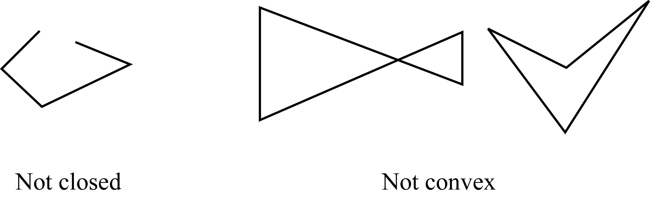
Conventions Figure 1

Begin skippable description of Conventions Figure 1.
Convention Figure 1 consists of three geometric figures. In the first geometric figure, which is labeled “Not closed”, the 4 sides are attached end to end like a quadrilateral, but unlike a quadrilateral, the end of the fourth side is not attached to the beginning of the first side.
The second and third geometric figures are labeled “Not convex”. In the second geometric figure two of the four sides cross each other. The figure looks like two triangles with a common vertex at the point where the two sides cross each other. The third geometric figure is a quadrilateral, but it does not enclose a convex region since the measure of one of the interior angles is greater than 180º.

End skippable figure description.

5. The phrase area of a rectangle means the area of the region enclosed by the rectangle. The same terminology applies to circles, triangles, and other closed figures.

6. The distance between a point and a line is the length of the perpendicular line segment from the point to the line, which is the shortest distance between the point and the line. Similarly, the distance between two parallel lines is the distance between a point on one line and the other line.

7. In a geometric context, the phrase similar triangles (or other figures) means that the figures have the same shape. See the Geometry chapter of the Math Review for further explanation of the terms similar and congruent.

Geometric figures

1. Geometric figures consist of points, lines, line segments, curves (such as circles), angles, and regions; also included are labels, and markings or shadings that identify these objects or their sizes. A point is indicated by a dot, a label, or the intersection of two or more lines or curves. All figures are assumed to lie in a plane unless otherwise indicated.

2. If points A, B, and C do not lie on the same line, then line segments AB and BC form two angles with vertex B: one angle with measure less than 180º and the other with measure greater than 180º as shown in Conventions Figure 2 below. Unless otherwise indicated, angle ABC, also denoted by angle B, refers to the smaller of the two angles.

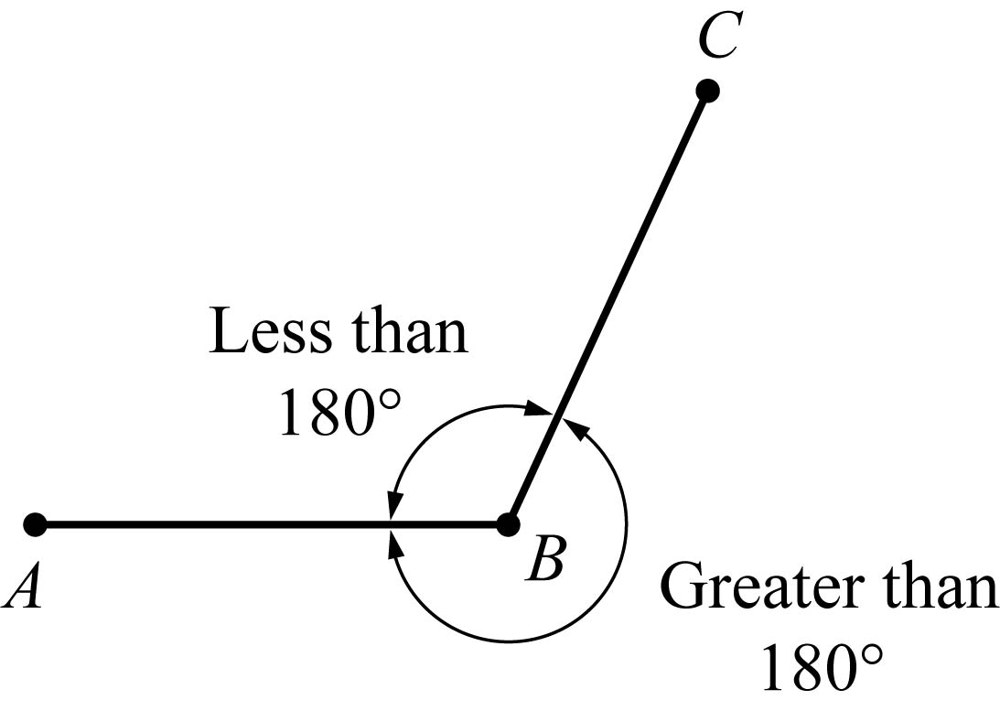
Conventions Figure 2

3. The notation AB may mean the line segment with endpoints A and B, or it may mean the length of the line segment. The meaning can be determined from the usage.

4. Geometric figures are not necessarily drawn to scale. That is, you should not assume that quantities such as lengths and angle measures are as they appear in a figure. However, you should assume that lines shown as straight are actually straight, and when curves are shown, you should assume they are not straight. Also, assume that points on a line or a curve are in the order shown, points shown to be on opposite sides of a line or curve are so oriented, and more generally, assume all geometric objects are in the relative positions shown. For questions with geometric figures, you should base your answers on geometric reasoning, not on estimating or comparing quantities from how they are drawn in the geometric figure.

To illustrate some of these conventions regarding geometric figures, consider Conventions Figure 3 below.

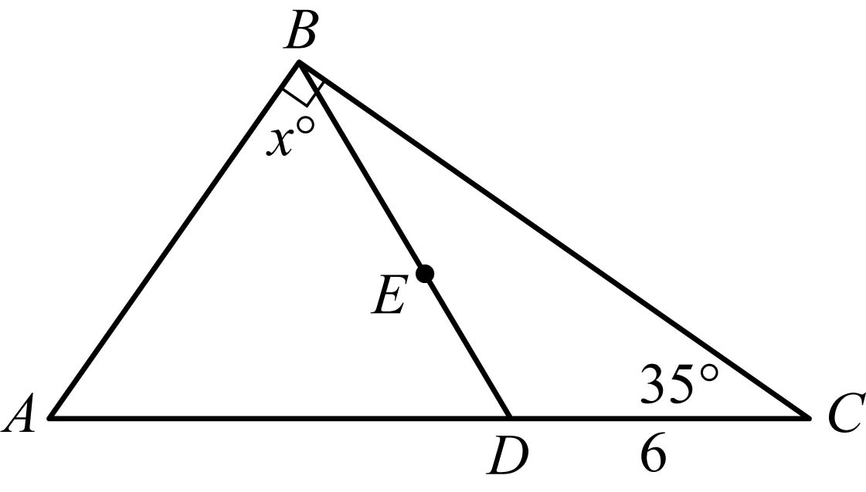
Conventions Figure 3

Begin skippable description of how Conventions Figure 3 is drawn.
This description reflects the way the figure is drawn. Following the description, there is a list of what can, and what cannot, be determined from the way the figure is drawn.

The figure consists of large triangle ABC, where side AC is horizontal, vertex A is to the left of vertex C, and vertex B is above side AC.

Point D lies on side AC and is closer to C than to A, and line segment BD is drawn from vertex B to point D.

BD divides angle B into two angles ABD and DBC, where angle ABD is bigger than angle DBC.

BD also divides triangle ABC into two smaller triangles ABD and DBC.

Triangle ABD looks like an isosceles triangle, with the length of side AB equal to the length of side BD; and the area of triangle ABD is greater than the area of triangle DBC.

Point E lies on line segment BD about halfway between point B and point D.

In the figure four measurements are given.
In the large triangle ABC, angle B is a right angle. (This is indicated by a small square symbol).
In the smaller triangle DBC, angle C measures 35º.
Line segment DC is of length 6.
In the smaller triangle ABD, angle B measures xº.

End skippable description.

The following eight statements about Conventions Figure 3 are consistent with the way the figure is drawn, and, according to the “not necessarily drawn to scale” conventions, you can assume that they are in fact true.

Statement 1: ABC, ABD, and DBC are triangles.
Statement 2: Points A, D, and C lie on a straight line.
Statement 3: Point D is a distinct point between points A and C.
Statement 4: Point E lies on line segment BD.
Statement 5: The length of AD is less than the length of AC.
Statement 6: Line segment DC is of length 6, and the measure of angle C is 35 degrees.
Statement 7: Angle ABC is a right angle, as indicated by the small square symbol at point B.
Statement 8: The measure of angle ABD is x degrees, and x is less than 90.

The following four statements about Conventions Figure 3 are consistent with the way the figure is drawn, however, according to the “not necessarily drawn to scale” conventions, you cannot assume that they are in fact true.

Statement 1: The length of line segment AD is greater than the length of line segment DC.
Statement 2: The measures of angles B A D and BDA are equal.
Statement 3: The measure of angle DBC is less than xº.
Statement 4: The area of triangle ABD is greater than the area of triangle DBC.

For another illustration, consider Conventions Figure 4 below.

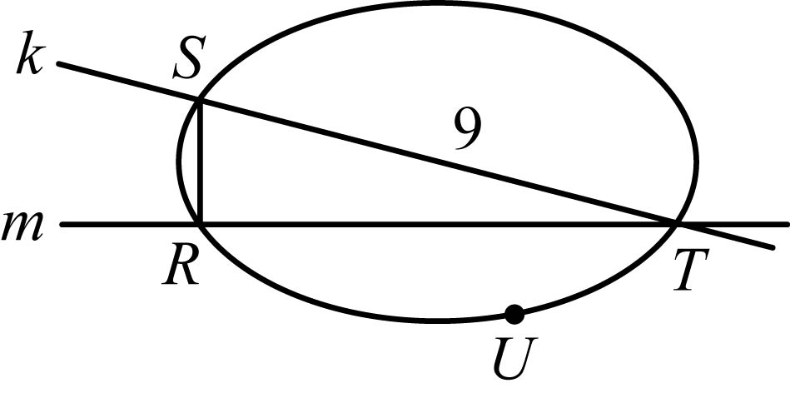
Conventions Figure 4

Begin skippable description of how Conventions Figure 4 is drawn.
This description reflects the way the figure is drawn.

In the figure, triangle RST is inscribed in an oval.
Vertices R, S, and T lie on the oval.
Side RT lies on horizontal line m.
Vertex S is above side RT, and side SR is vertical.
Vertical side SR meets horizontal side RT at vertex R.
Side ST lies on line k, which starts in the upper left part of the figure and slants downward and to the right.
The figure also shows point U, which is on the oval, below horizontal line m.
The only measurement given in the figure is that the length of line segment ST is equal to 9.

End skippable description.

The following five statements about Conventions Figure 4 are consistent with the way the figure is drawn, and according to the “not necessarily drawn to scale” conventions you can assume that they are in fact true.

Statement 1: Points R, S, T, and U lie on a closed curve.
Statement 2: Line k intersects the closed curve at points S and T.
Statement 3: Points S and U are on opposite sides of line m.
Statement 4: The length of side ST is 9.
Statement 5: The area of the region enclosed by the curve is greater than the area of triangle RST.

The statement “angle SRT is a right angle” is consistent with the way the figure is drawn, but according to the “not necessarily drawn to scale” conventions, you cannot assume that angle SRT is a right angle.

Coordinate systems

1. Coordinate systems, such as x y planes and number lines, are drawn to scale. Therefore, you can read, estimate, or compare quantities in such figures from how they are drawn in the coordinate system.

2. The positive direction of a number line is to the right.

3. As in geometry, distances in a coordinate system are nonnegative.

4. The rectangular coordinate plane, or rectangular coordinate system, commonly known as the x y plane, is shown in Conventions Figure 5 below. The x axis and y axis intersect at the origin O, and they partition the plane into four quadrants. Quadrant I is above the x axis and to the right of the y axis; Quadrant II is above the x axis and to the left of the y axis; Quadrant III is below the x axis and to the left of the y axis; and Quadrant IV is below the x axis and to the right of the y axis. Each point in the x y plane has coordinates x comma y that give its location with respect to the axes; for example, as shown in Conventions Figure 5 below, the point P 2 comma 8 is located 2 units to the right of the y axis and 8 units below the x axis. The units on the x axis have the same length as the units on the y axis, unless otherwise noted.

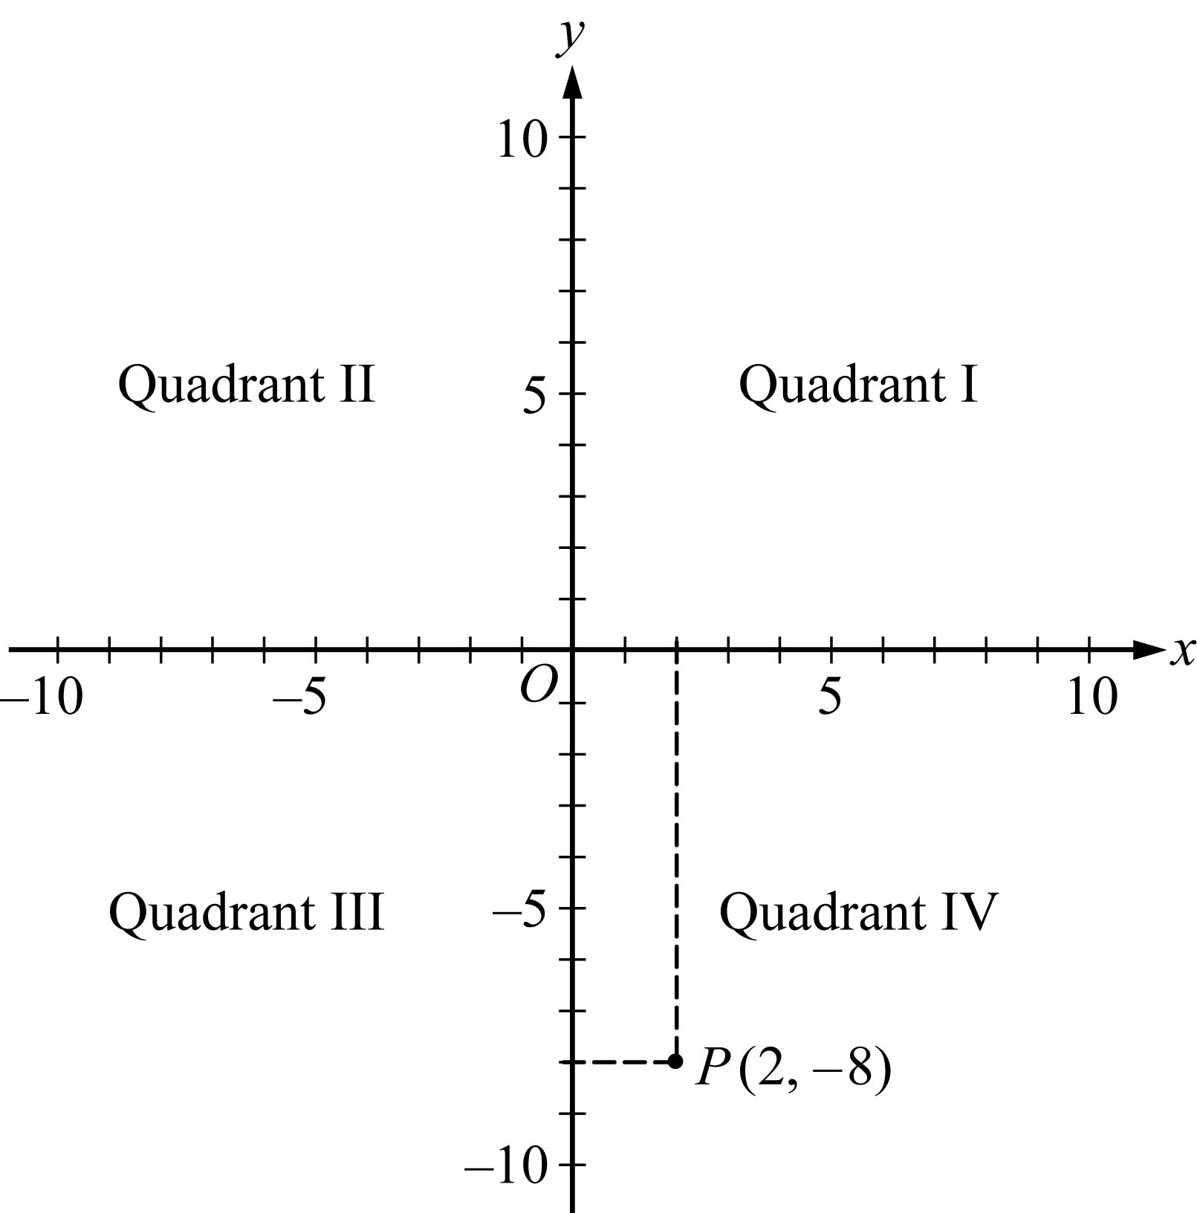
Conventions Figure 5

5. Intermediate grid lines or tick marks in a coordinate system are evenly spaced unless otherwise noted.

6. The term x intercept refers to the x coordinate of the point at which a graph in the x y plane intersects the x axis; it does not refer to the point itself. The term y intercept is used analogously.

Sets, lists, and sequences

1. Sets of numbers or other elements appear in some questions. Some sets are infinite, such as the set of integers; other sets are finite and may have all of their elements listed within curly brackets, such as the set open curly bracket, 2, 4, 6, 8, close curly bracket. When the elements of a set are given, repetitions are not counted as additional elements and the order of the elements is not relevant. Elements are also called members. A set with one or more members is called nonempty; there is a set with no members, called the empty set and denoted by the empty set symbol. If A and B are sets, then the intersection of A and B, denoted by A, followed by the intersection symbol, followed by B, is the set of elements that are in both A and B, and the union of A and B, denoted by A, followed by the union symbol, followed by B, is the set of elements that are in either A or B or both. If all of the elements in A are also in B, then A is a subset of B. By convention, the empty set is a subset of every set. If A and B have no elements in common, they are called disjoint sets or mutually exclusive sets.

2. Lists of numbers or other elements are also used in the test. When the elements of a list are given, repetitions are counted as additional elements and the order of the elements is relevant.

Example: The list 3, 1, 2, 3, 3 contains five numbers, and the first, fourth, and fifth numbers in the list are each 3.

3. The terms data set and set of data are not sets in the mathematical sense given above. Rather they refer to a list of data because there may be repetitions in the data, and if there are repetitions, they would be relevant.

4. Sequences are lists that often have an infinite number of elements, or terms. The terms of a sequence are often represented by a fixed letter along with a subscript that indicates the order of a term in the sequence.

Example: a sub 1, a sub 2, a sub 3, dot dot dot, a sub n, dot dot dot represents an infinite sequence in which the first term is a sub 1, the second term is a sub 2, and more generally, the nth term is a sub n for every positive integer n.

Sometimes the nth term of a sequence is given by a formula, such as 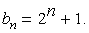 b sub n = 2 to the power n, +1. Sometimes the first few terms of a sequence are given explicitly, as in the following sequence of consecutive even negative integers: negative 2, negative 4, negative 6, negative 8, negative 10, dot dot dot.

5. Sets of consecutive integers are sometimes described by indicating the first and last integer, as in “the integers from 0 to 9, inclusive.” This phrase refers to 10 integers, with or without “inclusive” at the end. Thus, the phrase “during the years from 1985 to 2005” refers to 21 years.

Data and statistics

1. Numerical data are sometimes given in lists and sometimes displayed in other ways, such as in tables, bar graphs, or circle graphs. Various statistics, or measures of data, appear in questions: measures of central tendency—mean, median, and mode; measures of position—quartiles and percentiles; and measures of dispersion—standard deviation, range, and interquartile range.

2. The term average is used in two ways, with and without the qualification “(arithmetic mean)”. For a list of data, the average (arithmetic mean) of the data is the sum of the data divided by the number of data. The term average does not refer to either median or mode in the test. Without the qualification of “arithmetic mean”, average can refer to a rate or the ratio of one quantity to another, as in “average number of miles per hour” or “average weight per truckload”.

3. When mean is used in the context of data, it means arithmetic mean.

4. The median of an odd number of data is the middle number when the data are listed in increasing order; the median of an even number of data is the arithmetic mean of the two middle numbers when the data are listed in increasing order.

5. For a list of data, the mode of the data is the most frequently occurring number in the list. Thus, there may be more than one mode for a list of data.

6. For data listed in increasing order, the first quartile, second quartile, and third quartile of the data are three numbers that divide the data into four groups that are roughly equal in size. The first group of numbers is from the least number up to the first quartile. The second group is from the first quartile up to the second quartile, which is also the median of the data. The third group is from the second quartile up to the third quartile, and the fourth group is from the third quartile up to the greatest number. Note that the four groups themselves are sometimes referred to as quartiles—first quartile, second quartile, third quartile, and fourth quartile. The latter usage is clarified by the word “in” as in the phrase “the cow’s weight is in the third quartile of the herd.”

7. For data listed in increasing order, the percentiles of the data are 99 numbers that divide the data into 100 groups that are roughly equal in size. The 25th percentile equals the first quartile; the 50th percentile equals the second quartile, or median; and the 75th percentile equals the third quartile.

8. For a list of data, where the arithmetic mean is denoted by m, the standard deviation of the data refers to the nonnegative square root of the mean of the squared differences between m and each of the data. This statistic is also known as the population standard deviation and is not to be confused with the sample standard deviation.

9. For a list of data, the range of the data is the greatest number in the list minus the least number. The interquartile range of the data is the third quartile minus the first quartile.

Data distributions and probability distributions

1. Some questions display data in frequency distributions, where discrete data values are repeated with various frequencies, or where preestablished intervals of possible values are assigned frequencies corresponding to the numbers of data in the intervals.

Example: The lifetimes, rounded to the nearest hour, of 300 lightbulbs could be in the following 10 intervals: 501 to 550 hours, 551 to 600 hours, 601 to 650 hours, and so on, up to 951 to 1,000 hours; consequently, each of the intervals would have a number, or frequency, of lifetimes, and the sum of the 10 frequencies is 300.

2. Questions may involve relative frequency distributions, where each frequency of a frequency distribution is divided by the total number of data in the distribution, resulting in a relative frequency. In the example above, the 10 frequencies of the 10 intervals would each be divided by 300, yielding 10 relative frequencies.

3. Some questions describe probability experiments, or random experiments, that have a finite number of possible outcomes. In a random experiment, any particular set of outcomes is called an event, and every event E has a probability, denoted by P of, E, where 0 is less than or equal to P of, E, which is less than or equal to 1. If each outcome of an experiment is equally likely, then the probability of an event E is defined as the following ratio:
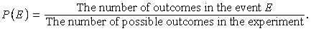
P of, E = the number of outcomes in the event E, over, the number of possible outcomes in the experiment.

4. If E and F are two events in an experiment, then “E and F ” is an event, which is the set of outcomes that are in the intersection of events E and F. Another event is “E or F ”, which is the set of outcomes that are in the union of events E and F.

5. If E and F are two events and E and F are mutually exclusive, then P of, E and F, = 0.

6. If E and F are two events such that the occurrence of either event does not affect the occurrence of the other, then E and F are said to be independent events. Events E and F are independent if and only if P of, E and F, =, P of, E times P of, F.

7. A random variable is a variable that represents values resulting from a random experiment. The values of the random variable may be the actual outcomes of the experiment if the outcomes are numerical, or the random variable may be related to the outcomes more indirectly. In either case, random variables can be used to describe events in terms of numbers.

8. A random variable from an experiment with only a finite number of possible outcomes also has only a finite number of values and is called a discrete random variable. When the values of a random variable form a continuous interval of real numbers, such as all of the numbers between 0 and 2, the random variable is called a continuous random variable.

9. Every value of a discrete random variable X, say X = a has a probability denoted by P of, a. A histogram (or a table) showing all of the values of X and their probabilities P of, X is called the probability distribution of X. The mean of the random variable X is the sum of the products X times P of, X for all values of X.

10. The mean of a random variable X is also called the expected value of X or the mean of the probability distribution of X.

11. For a continuous random variable X, every interval of values, say a is less than or equal to X, which is less than or equal to b, has a probability, which is denoted by P of, a is less than or equal to X, which is less than or equal to b. The probability distribution of X can be described by a curve in the X y plane that mimics the tops of the bars of a histogram, only smoother. The curve is the graph of a function f whose values are nonnegative and whose graph is therefore above the X axis. The curve y = f of, X is related to the probability of each interval a is less than or equal to X, which is less than or equal to b in the following way: the probability that a is less than or equal to X, which is less than or equal to b is equal to the area of the region that is below the curve, above the X axis, and between the vertical lines X = a and X = b. The area of the entire region under the curve is 1.

12. The mean of a continuous random variable X is the point m on the X axis at which the region under the distribution curve would perfectly balance if a fulcrum were placed at X = m The median of X is the point M on the X axis at which the line X = M divides the region under the distribution curve into two regions of equal area. (Note that a lower case m is used to denote the mean, and an upper case M is used to denote the median).

13. The standard deviation of a random variable X is a measure of dispersion, which indicates how spread out the probability distribution of X is from its mean. It is also called the standard deviation of the probability distribution of X.

14. The most important probability distribution is the normal distribution, whose distribution curve is shaped like a bell. A random variable X with this distribution is called normally distributed. The curve is symmetric about the line X = m, where m is the mean as well as the median. The right and left tails of the distribution become closer and closer to the X axis but never touch it.

15. The standard normal distribution has mean 0 and standard deviation 1. Conventions Figure 6 below shows the standard normal distribution, including approximate probabilities corresponding to the six intervals shown in the figure.

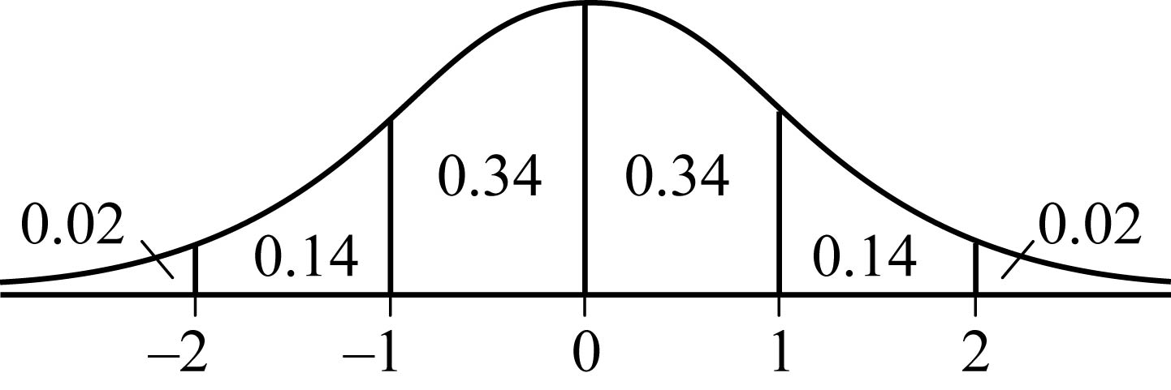
Conventions Figure 6

Begin skippable description of Conventions Figure 6.
The figure consists of a bell shaped curve graphed above a number line. Along the number line are equally spaced numbers negative 2, negative 1, 0, 1, and 2. The graph reaches its greatest height at 0. The graph is symmetric about 0.

The six intervals shown, along with the approximate probabilities are as follows.
The interval to the left of negative 2, approximate probability 0.02
The interval between negative 2 and negative 1, approximate probability 0.14.
The interval between negative 1 and 0, approximate probability 0.34.
The interval between 0 and 1, approximate probability 0.34.
The interval between 1 and 2, approximate probability 0.14.
The interval to the right of 2, approximate probability 0.02.

End skippable figure description.

Graphical representations of data

1. Graphical data presentations, such as bar graphs, circle graphs, and line graphs, are drawn to scale; therefore, you can read, estimate, or compare data values from how they are drawn in the graphical data presentation.

2. Standard conventions apply to graphs of data unless otherwise indicated.
Example 1: A circle graph represents 100 percent of the data indicated in the graph’s title, and the areas of the individual sectors are proportional to the percents they represent.
Example 2: Scales, grid lines, dots, bars, shadings, solid and dashed lines, legends, etc., are used on graphs to indicate the data. Sometimes, scales that do not begin at 0 are used, and sometimes broken scales are used.

3. In Venn diagrams, various sets of objects are represented by circular regions and by regions formed by intersections of the circles. In some Venn diagrams, all of the circles are inside a rectangular region that represents a universal set. A number placed in a region is the number of elements in the subset represented by the smallest region containing the number, unless otherwise noted. Sometimes a number is placed above a circle to indicate the number of elements in the entire circle.

Miscellaneous Guidelines for Interpreting and Using Information in Test Questions

1. Numbers given in a question are to be used as exact numbers, even though in some real life settings they are likely to have been rounded.

Example: If a question states that “30 percent of the company’s profit was from health products”, then 30 is to be used as an exact number; it is not to be used as a rounded number obtained from, say, 29 or 30.1.

2. An integer that is given as the number of certain objects, whether in a real life or pure math setting, is to be taken as the total number of such objects.

Example: If a question states that “a bag contains 50 marbles, and 23 of the marbles are red”, then 50 is to be taken as the total number of marbles in the bag and 23 is to be taken as the total number of red marbles in the bag, so that the other 27 marbles are not red. Fractions and percents are understood in a similar way, so “one fifth, or 20 percent, of the 50 marbles in the bag are green” means 10 marbles in the bag are green and 40 marbles are not green.

3. When a multiple choice question asks for an approximate quantity without stipulating a degree of approximation, the correct answer is the choice that is closest in value to the quantity that can be computed from the information given.

4. Unless otherwise indicated, the phrase “difference between two quantities” is assumed to mean “positive difference”, that is, the greater quantity minus the lesser quantity.
Example: For which two consecutive years was the difference in annual rainfall least? means for which two consecutive years was the absolute value of the difference in annual rainfall least?

5. When the term profit is used in a question, it refers to gross profit, which is the sales revenue minus the cost of production. The profit does not involve any other amounts unless they are explicitly given.

6. The common meaning of terms such as months and years and other everyday terms are assumed in questions where the terms appear.

7. In questions involving real life scenarios in which a variable is given to represent a number of existing objects or another nonnegative amount, the context implies that the variable is greater than 0.
Example: Jane sold x rugs and deposited her profit of y dollars into her savings account implies that x and y are greater than 0.

8. Some quantities may involve units, such as inches, pounds, and Celsius degrees, while other quantities are pure numbers. Any units of measurement, such as English units or metric units, may be used. However, if an answer to a question requires converting one unit of measurement to another, then the relationship between the units is given in the question, unless the relationship is a common one, such as the relationships between minutes and hours, dollars and cents, and metric units like centimeters and meters.

9. In any question, there may be some information that is not needed for obtaining the correct answer.

10. When reading questions, do not introduce unwarranted assumptions.

Example: If a question describes a trip that begins and ends at certain times, the intended answer will assume that the times are unaffected by crossing time zones or by changes to the local time for daylight savings, unless those matters are explicitly mentioned. As another example, do not consider sales taxes on purchases unless explicitly mentioned.

11. The display of data in a Data Interpretation set of questions is the same for each question in the set. Also, the display may contain more than one graph or table. Each question will refer to some of the data, but it may happen that some part of the data will have no question that refers to it.

12. In a Data Interpretation set of questions, each question should be considered separately from the others. No information except what is given in the display of data should be carried over from one question to another.

13. In many questions, mathematical expressions and words appear together in a phrase. In such a phrase, each mathematical expression should be interpreted separately from the words before it is interpreted along with the words. For example, if n is an integer, then the phrase “the sum of the first two consecutive integers greater than n + 6” means the number n + 7, + the number n + 8; it does not mean “the sum of the first two consecutive integers greater than n” plus 6, or the number n + 1, + the number n + 2, plus the number 6. That is, the expression n + 6 should be interpreted first, separately from the words. However, in a phrase like “the function g is defined for all x greater than or equal to 0,”, the phrase “for all x greater than or equal to 0” is a mathematical shorthand for “for all numbers x such that x is greater than or equal to 0”.

