GRADUATE RECORD EXAMINATIONS®

Math Review
Chapter 2: Algebra

Copyright © 2010 by Educational Testing Service. All rights reserved. ETS, the ETS logo, GRADUATE RECORD EXAMINATIONS, and GRE are registered trademarks of Educational Testing Service (ETS) in the United States and other countries.
The GRE® Math Review consists of 4 chapters: Arithmetic, Algebra, Geometry, and Data Analysis. This is the accessible electronic format (Word) edition of the Algebra Chapter of the Math Review. Downloadable versions of large print (PDF) and accessible electronic format (Word) of each of the 4 chapters of the of the Math Review, as well as a Large Print Figure supplement for each chapter are available from the GRE® website. Other downloadable practice and test familiarization materials in large print and accessible electronic formats are also available. Tactile figure supplements for the four chapters of the Math Review, along with additional accessible practice and test familiarization materials in other formats, are available from E T S Disability Services Monday to Friday 8:30 a m to 5 p m New York time, at 1-6 0 9-7 7 1-7 7 8 0, or 1-8 6 6-3 8 7-8 6 0 2 (toll free for test takers in the United States, U S Territories and Canada), or via email at stassd@ets.org.

The mathematical content covered in this edition of the Math Review is the same as the content covered in the standard edition of the Math Review. However, there are differences in the presentation of some of the material. These differences are the result of adaptations made for presentation of the material in accessible formats. There are also slight differences between the various accessible formats, also as a result of specific adaptations made for each format.

Information for screen reader users:
This document has been created to be accessible to individuals who use screen readers. You may wish to consult the manual or help system for your screen reader to learn how best to take advantage of the features implemented in this document. Please consult the separate document, GRE Screen Reader Instructions.doc, for important details.

Figures
The Math Review includes figures. In accessible electronic format (Word) editions, following each figure on screen is text describing that figure. Readers using visual presentations of the figures may choose to skip parts of the text describing the figure that begin with “Begin skippable part of description of …” and end with “End skippable figure description.”

Mathematical Equations and Expressions
The Math Review includes mathematical equations and expressions. In accessible electronic format (Word) editions some of the mathematical equations and expressions are presented as graphics. In cases where a mathematical equation or expression is presented as a graphic, a verbal presentation is also given and the verbal presentation comes directly after the graphic presentation. The verbal presentation is in green font to assist readers in telling the two presentation modes apart. Readers using audio alone can safely ignore the graphical presentations, and readers using visual presentations may ignore the verbal presentations.

Table of Contents

Overview of the Math Review 5
Overview of this Chapter 5
2.1 Operations with Algebraic Expressions 6
2.2 Rules of Exponents 11
2.3 Solving Linear Equations 17
2.4 Solving Quadratic Equations 22
2.5 Solving Linear Inequalities 25
2.6 Functions 28
2.7 Applications 30
2.8 Coordinate Geometry 41
2.9 Graphs of Functions 60
Algebra Exercises 74
Answers to Algebra Exercises 82

Overview of the Math Review

The Math Review consists of 4 chapters: Arithmetic, Algebra, Geometry, and Data Analysis.

Each of the 4 chapters in the Math Review will familiarize you with the mathematical skills and concepts that are important to understand in order to solve problems and reason quantitatively on the Quantitative Reasoning measure of the GRE® revised General Test.

The material in the Math Review includes many definitions, properties, and examples, as well as a set of exercises (with answers) at the end of each chapter. Note, however that this review is not intended to be all inclusive. There may be some concepts on the test that are not explicitly presented in this review. If any topics in this review seem especially unfamiliar or are covered too briefly, we encourage you to consult appropriate mathematics texts for a more detailed treatment.

Overview of this Chapter
Basic algebra can be viewed as an extension of arithmetic. The main concept that distinguishes algebra from arithmetic is that of a variable, which is a letter that represents a quantity whose value is unknown. The letters x and y are often used as variables, although any letter can be used. Variables enable you to present a word problem in terms of unknown quantities by using algebraic expressions, equations, inequalities, and functions. This chapter reviews these algebraic tools and then progresses to several examples of applying them to solve real life word problems. The chapter ends with coordinate geometry and graphs of functions as other important algebraic tools for solving problems.

2.1 Operations with Algebraic Expressions

An algebraic expression has one or more variables and can be written as a single term or as a sum of terms. Here are four examples of algebraic expressions.

Example A: 2x
Example B: 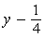 y minus, one fourth
Example C: w cubed z, +, 5, z squared, minus z squared, +, 6
Example D: 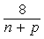 the expression with numerator 8 and denominator n + p

In the examples above, 2x is a single term,
y minus, one fourth has two terms,
w cubed z, +, 5, z squared, minus z squared, +, 6 has four terms, and the expression with numerator 8 and denominator n + p has one term.
In the expression 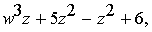 w cubed z, +, 5, z squared, minus z squared, +, 6,
the terms 5, z squared, and negative, z squared
are called like terms because they have the same variables, and the corresponding variables have the same exponents. A term that has no variable is called a constant term. A number that is multiplied by variables is called the coefficient of a term. For example, in the expression
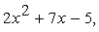 2, x squared, +, 7x, minus 5,
2 is the coefficient of the term 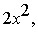 2, x squared,
7 is the coefficient of the term 7x, and
negative 5 is a constant term.

The same rules that govern operations with numbers apply to operations with algebraic expressions. One additional rule, which helps in simplifying algebraic expressions, is that like terms can be combined by simply adding their coefficients, as the following three examples show.

Example A: 2x + 5x = 7x
Example B:
w cubed z, +, 5, z squared, minus z squared, +, 6 = w cubed z, +, 4, z squared, +, 6
Example C:
3 x y, +, 2x, minus x y, minus 3x = 2 x y, minus x

A number or variable that is a factor of each term in an algebraic expression can be factored out, as the following three examples show.

Example A:
4x + 12 = 4 times, open parenthesis, x + 3, close parenthesis
Example B: 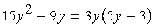
15, y squared, minus 9y, =, 3y times, open parenthesis, 5y minus 3, close parenthesis
Example C: For values of x where it is defined, the algebraic expression 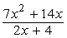
with numerator 7, x squared, +, 14x and denominator 2x, +, 4
can be simplified as follows.
First factor the numerator and the denominator to get 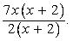
the algebraic expression with numerator 7x times, open parenthesis, x + 2, close parenthesis, and denominator 2 times, open parenthesis, x + 2, close parenthesis.
Now, since x + 2 occurs in both the numerator and the denominator, it can be canceled out when x + 2 is not equal to 0, that is, when x is not equal to negative 2 (since division by 0 is not defined). Therefore, for all x not equal to negative 2, the expression is equivalent to 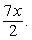 7x over 2.

To multiply two algebraic expressions, each term of the first expression is multiplied by each term of the second expression, and the results are added, as the following example shows.

To multiply
open parenthesis, x + 2, close parenthesis, times, open parenthesis 3x minus 7, close parenthesis
first multiply each term of the expression x + 2 by each term of the expression 3x minus 7 to get the expression
x times 3x, +, x times negative 7, +, 2 times 3x, +, 2 times negative 7.
Then multiply each term to get
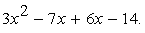
3, x squared, minus 7x, +, 6x, minus 14.
Finally, combine like terms to get
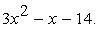
3, x squared, minus x, minus 14.
So you can conclude that 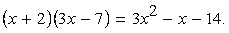
open parenthesis, x + 2, close parenthesis, times, open parenthesis 3x minus 7, close parenthesis = 3, x squared, minus x, minus 14.

A statement of equality between two algebraic expressions that is true for all possible values of the variables involved is called an identity. All of the statements above are identities. Here are three standard identities that are useful.

Identity 1: 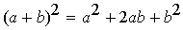
open parenthesis, a + b, close parenthesis, squared, =, a squared, +, 2 a b, +, b squared
Identity 2: 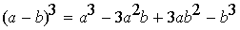
open parenthesis, a minus b, close parenthesis, cubed, =, a cubed, minus 3, a squared b, +, 3a b squared, minus b cubed
Identity 3: 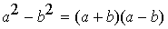
a squared minus b squared = open parenthesis, a + b, close parenthesis, times, open parenthesis, a minus b, close parenthesis

All of the identities above can be used to modify and simplify algebraic expressions. For example, identity 3,
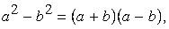
a squared minus b squared = open parenthesis, a + b, close parenthesis, times, open parenthesis, a minus b, close parenthesis

can be used to simplify the algebraic expression 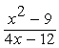
with numerator x squared minus 9 and denominator 4x, minus 12
as follows.

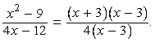
the algebraic expression with numerator x squared minus 9 and denominator 4x minus 12 = the algebraic expression with numerator, open parenthesis, x + 3, close parenthesis, times, open parenthesis, x minus 3, close parenthesis, and denominator 4 times, open parenthesis, x minus 3, close parenthesis.
Now, since x minus 3 occurs in both the numerator and the denominator, it can be canceled out when x minus 3 is not equal to 0, that is, when x is not equal to 3 (since division by 0 is not defined). Therefore, for all x not equal to 3, the expression is equivalent to 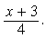 the expression with numerator x + 3 and denominator 4.

A statement of equality between two algebraic expressions that is true for only certain values of the variables involved is called an equation. The values are called the solutions of the equation.

The following are three basic types of equations.

Type 1: A linear equation in one variable: for example,
3x + 5 = negative 2
Type 2: A linear equation in two variables: for example,
x minus 3y = 10
Type 3: A quadratic equation in one variable: for example 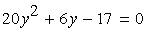
20, y squared, +, 6y minus 17 = 0

2.2 Rules of Exponents

In the algebraic expression x superscript a, where x is raised to the power a, x is called a base and a is called an exponent. Here are seven basic rules of exponents, where the bases x and y are nonzero real numbers and the exponents a and b are integers.

Rule 1: 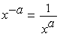
x to the power negative a = 1, over, x to the power a
Example A: 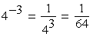
4 to the power negative 3 = 1, over, 4 to the power 3, which is equal to 1 over 64
Example B: 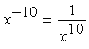
x to the power negative 10 = 1 over, x to the power 10
Example C: 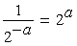
1, over, 2 to the power negative a = 2 to the power a

Rule 2: 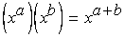
Open parenthesis, x to the power a, close parenthesis, times, open parenthesis, x to the power b, close parenthesis, =, x to the power a + b
Example A: 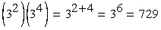
Open parenthesis, 3 squared, close parenthesis, times, open parenthesis, 3 to the power 4, close parenthesis, =, 3 to the power 2 + 4, which is equal to 3 to the power 6, or 729
Example B: 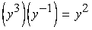
Open parenthesis, y cubed, close parenthesis, times, open parenthesis, y to the power negative 1, close parenthesis =, y squared

Rule 3: 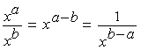
x to the power a, over, x to the power b, =, x to the power a minus b, which is equal to 1 over, x to the power, b minus a
Example A: 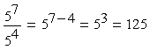
5 to the power 7, over, 5 to the power 4, =, 5 to the power 7 minus 4, which is equal to 5 to the power 3, or 125
Example B: 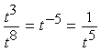
t to the power 3, over, t to the power 8, =, t to the power negative 5, which is equal to 1, over, t to the power 5

Rule 4: 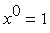 x to the power 0 = 1
Example A: 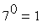 7 to the power 0 = 1
Example B: 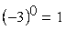
open parenthesis, negative 3, close parenthesis, to the power 0, =, 1
Note that 0 to the power 0 is not defined.

Rule 5: 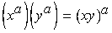
Open parenthesis, x to the power a, close parenthesis, times, open parenthesis, y to the power a, close parenthesis, =, open parenthesis, x y, close parenthesis, to the power a
Example A: 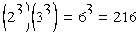
Open parenthesis, 2 to the power 3, close parenthesis, times, open parenthesis, 3 to the power 3, close parenthesis, =, 6 to the power 3, or 216
Example B: 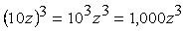
Open parenthesis, 10z, close parenthesis, cubed, =, 10 cubed times z cubed, which is equal to 1,000, z cubed
Rule 6: 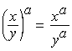
Open parenthesis, x over y, close parenthesis, to the power a, =, x to the power a, over y to the power a
Example A: 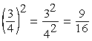
Open parenthesis, 3 fourths, close parenthesis, squared, =, 3 squared over 4 squared, which is equal to 9 over 16
Example B: 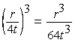
Open parenthesis, r over 4t, close parenthesis, cubed, = r cubed, over, 64, t cubed

Rule 7: 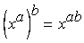
Open parenthesis, x to the power a, close parenthesis, to the power b, =, x to the power a b
Example A: 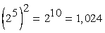
Open parenthesis, 2 to the power 5, close parenthesis, squared, =, 2 to the power 10, which is equal to 1,024
Example B: 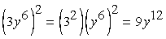
Open parenthesis, 3, y to the power 6, close parenthesis, squared, =, open parenthesis, 3 squared, close parenthesis, times, open parenthesis, y to the power 6, close parenthesis, squared, which is equal to 9, y to the power 12

The rules above are identities that are used to simplify expressions. Sometimes algebraic expressions look like they can be simplified in similar ways, but in fact they cannot. In order to avoid mistakes commonly made when dealing with exponents keep the following six cases in mind.

Case 1: 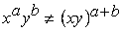
x to the power a times y to the power b is not equal to, open parenthesis, x y, close parenthesis, to the power a + b
Note that in the expression 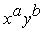 x to the power a times y to the power b the bases are not the same, so Rule 2, 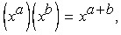
open parenthesis, x to the power a, close parenthesis, times, open parenthesis, x to the power b, close parenthesis, =, x to the power a + b,
does not apply.

Case 2: 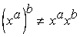
Open parenthesis, x to the power a, close parenthesis, to the power b is not equal to, x to the power a times x to the power b
Instead,
Open parenthesis, x to the power a, close parenthesis, to the power b, =, x to the power a b
and 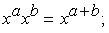
x to the power a times x to the power b, =, x to the power a + b;
for example, 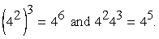
open parenthesis, 4 squared, close parenthesis, cubed, =, 4 to the power 6, and 4 squared times 4 cubed, =, 4 to the power 5.

Case 3: 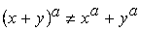
open parenthesis, x + y, close parenthesis, to the power a, is not equal to x to the power a, +, y to the power a
Recall that 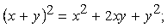
open parenthesis, x + y, close parenthesis, squared, =, x squared, +, 2x y, +, y squared;
that is, the correct expansion contains terms such as 2x y.

Case 4: 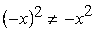
Open parenthesis, negative x, close parenthesis, squared, is not equal to the negative of, x squared
Instead, 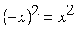
Open parenthesis, negative x, close parenthesis, squared =, x squared
Note carefully where each negative sign appears.

Case 5: 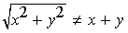
The positive square root of the quantity x squared + y squared, is not equal to x + y

Case 6: 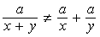
The expression with numerator a and denominator x + y, is not equal to a over x, +, a over y
But it is true that 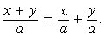
the expression with numerator x + y, and denominator a =, x over a, +, y over a.

2.3 Solving Linear Equations

To solve an equation means to find the values of the variables that make the equation true; that is, the values that satisfy the equation. Two equations that have the same solutions are called equivalent equations. For example, x + 1 = 2 and 2x + 2 = 4 are equivalent equations; both are true when x = 1, and are false otherwise. The general method for solving an equation is to find successively simpler equivalent equations so that the simplest equivalent equation makes the solutions obvious.

The following two rules are important for producing equivalent equations.

Rule 1: When the same constant is added to or subtracted from both sides of an equation, the equality is preserved and the new equation is equivalent to the original equation.

Rule 2: When both sides of an equation are multiplied or divided by the same nonzero constant, the equality is preserved and the new equation is equivalent to the original equation.

A linear equation is an equation involving one or more variables in which each term in the equation is either a constant term or a variable multiplied by a coefficient. None of the variables are multiplied together or raised to a power greater than 1. For example, 2x + 1 = 7x and 10x minus 9y minus z = 3 are linear equations, but x, +, y squared, =, 0 and xz = 3 are not.

Linear Equations in One Variable

To solve a linear equation in one variable, simplify each side of the equation by combining like terms. Then use the rules for producing simpler equivalent equations.

Example 2.3.1: Solve the equation
11x, minus 4, minus 8x, =, 2 times, open parenthesis, x + 4, close parenthesis, minus 2x
as follows.

Combine like terms to get
3x minus 4, =, 2x + 8 minus 2x
Simplify the right side to get 3x minus 4, =, 8
Add 4 to both sides to get 3x, minus 4, + 4, =, 8 + 4
Divide both sides by 3 to get 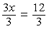 3x over 3 = 12 over 3
Simplify to get x = 4

You can always check your solution by substituting it into the original equation.

Note that it is possible for a linear equation to have no solutions. For example, the equation 2x + 3, =, 2 times, open parenthesis, 7 + x, close parenthesis, has no solution, since it is equivalent to the equation 3 = 14, which is false. Also, it is possible that what looks to be a linear equation turns out to be an identity when you try to solve it. For example, 3x minus 6, =, negative 3 times, open parenthesis, 2 minus x, close parenthesis is true for all values of x, so it is an identity.

Linear Equations in Two Variables

A linear equation in two variables, x and y, can be written in the form a x + b y = c,
where a, b, and c are real numbers and a and b are not both zero. For example, 3x + 2y = 8, is a linear equation in two variables.

A solution of such an equation is an ordered pair of numbers x comma y that makes the equation true when the values of x and y are substituted into the equation. For example, both pairs 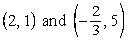 2 comma 1, and negative 2 over 3 comma 5 are solutions of the equation 3x + 2y = 8, but 1 comma 2 is not a solution. A linear equation in two variables has infinitely many solutions. If another linear equation in the same variables is given, it may be possible to find a unique solution of both equations. Two equations with the same variables are called a system of equations, and the equations in the system are called simultaneous equations. To solve a system of two equations means to find an ordered pair of numbers that satisfies both equations in the system.

There are two basic methods for solving systems of linear equations, by substitution or by elimination. In the substitution method, one equation is manipulated to express one variable in terms of the other. Then the expression is substituted in the other equation.

For example, to solve the system of two equations
4x + 3y = 13, and
x + 2y = 2
you can express x in the second equation in terms of y as
x = 2 minus 2y.
Then substitute 2 minus 2y for x in the first equation to find the value of y.

The value of y can be found as follows.
Substitute for x in the first equation to get
4 times, open parenthesis, 2 minus 2y, close parenthesis, +, 3y, =, 13
Multiply out the first term and get:
8 minus 8y, +, 3y, =, 13
Subtract 8 from both sides to get
negative 8y + 3y = 5
Combine like terms to get negative 5y = 5
Divide both sides by negative 5 to get y = negative 1.

Then negative 1 can be substituted for y in either equation to find the value of x. We use the second equation as follows:

Substitute for y in the second equation to get
x +, 2 times negative 1 = 2
That is, x minus 2 = 2

Add 2 to both sides to get x = 4

In the elimination method, the object is to make the coefficients of one variable the same in both equations so that one variable can be eliminated either by adding the equations together or by subtracting one from the other. In the example above, multiplying both sides of the second equation, x + 2y = 2, by 4 yields
4 times, open parenthesis, x + 2y, close parenthesis, =, 4 times 2,
or 4x + 8y = 8.
Now you have two equations with the same coefficient of x.

4x + 3y = 13, and
4x + 8y = 8

If you subtract the equation 4x + 8y = 8 from the equation 4x + 3y = 13, the result is negative 5y = 5. Thus, y = negative 1, and substituting negative 1 for y in either of the original equations yields x = 4.

By either method, the solution of the system is x = 4 and y = negative 1, or the ordered pair x comma y = the ordered pair 4 comma negative 1.

2.4 Solving Quadratic Equations

A quadratic equation in the variable x is an equation that can be written in the form
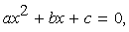
a x squared + bx + c = 0,
where a, b, and c are real numbers and a is not equal to 0. When such an equation has solutions, they can be found using the quadratic formula:

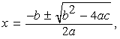
x = the fraction with numerator negative b plus or minus the square root of the quantity b squared minus 4a c, and denominator 2a,
where the notation plus or minus is shorthand for indicating two solutions, one that uses the plus sign and the other that uses the minus sign.

Example 2.4.1: In the quadratic equation 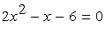
2, x squared, minus x, minus 6 = 0, we have
a = 2, b = negative 1, and c = negative 6.
Therefore, the quadratic formula yields

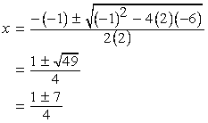
x = the fraction with numerator, negative, open parenthesis, negative 1, close parenthesis, plus or minus the square root of the quantity, open parenthesis, negative 1, close parenthesis, squared, minus 4 times 2 times negative 6, and denominator 2 times 2, which is equal to the fraction with numerator 1 plus or minus the square root of 49 and denominator 4, which is equal to the fraction with numerator 1 plus or minus 7, and denominator 4
Hence the two solutions are 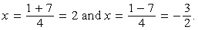
x = the fraction with numerator 1 + 7, and denominator 4, which is equal to 2, and x = the fraction with numerator 1 minus 7, and denominator 4, which is equal to negative 3 over 2.

Quadratic equations have at most two real solutions, as in example 2.4.1 above. However, some quadratic equations have only one real solution. For example, the quadratic equation 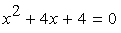 x squared, + 4x, + 4 = 0 has only one solution, which is x = negative 2. In this case, the expression under the square root symbol in the quadratic formula is equal to 0, and so adding or subtracting 0 yields the same result. Other quadratic equations have no real solutions; for example, 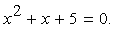 x squared, + x, + 5 = 0. In this case, the expression under the square root symbol is negative, so the entire expression is not a real number.

Some quadratic equations can be solved more quickly by factoring. For example, the quadratic equation 2, x squared, minus x, minus 6 = 0 in example 2.4.1 can be factored as
open parenthesis, 2x + 3, close parenthesis, times, open parenthesis, x minus 2, close parenthesis, = 0.
When a product is equal to 0, at least one of the factors must be equal to 0, so either 2x + 3 = 0 or x minus 2 = 0.

If 2x + 3 = 0, then 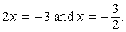
2x = negative 3, and x = negative 3 over 2.
If x minus 2 = 0, then x = 2.
Thus the solutions are 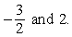 negative 3 over 2, and 2.

Example 2.4.2: The quadratic equation 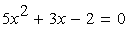
5, x squared, + 3x, minus 2 = 0
can be easily factored as
open parenthesis, 5x, minus 2, close parenthesis, times, open parenthesis, x + 1, close parenthesis, = 0.
Therefore, either , 5x, minus 2 = 0, or x + 1 = 0.
If 5x, minus 2 = 0, then 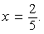 x = 2 over 5.
If x + 1 = 0, then x = negative 1.
Thus the solutions are 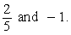 2 over 5, and negative 1.

2.5 Solving Linear Inequalities

A mathematical statement that uses one of the following four inequality signs is called an inequality.
Note: The four inequality signs are given as graphics. Since the meaning of each is given directly after the graphic, a “green font” verbal description of these symbols is not included.

the less than sign
the greater than sign
the less than or equal to sign
the greater than or equal to sign

Inequalities can involve variables and are similar to equations, except that the two sides are related by one of the inequality signs instead of the equality sign used in equations. For example, the inequality 4x minus 1, followed by the less than or equal to sign, followed by the number 7 is a linear inequality in one variable, which states that
“ 4x minus 1 is less than or equal to 7”. To solve an inequality means to find the set of all values of the variable that make the inequality true. This set of values is also known as the solution set of an inequality. Two inequalities that have the same solution set are called equivalent inequalities.

The procedure used to solve a linear inequality is similar to that used to solve a linear equation, which is to simplify the inequality by isolating the variable on one side of the inequality, using the following two rules.

Rule 1: When the same constant is added to or subtracted from both sides of an inequality, the direction of the inequality is preserved and the new inequality is equivalent to the original.

Rule 2: When both sides of the inequality are multiplied or divided by the same nonzero constant, the direction of the inequality is preserved if the constant is positive but the direction is reversed if the constant is negative. In either case, the new inequality is equivalent to the original.

Example 2.5.1: The inequality negative 3x, +, 5 is less than or equal to 17 can be solved as follows.

Subtract 5 from both sides to get negative 3x is less than or equal to 12
Divide both sides by negative 3 and reverse the direction of the inequality to get
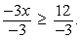
negative 3x over negative 3 is greater than or equal to 12 over negative 3.
That is, x is greater than or equal to negative 4.
Therefore, the solution set of
negative 3x, +, 5, is less than or equal to 17
consists of all real numbers greater than or equal to negative 4.

Example 2.5.2: The inequality 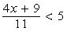 the algebraic expression with numerator 4x + 9 and denominator 11, is less than 5 can be solved as follows.

Multiply both sides by 11 to get 4x + 9 is less than 55.
Subtract 9 from both sides to get 4x is less than 46.
Divide both sides by 4 to get 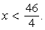 x is less than 46 over 4.
That is, x is less than 11.5.

Therefore, the solution set of the inequality the algebraic expression with numerator 4x + 9 and denominator 11, is less than 5 consists of all real numbers less than 11.5.

2.6 Functions

An algebraic expression in one variable can be used to define a function of that variable. Functions are usually denoted by letters such as f, g, and h. For example, the algebraic expression 3x + 5 can be used to define a function f by

f of, x = 3x + 5,

where f of, x is called the value of f at x and is obtained by substituting the value of x in the expression above. For example, if x = 1 is substituted in the expression above, the result is f of, 1 = 8.

It might be helpful to think of a function f as a machine that takes an input, which is a value of the variable x, and produces the corresponding output, f of, x. For any function, each input x gives exactly one output f of, x. However, more than one value of x can give the same output f of, x. For example, if g is the function defined by 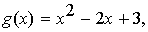 g of, x = x squared, minus 2x, +, 3,
then g of, 0 = 3 and g of, 2 = 3.

The domain of a function is the set of all permissible inputs, that is, all permissible values of the variable x. For the functions f and g defined above, the domain is the set of all real numbers. Sometimes the domain of the function is given explicitly and is restricted to a specific set of values of x. For example, we can define the function h by 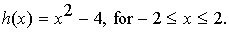 h of, x = x squared minus 4, for, negative 2 less than or equal to x, which is less than or equal to 2.
Without an explicit restriction, the domain is assumed to be the set of all values of x for which f of, x is a real number.

Example 2.6.1: Let f be the function defined by 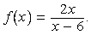
f of, x = the algebraic expression with numerator 2x, and denominator, x minus 6.
In this case, f is not defined at x = 6, because 12 over 0 is not defined.
Hence, the domain of f consists of all real numbers except for 6.

Example 2.6.2: Let g be the function defined by 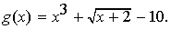
g of, x = x cubed, +, the positive square root of x + 2, minus 10.
In this case, g of, x is not a real number if x is less than negative 2. Hence, the domain of g consists of all real numbers x such that x is greater than or equal to negative 2.

Example 2.6.3: Let h be the function defined by h of, x = the absolute value of x, which is the distance between x and 0 on the number line (see Chapter 1: Arithmetic, Section 1.5). The domain of h is the set of all real numbers. Also, h of, x = h of, negative x for all real numbers x, which reflects the property that on the number line the distance between x and 0 is the same as the distance between negative x and 0.

2.7 Applications

Translating verbal descriptions into algebraic expressions is an essential initial step in solving word problems. Three examples of verbal descriptions and their translations are given below.

Example A: If the square of the number x is multiplied by 3, and then 10 is added to that product, the result can be represented algebraically by 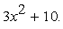 3, x squared, +, 10.
Example B: If John’s present salary s is increased by 14 percent, then his new salary can be represented algebraically by 1.14s.
Example C: If y gallons of syrup are to be distributed among 5 people so that one particular person gets 1 gallon and the rest of the syrup is divided equally among the remaining 4, then the number of gallons of syrup each of those 4 people will get can be represented algebraically by
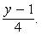 the expression with numerator y minus 1, and denominator 4.

The remainder of this section gives examples of various applications.

Applications Involving Average, Mixture, Rate, and Work Problems

Example 2.7.1: Ellen has received the following scores on 3 exams: 82, 74, and 90. What score will Ellen need to receive on the next exam so that the average (arithmetic mean) score for the 4 exams will be 85 ?

Solution: Let x represent the score on Ellen’s next exam. This initial step of assigning a variable to the quantity that is sought is an important beginning to solving the problem. Then in terms of x, the average of the 4 exams is

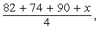 the fraction with numerator 82 + 74 + 90 + x, and denominator 4,

which is supposed to equal 85. Now simplify the expression and set it equal to 85:

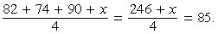
the fraction with numerator 82 + 74 + 90 + x, and denominator 4, =, the fraction with numerator 246 + x, and denominator 4, which is equal to 85.

Solving the resulting linear equation for x, you get 246 + x = 340, and x = 94.

Therefore, Ellen will need to attain a score of 94 on the next exam.

Example 2.7.2: A mixture of 12 ounces of vinegar and oil is 40 percent vinegar, where all of the measurements are by weight. How many ounces of oil must be added to the mixture to produce a new mixture that is only 25 percent vinegar?

Solution: Let x represent the number of ounces of oil to be added. Then the total number of ounces of the new mixture will be 12 + x and the total number of ounces of vinegar in the new mixture will be 0.40 times 12.
Since the new mixture must be 25 percent vinegar,

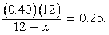
the fraction with numerator 0.40 times 12 and denominator 12 + x, =, 0.25.

Therefore,
0.40 times 12, =, open parenthesis, 12 + x, close parenthesis, times 0.25.

Multiplying out gives 4.8 = 3 + 0.25x, so 1.8 = 0.25x, and 7.2 = x.

Thus, 7.2 ounces of oil must be added to produce a new mixture that is 25 percent vinegar.

Example 2.7.3: In a driving competition, Jeff and Dennis drove the same course at average speeds of 51 miles per hour and 54 miles per hour, respectively. If it took Jeff 40 minutes to drive the course, how long did it take Dennis?

Solution: Let x be the time, in minutes, that it took Dennis to drive the course. The distance d, in miles, is equal to the product of the rate r, in miles per hour, and the time t, in hours; that is,

d = rt.

Note that since the rates are given in miles per hour, it is necessary to express the times in hours; for example, 40 minutes equals 40 over 60 of an hour. Thus, the distance traveled by Jeff is the product of his speed and his time, 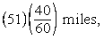
51 times, open parenthesis, 40 over 60, close parenthesis, miles,
and the distance traveled by Dennis is similarly represented by 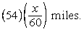
54 times, open parenthesis, x over 60, close parenthesis, miles.
Since the distances are equal, it follows that 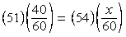.
51, times, open parenthesis, 40 over 60, close parenthesis, =, 54, times, open parenthesis, x over 60, close parenthesis.
From this equation it follows that
51 times 40 = 54x
and 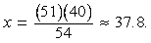
x = the fraction with numerator 51 times 40 and denominator 54, which is approximately 37.8.
Thus, it took Dennis approximately 37.8 minutes to drive the course.

Example 2.7.4: Working alone at its constant rate, machine A takes 3 hours to produce a batch of identical computer parts. Working alone at its constant rate, machine B takes 2 hours to produce an identical batch of parts. How long will it take the two machines, working simultaneously at their respective constant rates, to produce an identical batch of parts?

Solution: Since machine A takes 3 hours to produce a batch, machine A can produce one third of the batch in 1 hour. Similarly, machine B can produce one half of the batch in 1 hour. If we let x represent the number of hours it takes both machines, working simultaneously, to produce the batch, then the two machines will produce 1 over x of the job in 1 hour. When the two machines work together, adding their individual production rates, 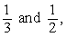 one third and one half, gives their combined production rate 1 over x. Therefore, it follows that 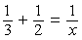.
one third, +, one half, =, 1 over x.
This equation is equivalent to 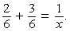
2 over 6, +, 3 over 6, =, 1 over x.
So 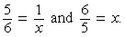
5 over 6, =, 1 over x, and, 6 over 5, =, x.

Thus, working together, the machines will take 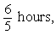 6 over 5 hours, or 1 hour 12 minutes, to produce a batch of parts.

Example 2.7.5: At a fruit stand, apples can be purchased for $0.15 each and pears for $0.20 each. At these rates, a bag of apples and pears was purchased for $3.80. If the bag contained 21 pieces of fruit, how many of the pieces were pears?

Solution: If a represents the number of apples purchased and p represents the number of pears purchased, the information can be translated into the following system of two equations.

Total Cost Equation: 0.15a + 0.20p = 3.80
Total Number of Fruit Equation: a + p = 21

From the total number of fruit equation, a = 21 minus p.
Substituting 21 minus p into the total cost equation for a gives the equation
0.15 times, open parenthesis, 21 minus p, close parenthesis, +, 0.20p, =, 3.80
So,
0.15 times 21, minus, 0.15p, +, 0.20p, =, 3.80,
which is equivalent to
3.15, minus, 0.15p, +, 0.20p, =, 3.80.
Therefore 0.05p = 0.65, and p = 13.

Thus, of the 21 pieces of fruit, 13 were pears.

Example 2.7.6: To produce a particular radio model, it costs a manufacturer $30 per radio, and it is assumed that if 500 radios are produced, all of them will be sold. What must be the selling price per radio to ensure that the profit (revenue from the sales minus the total production cost) on the 500 radios is greater than $8,200 ?

Solution: If y represents the selling price per radio, then the profit is
500 times, open parenthesis, y minus 30, close parenthesis.
Therefore,
500 times, open parenthesis, y minus 30, close parenthesis is greater than 8,200.
Multiplying out gives
500y minus 15,000 is greater than 8,200,
which simplifies to
500y is greater than 23,200
and then to y is greater than 46.4. Thus, the selling price must be greater than $46.40 to ensure that the profit is greater than $8,200.

Applications Involving Interest

Some applications involve computing interest earned on an investment during a specified time period. The interest can be computed as simple interest or compound interest.

Simple interest is based only on the initial deposit, which serves as the amount on which interest is computed, called the principal, for the entire time period. If the amount P is invested at a simple annual interest rate of r percent, then the value V of the investment at the end of t years is given by the formula

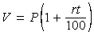
V = P times, open parenthesis, 1, +, rt over 100, close parenthesis,
where P and V are in dollars.

In the case of compound interest, interest is added to the principal at regular time intervals, such as annually, quarterly, and monthly. Each time interest is added to the principal, the interest is said to be compounded. After each compounding, interest is earned on the new principal, which is the sum of the preceding principal and the interest just added. If the amount P is invested at an annual interest rate of r percent, compounded annually, then the value V of the investment at the end of t years is given by the formula

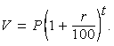
V = P times, open parenthesis, 1, +, r over 100, close parenthesis, to the power t.

If the amount P is invested at an annual interest rate of r percent, compounded n times per year, then the value V of the investment at the end of t years is given by the formula

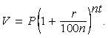
V = P times, open parenthesis, 1, +, r over 100n, close parenthesis, to the power nt.

Example 2.7.7: If $10,000 is invested at a simple annual interest rate of 6 percent, what is the value of the investment after half a year?

Solution: According to the formula for simple interest, the value of the investment after one half year is

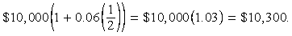
$10,000 times, open parenthesis, 1, +, 0.06 times one half, close parenthesis, =, $10,000 times 1.03, which is equal to $10,300.

Example 2.7.8: If an amount P is to be invested at an annual interest rate of 3.5 percent, compounded annually, what should be the value of P so that the value of the investment is $1,000 at the end of 3 years?

Solution: According to the formula for 3.5 percent annual interest, compounded annually, the value of the investment after 3 years is

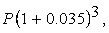
P times, open parenthesis, 1 + 0.035, close parenthesis, to the power 3,
and we set it to be equal to $1,000.

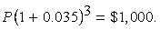
P times, open parenthesis, 1 + 0.035, close parenthesis, to the power 3, =, $1,000.
To find the value of P, we divide both sides of the equation by 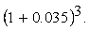
open parenthesis 1 + 0.035, close parenthesis, to the power 3.

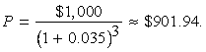
P = $1,000 over, open parenthesis, 1 + 0.035, close parenthesis, to the power 3, which is approximately equal to $901.94.

Thus, an amount of approximately $901.94 should be invested.

Example 2.7.9: A college student expects to earn at least $1,000 in interest on an initial investment of $20,000. If the money is invested for one year at interest compounded quarterly, what is the least annual interest rate that would achieve the goal?

Solution: According to the formula for r percent annual interest, compounded quarterly, the value of the investment after 1 year is

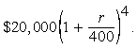
$20,000 times, open parenthesis, 1, +, r over 400, close parenthesis, to the power 4.

By setting this value greater than or equal to $21,000 and solving for r, we get 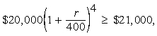
$20,000 times, open parenthesis, 1, +, r over 400, close parenthesis, to the power 4, is greater than or equal to $21,000,
which simplifies to 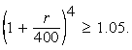
open parenthesis, 1, +, r over 400, close parenthesis, to the power 4, is greater than or equal to 1.05.

Recall that taking the positive fourth root of each side of an inequality preserves the direction of the inequality. (It is also true that taking the positive square root or any other positive root of each side of an inequality preserves the direction of the inequality). Using this fact, we get that taking the positive fourth root of both sides of 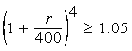 open parenthesis, 1, +, r over 400, close parenthesis, to the power 4, is greater than or equal to 1.05
yields 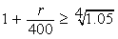 1, +, r over 400 is greater than or equal to the positive fourth root of 1.05
which simplifies to 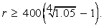 r is greater than or equal to 400 times, open parenthesis, the positive fourth root of 1.05, minus 1, close parenthesis.

To compute the positive fourth root of 1.05, recall that for any number
x greater than or equal to 0,
the positive fourth root of x, =, the positive square root of the positive square root of x.

This allows us to compute the positive fourth root 1.05 by taking the positive square root of 1.05 and then take the positive square root of the result.
Therefore we can conclude that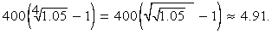
400 times, open parenthesis, the positive fourth root of 1.05, minus 1, close parenthesis, =, 400 times, open parenthesis, the positive square root of the positive square root of 1.05, minus 1, close parenthesis, which is approximately 4.91.

Since 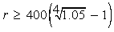
r is greater than or equal to 400 times, open parenthesis, the positive fourth root of 1.05, minus 1, close parenthesis,
and 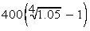
400 times, open parenthesis, the positive fourth root of 1.05, minus 1, close parenthesis
is approximately 4.91, the least annual interest rate is approximately 4.91 percent.

2.8 Coordinate Geometry

Two real number lines that are perpendicular to each other and that intersect at their respective zero points define a rectangular coordinate system, often called the x y coordinate system or x y plane. The horizontal number line is called the x axis and the vertical number line is called the y axis. The point where the two axes intersect is called the origin, denoted by O. The positive half of the x axis is to the right of the origin, and the positive half of the y axis is above the origin. The two axes divide the plane into four regions called quadrants. The four quadrants are labeled 1, 2, 3, and 4, as shown in Algebra Figure 1 below.

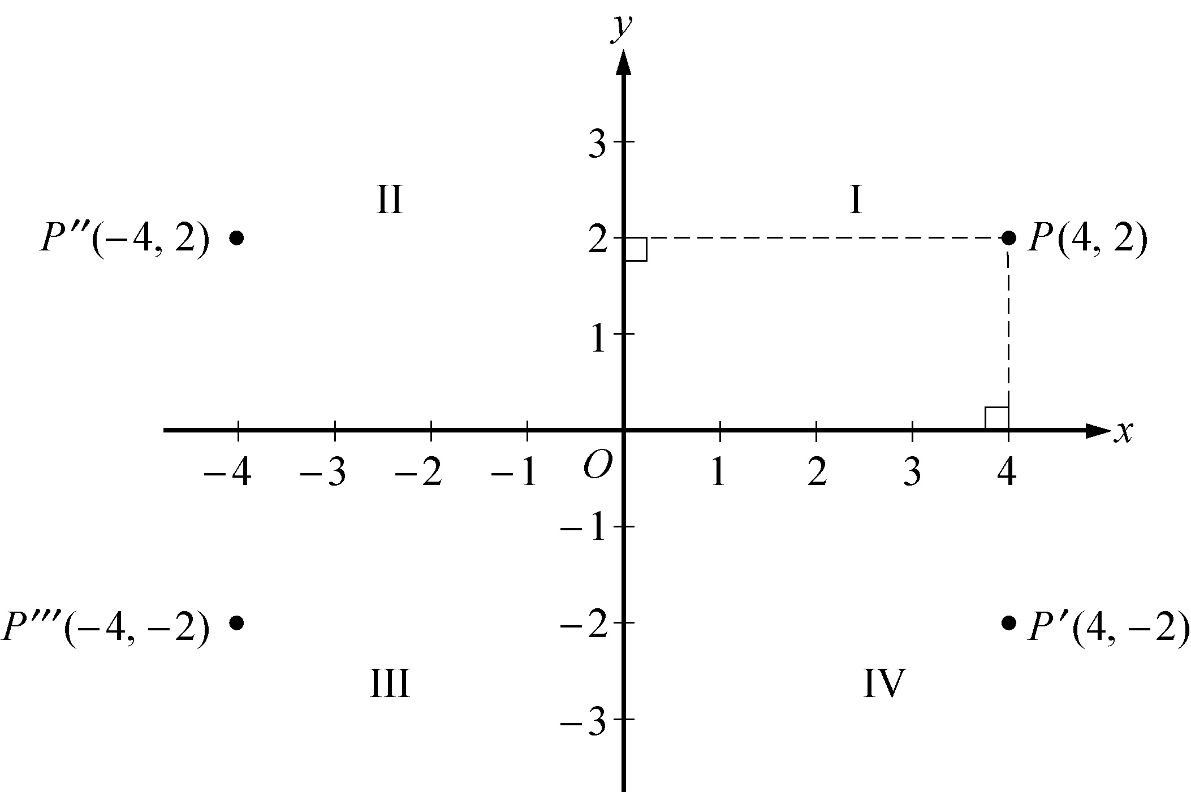
Algebra Figure 1

Begin skippable part of description of Algebra Figure 1.
Quadrant 1 is the region of the x y plane that is above the x axis and to the right of the y axis. Quadrant 2 is the region that is above the x axis and to the left of the y axis. Quadrant 3 is the region that is below the x axis and to the left of the y axis. Quadrant 4 is the region that is below the x axis and to the right of the y axis.

There are equally spaced tick marks along each of the axes. Along the x axis, to the right of the origin the tick marks are labeled 1, 2, 3, and 4; and to the left of the origin the tick marks are labeled negative 1, negative 2, negative 3, and negative 4. Along the y axis, above the origin the tick marks are labeled 1, 2, and 3; and below the origin the tick marks are labeled negative 1, negative 2, and negative 3.

End skippable part of figure description.

Each point in the x y plane can be identified with an ordered pair x comma y of real numbers. The first number in the ordered pair is called the x coordinate, and the second number is called the y coordinate. A point with coordinates x comma y is located the absolute value of x units to the right of the y axis if x is positive, or to the left of the y axis if x is negative. Also, the point is located the absolute value of y units above the x axis if y is positive, or below the x axis if y is negative. If x = 0, the point lies on the y axis, and if y = 0 the point lies on the x axis. The origin has coordinates 0 comma 0. Unless otherwise noted, the units used on the x axis and the y axis are the same.

A point P with coordinates x comma y is denoted by P, open parenthesis x comma y, close parenthesis.

In Algebra Figure 1 above, the point P with coordinates 4 comma 2 is 4 units to the right of the y axis and 2 units above the x axis, the point P prime with coordinates 4 comma negative 2 is 4 units to the right of the y axis and 2 units below the x axis, the point P double prime with coordinates negative 4 comma 2 is 4 units to the left of the y axis and 2 units above the x axis, and the point P triple prime with coordinates negative 4 comma negative 2 is 4 units to the left of the y axis and 2 units below the x axis.

Note that the three points
P prime with coordinates 4 comma negative 2, P double prime with coordinates negative 4 comma 2, and P triple prime with coordinates negative 4 comma negative 2
have the same coordinates as P except for the signs. These points are geometrically related to P as follows.

P prime is the reflection of P about the x axis, or P prime and P are symmetric about the x axis.
P double prime is the reflection of P about the y axis, or P double prime and P are symmetric about the y axis.
P triple prime is the reflection of P about the origin, or P triple prime and P are symmetric about the origin.

The distance between two points in the x y plane can be found by using the Pythagorean theorem. For example, the distance between the two points
Q with coordinates negative 2 comma negative 3, and R with coordinates 4 comma 1.5
in Algebra Figure 2 below is the length of line segment QR. To find this length, construct a right triangle with hypotenuse QR by drawing a vertical line segment downward from R and a horizontal line segment rightward from Q until these two line segments intersect at the point with coordinates 4 comma negative 3 forming a right angle, as shown in Algebra Figure 2. Then note that the horizontal side of the triangle has length 4 minus negative 2 = 6 and the vertical side of the triangle has length 1.5 minus negative 3, =, 4.5.

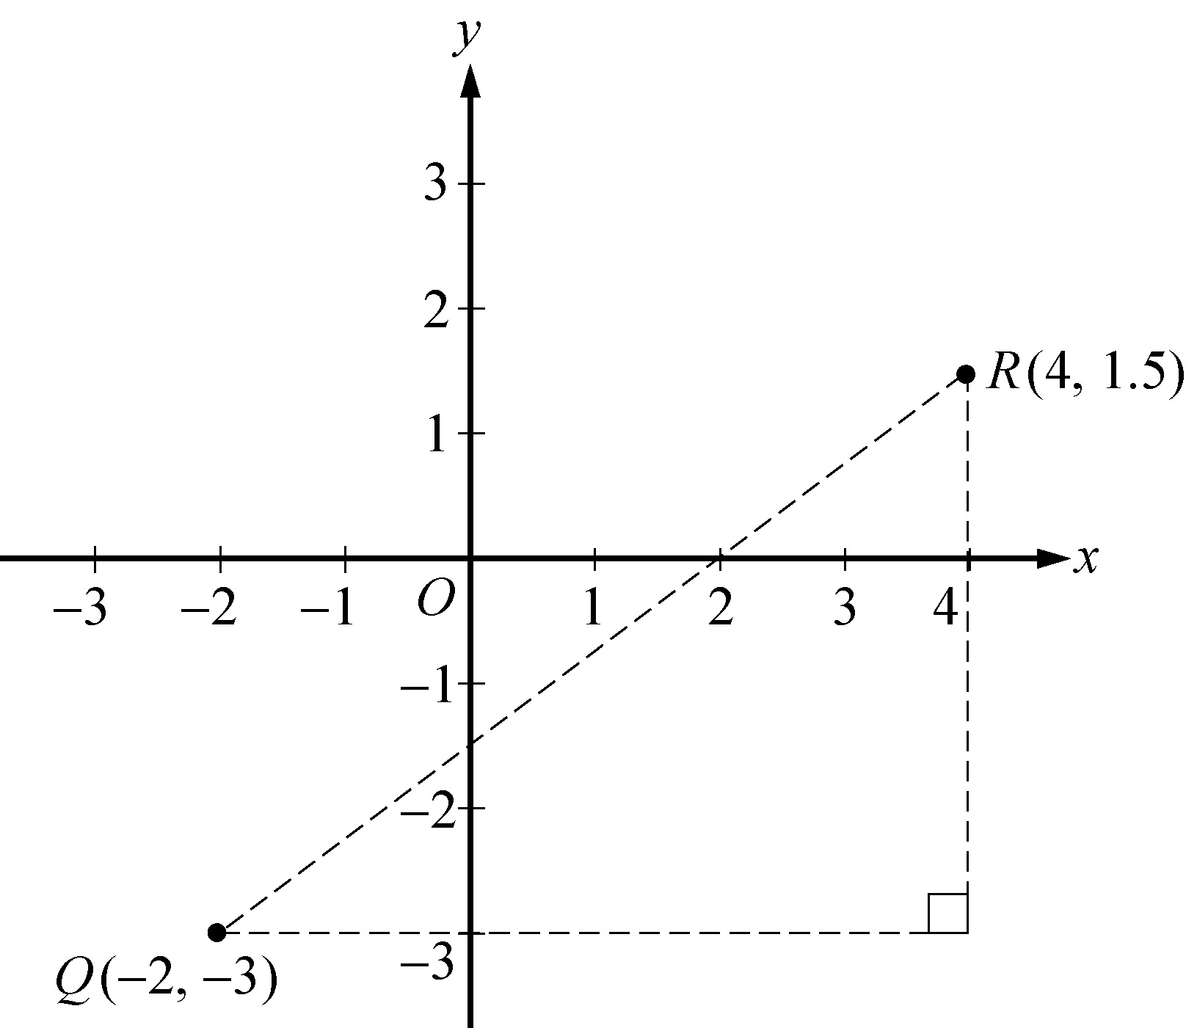
Algebra Figure 2

Since line segment QR is the hypotenuse of the triangle, you can apply the Pythagorean theorem:

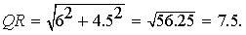
QR = the positive square root of the quantity 6 squared + 4.5 squared, which is equal to the positive square root of 56.25, or 7.5.

(For a discussion of right triangles and the Pythagorean theorem, see Chapter 3: Geometry, Section 3.3).

Equations in two variables can be represented as graphs in the coordinate plane. In the x y plane, the graph of an equation in the variables x and y is the set of all points whose ordered pairs x comma y satisfy the equation.

The graph of a linear equation of the form y = mx + b is a straight line in the x y plane, where m is called the slope of the line and b is called the y intercept.

The x intercepts of a graph are the x values of the points at which the graph intersects the x axis. Similarly, the y intercepts of a graph are the y values of the points at which the graph intersects the y axis.

The slope of a line passing through two points Q with coordinates x sub 1 comma y sub 1, and R with coordinates x sub 2 comma y sub 2,
where x sub 1 is not equal to x sub 2, is defined as

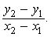
the fraction with numerator y sub 2 minus y sub 1, and denominator x sub 2 minus x sub 1.
This ratio is often called “rise over run”, where rise is the change in y when moving from Q to R and run is the change in x when moving from Q to R. A horizontal line has a slope of 0, since the rise is 0 for any two points on the line. So the equation of every horizontal line has the form y = b, where b is the y intercept. The slope of a vertical line is not defined, since the run is 0. The equation of every vertical line has the form x = a, where a is the x intercept.

Two lines are parallel if their slopes are equal. Two lines are perpendicular if their slopes are negative reciprocals of each other. For example, the line with equation y = 2x + 5 is perpendicular to the line with equation 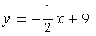
y = negative one half x, + 9.

Example 2.8.1: Algebra Figure 3 below shows the graph of the line through points Q with coordinates negative 2 comma negative 3, and R with coordinates 4 comma 1.5 in the x y plane.
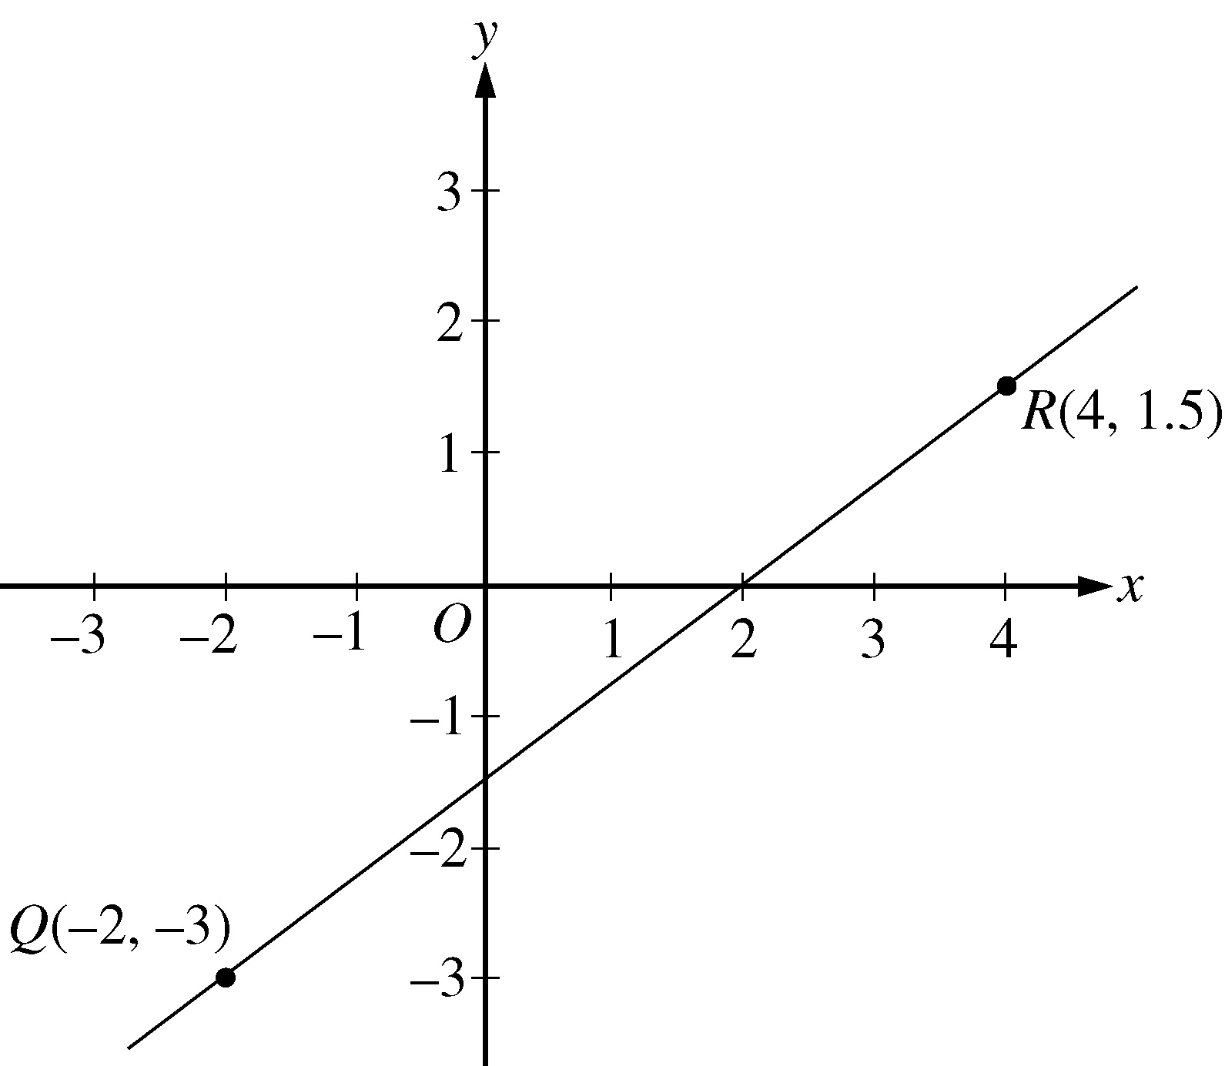
Algebra Figure 3

Begin skippable part of description of Algebra Figure 3.
Point Q with coordinates negative 2 comma negative 3 is 2 units to the left, and 3 units below the origin. Point R with coordinates 4 comma 1.5 is 4 units to the right, and 1.5 units above the origin. Line QR crosses the y axis about halfway between negative 1 and negative 2, and crosses the x axis at 2.

End skippable part of figure description.

In Algebra Figure 3 above, the slope of the line passing through the points 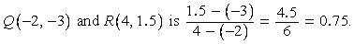
Q with coordinates negative 2 comma negative 3, and R with coordinates 4 comma 1.5 is the fraction with numerator 1.5 minus negative 3, and denominator 4 minus negative 2, which is equal to the fraction 4.5 over 6, or 0.75.
Line QR appears to intersect the y axis close to the point with coordinates 0 comma negative 1.5, so the y intercept of the line must be close to negative 1.5. To get the exact value of the y intercept, substitute the coordinates of any point on the line into the equation y = 0.75x + b, and solve it for b.

For example, if you pick the point Q with coordinates negative 2 comma negative 3, and substitute its coordinates into the equation you get negative 3 = 0.75 times negative 2, +, b.
Then adding 0.75 times 2 to both sides of the equation yields
b = negative 3, +, 0.75 times 2, or b = negative 1.5.

Therefore, the equation of line QR is
y = 0.75x, minus, 1.5.
You can see from the graph in Algebra Figure 3 that the x intercept of line QR is 2, since QR passes through the point 2 comma 0. More generally, you can find the x intercept of a line by setting y = 0 in an equation of the line and solving it for x. So you can find the x intercept of line QR by setting y = 0 in the equation y = 0.75x, minus, 1.5 and solving it for x as follows.

Setting y = 0 in the equation y = 0.75x, minus, 1.5 gives the equation 0 = 0.75x, minus, 1.5. Then adding 1.5 to both sides yields 1.5 = 0.75x. Finally, dividing both sides by 0.75 yields 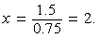 x = 1.5 over 0.75, or 2.

Graphs of linear equations can be used to illustrate solutions of systems of linear equations and inequalities, as can be seen in examples 2.8.2 and 2.8.3.

Example 2.8.2: Consider the system of two linear equations in two variables:

4x + 3y = 13, and
x + 2y = 2
(Note that this system was solved by substitution, and by elimination in Algebra Section 2.3.)

Solving each equation for y in terms of x yields

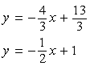
y = negative four thirds x, +, 13 over 3, and, y = negative one half x, +, 1

Algebra Figure 4 below shows the graphs of the two equations in the x y plane. The solution of the system of equations is the point at which the two graphs intersect, which is 4 comma negative 1.

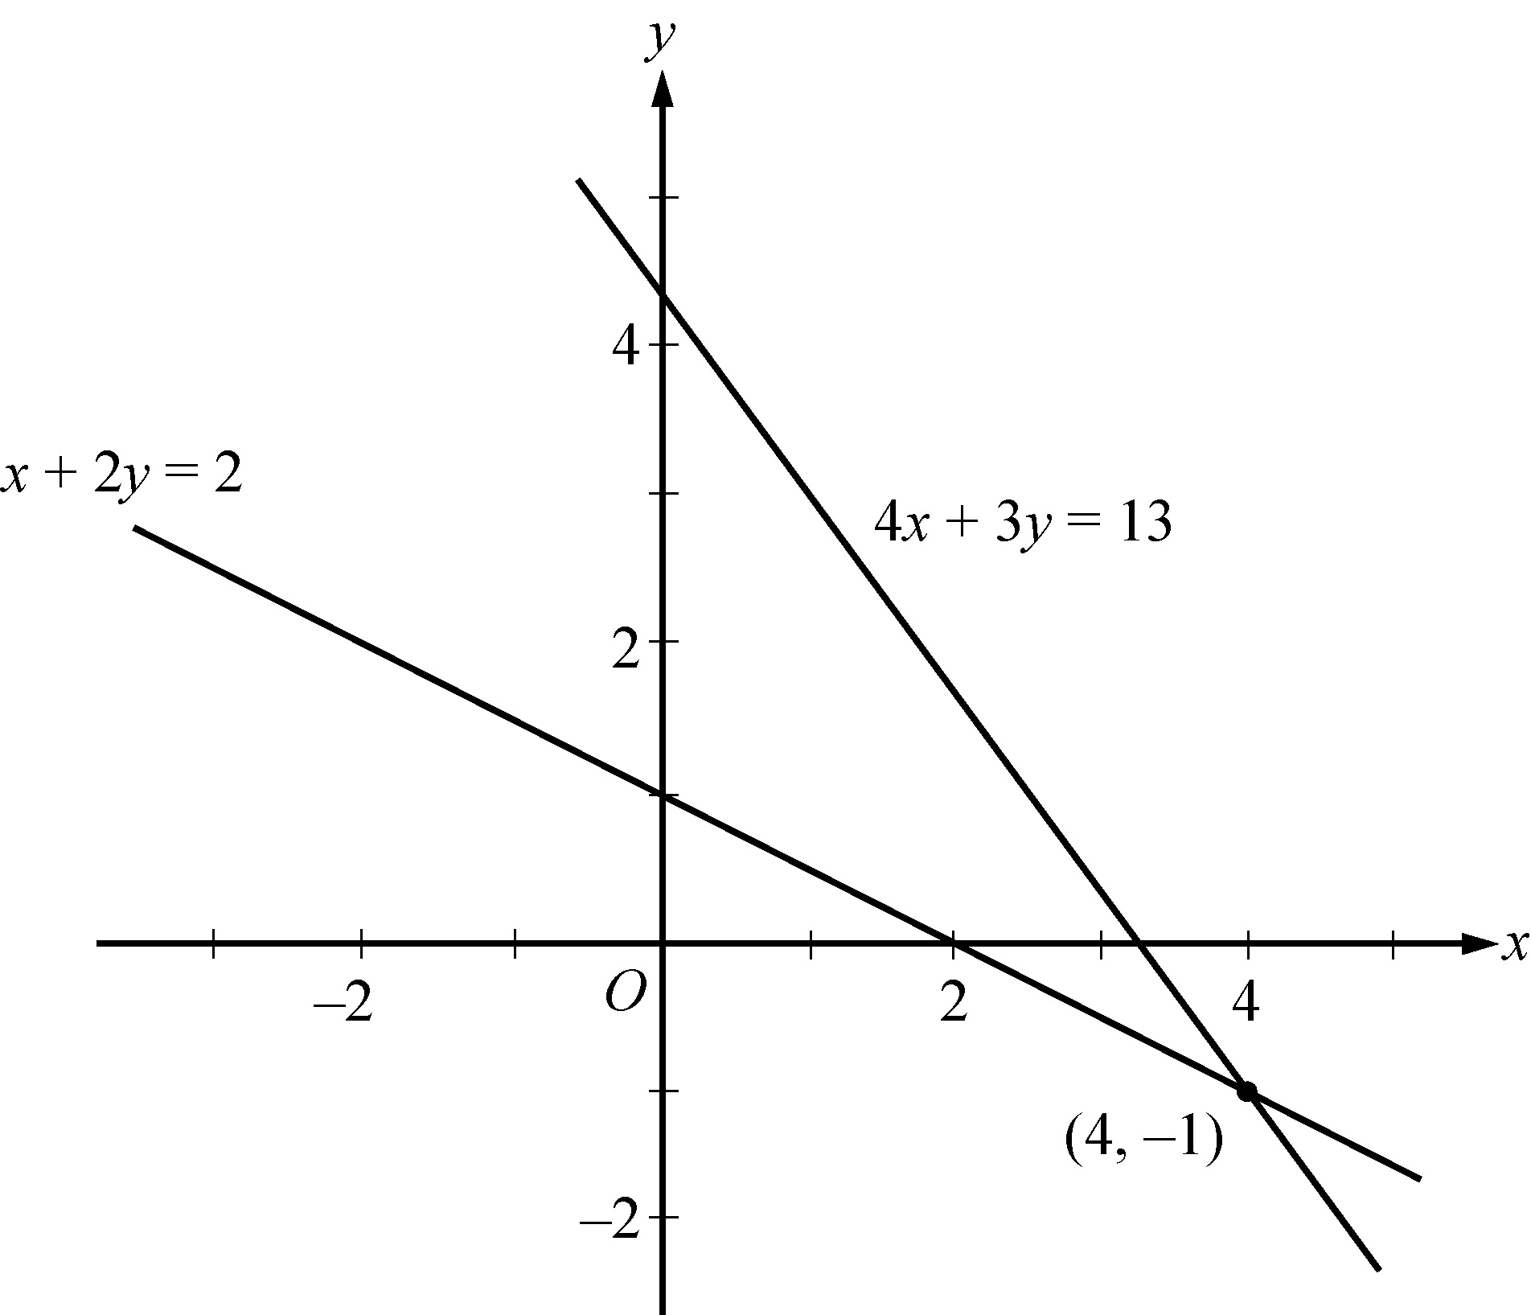
Algebra Figure 4

Begin skippable part of description of Algebra Figure 4.
The graphs of both equations are lines that slant downward as they go from left to right. The graph of the equation 4x + 3y = 13 crosses the y axis at a number that is between 4 and 5, and crosses the x axis at a number that is between 3 and 4. The graph of the equation x + 2y = 2 intersects the y axis at 1 and the x axis at 2. The two graphs intersect at the point 4 comma negative 1, which is in the fourth quadrant.

End skippable part of figure description

Example 2.8.3: Consider the following system of two linear inequalities.
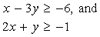
x minus 3y is greater than or equal to negative 6, and, 2x + y is greater than or equal to negative 1

Solving each inequality for y in terms of x yields
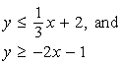
y is less than or equal to one third x, +, 2, and, y is greater than or equal to negative 2x, minus 1

Each point x comma y that satisfies the first inequality, 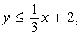 y is less than or equal to one third x, +, 2, is either on the line 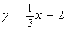 y = one third x, +, 2 or below the line because the y coordinate is either equal to or less than 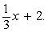 one third x, +, 2. Therefore, the graph of 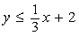 y is less than or equal to one third x, +, 2 consists of the line y = one third x, +, 2 and the entire region below it. Similarly, the graph of y is greater than or equal to negative 2x, minus 1 consists of the line y = negative 2x, minus 1 and the entire region above it. Thus, the solution set of the system of inequalities consists of all of the points that lie in the shaded region shown in Algebra Figure 5 below, which is the intersection of the two regions described.

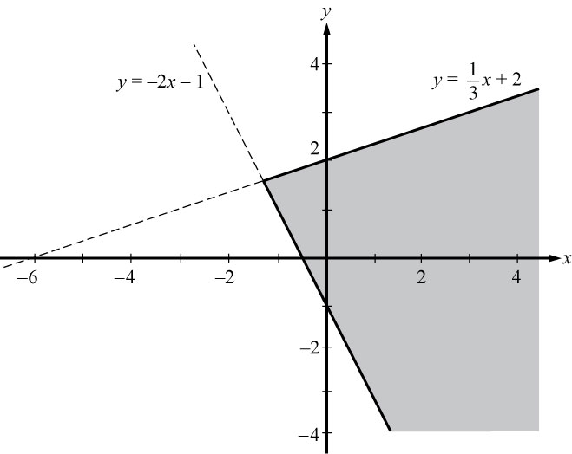
Algebra Figure 5

Begin skippable part of description of Algebra Figure 5.
The graph of the equation y = one third x, +, 2 is a line that slants upward as it goes from left to right, crossing the x axis at negative 6 and the y axis at 2. The graph of the equation y = negative 2x, minus 1 slants downward as it goes from left to right, crossing the x axis between negative 1 and 0 and the y axis at negative 1. The two lines intersect in the second quadrant. The region below the graph of y = one third x, +, 2 and to the right of the graph of y = negative 2x, minus 1 is shaded.

End skippable part of figure description.

Symmetry with respect to the x axis, the y axis, and the origin is mentioned earlier in this section. Another important symmetry is symmetry with respect to the line with equation y = x. The line y = x passes through the origin, has a slope of 1, and makes a 45 degree angle with each axis. For any point with coordinates a comma b, the point with interchanged coordinates b comma a is the reflection of a comma b about the line y = x; that is, a comma b, and, b comma a are symmetric about the line y = x. It follows that interchanging x and y in the equation of any graph yields another graph that is the reflection of the original graph about the line y = x.

Example 2.8.4: Consider the line whose equation is y = 2x + 5. Interchanging x and y in the equation yields x = 2y + 5. Solving this equation for y yields 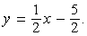
y = one half x, minus 5 halves.
The line y = 2x + 5 and its reflection 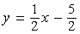 y = one half x, minus 5 halves are graphed in Algebra Figure 6 below.
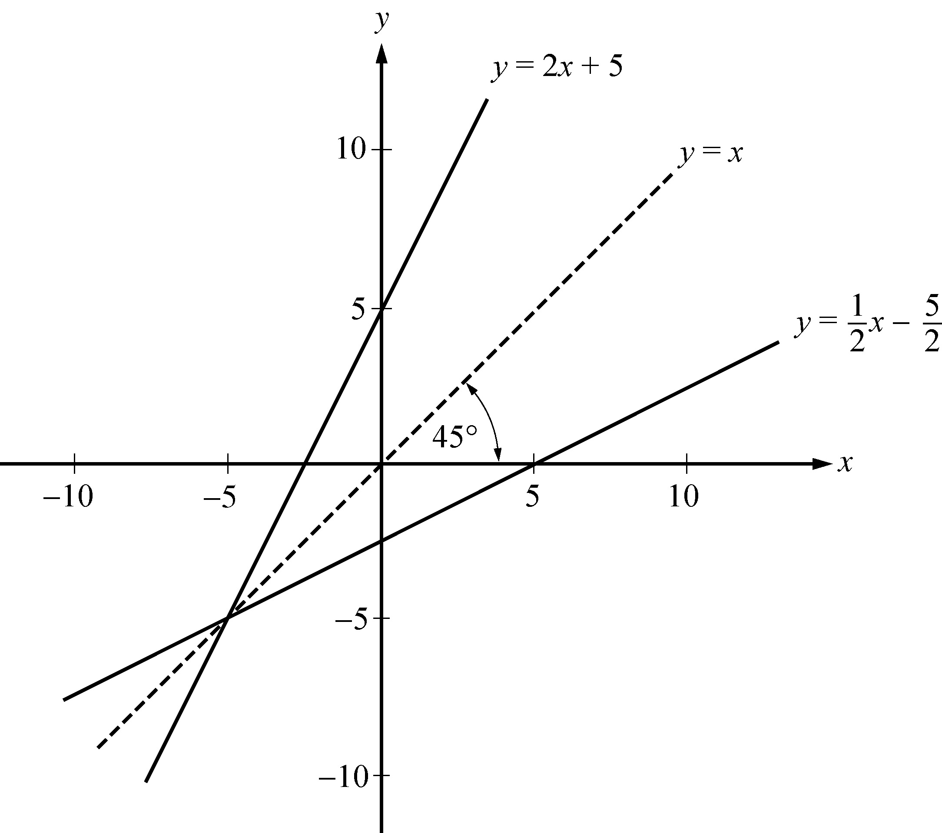
Algebra Figure 6

Begin skippable part of description of Algebra Figure 6.
The figure shows the lines y = 2x + 5 and y = one half x, minus 5 halves and the dashed line y = x between them. The three lines intersect at a point in the third quadrant. When the line y = 2x + 5 is flipped over the line y = x, the result is the line y = one half x, minus 5 halves. The result of this flipping on the intercepts of the lines is that the y intercept of y = 2x + 5 and the x intercept of y = one half x, minus 5 halves are equal; and the x intercept of y = 2x + 5 and the y intercept of the line y = one half x, minus 5 halves are equal.

End skippable part of figure description.

The line y = x is a line of symmetry for the graphs of y = 2x + 5 and y = one half x, minus 5 halves.

The graph of a quadratic equation of the form 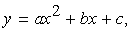 y = a x squared, +, bx, +, c, where a, b, and c are constants and a is not equal to 0, is a parabola. The x intercepts of the parabola are the solutions of the equation 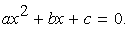 a x squared, +, bx, +, c = 0. If a is positive, the parabola opens upward and the vertex is its lowest point. If a is negative, the parabola opens downward and the vertex is its highest point. Every parabola is symmetric with itself about the vertical line that passes through its vertex. In particular, the two x intercepts are equidistant from this line of symmetry.

Example 2.8.5: The equation 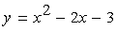 y = x squared, minus 2x, minus 3 has the graph shown in Algebra Figure 7 below.

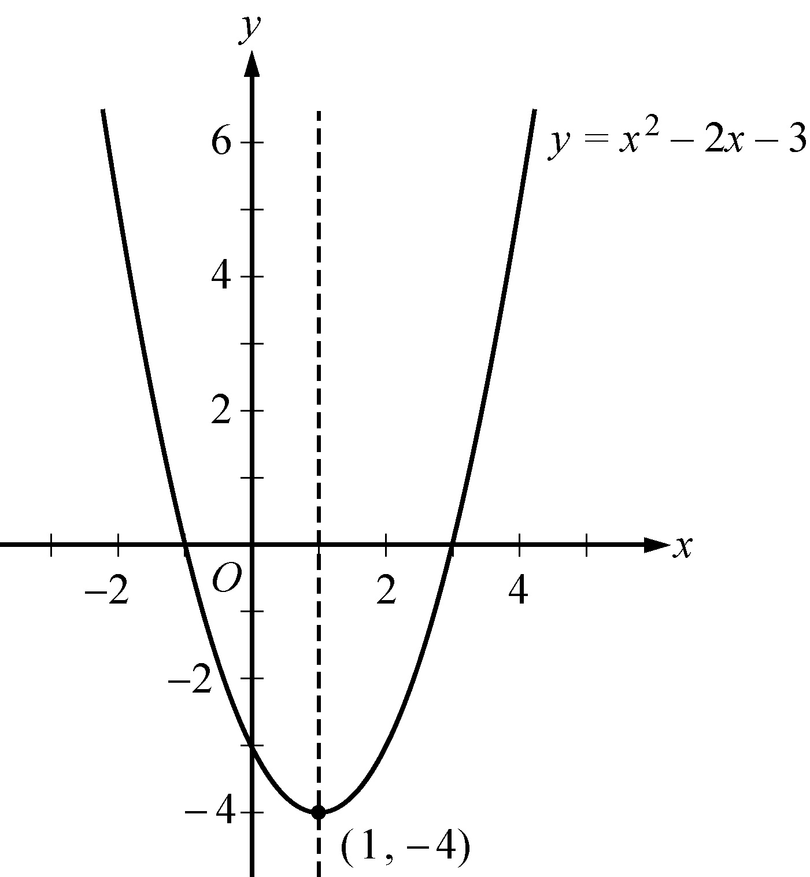
Algebra Figure 7

Begin skippable part of description of Algebra Figure 7.
The figure shows the parabola, which is an upward facing, U shaped curve, and the vertical dashed line x = 1.

End skippable part of figure description.

The graph indicates that the x intercepts of the parabola are negative 1 and 3. The values of the x intercepts can be confirmed by solving the quadratic equation 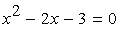 x squared, minus 2x, minus 3 = 0 to get x = negative 1 and x = 3. The point 1 comma negative 4 is the vertex of the parabola, and the line x = 1 is its line of symmetry. The y intercept is the y coordinate of the point on the parabola at which x = 0, which is 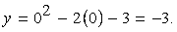
y = 0 squared, minus 2 times 0, minus 3 = negative 3.

The graph of an equation of the form 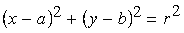
open parenthesis, x minus a, close parenthesis, squared, +, open parenthesis, y minus b, close parenthesis, squared, =, r squared
is a circle with its center at the point a comma b and with radius r.

Example 2.8.6: Algebra Figure 8 below shows the graph of two circles in the x y plane. The larger of the two circles is centered at the origin and has radius 10, so its equation is 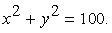 x squared, +, y squared, =, 100. The smaller of the two circles has center 6 comma negative 5 and radius 3, so its equation is 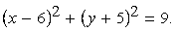
open parenthesis, x minus 6, close parenthesis, squared, +, open parenthesis, y + 5, close parenthesis, squared =, 9.

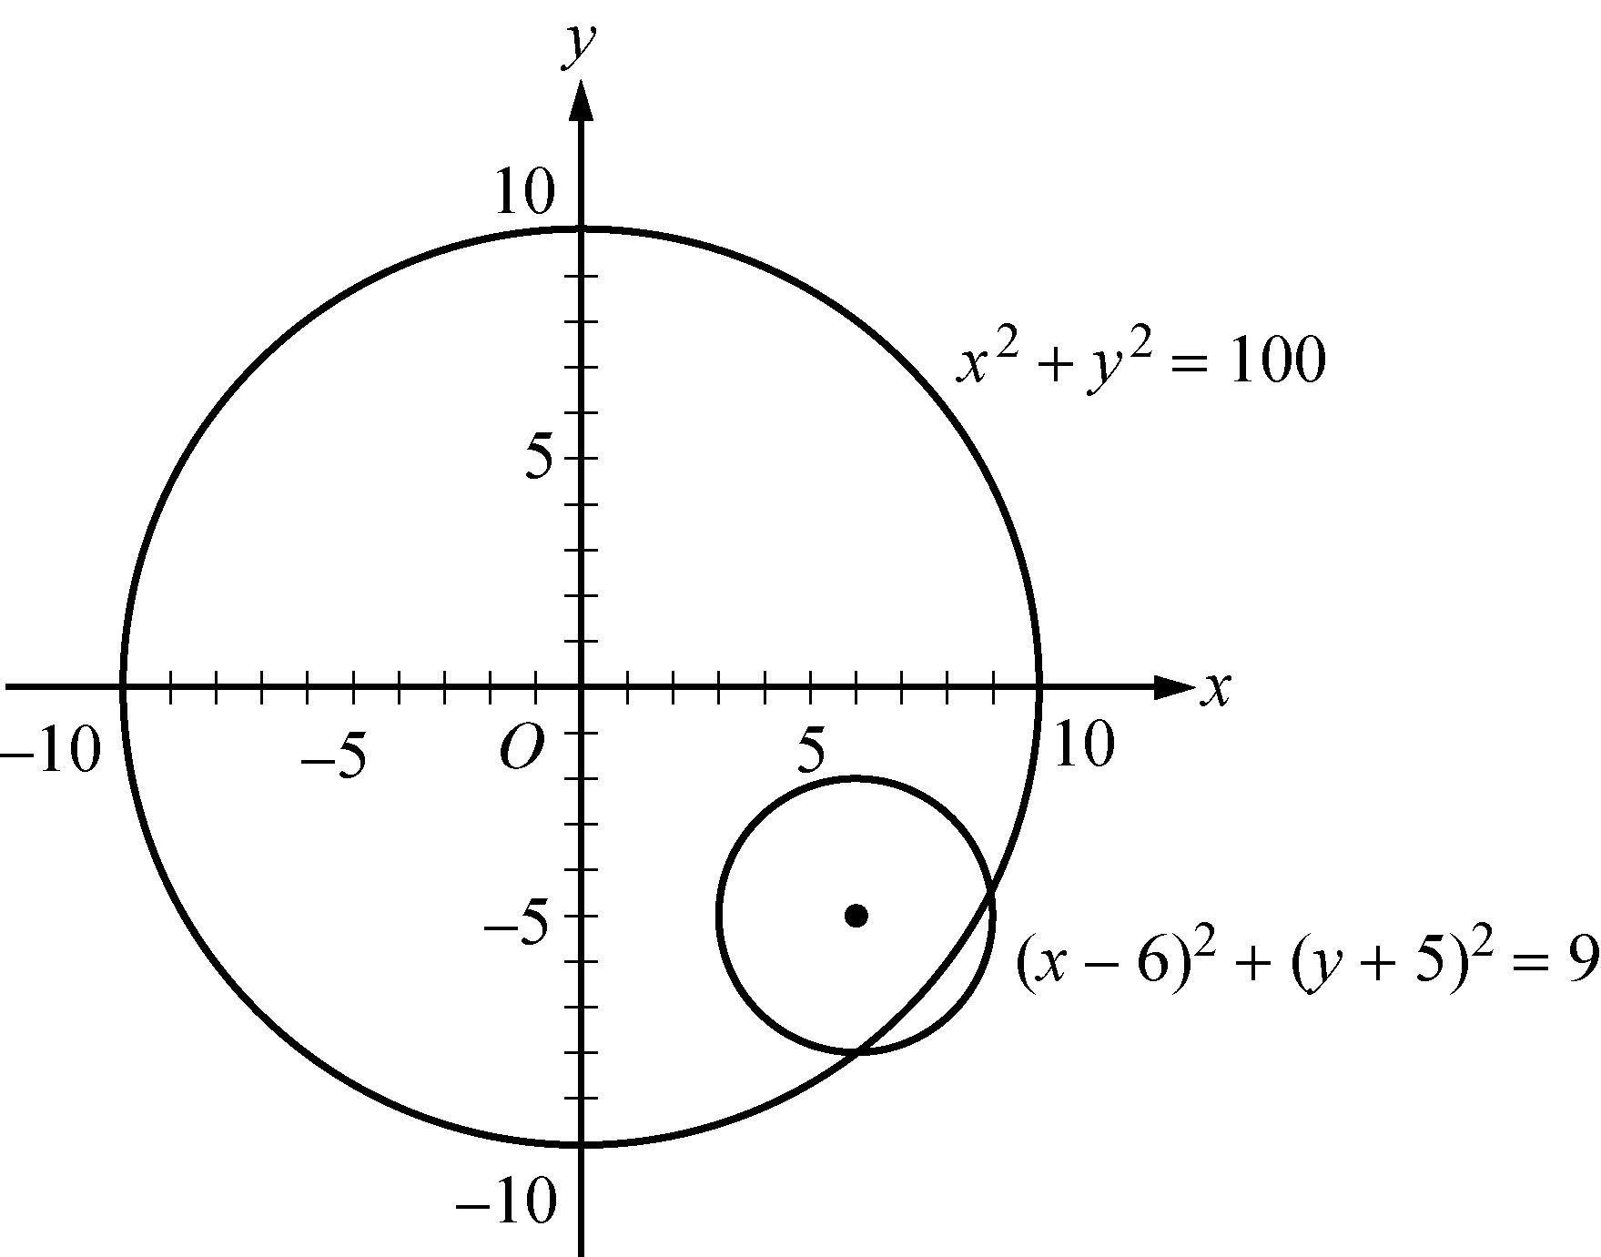
Algebra Figure 8

Begin skippable part of description of Algebra Figure 8.
The center of the smaller circle is in the fourth quadrant and lies inside the large circle. The two circles intersect at two points, both of which are in the fourth quadrant.

End skippable part of figure description.

2.9 Graphs of Functions

The coordinate plane can be used for graphing functions. To graph a function in the x y plane, you represent each input x and its corresponding output f of, x as a point x comma y, where y = f of, x. In other words, you use the x axis for the input and the y axis for the output.

Below are several examples of graphs of elementary functions.

Example 2.9.1: Consider the linear function defined by 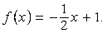
f of, x = negative one half x, +, 1.
Its graph in the x y plane is the line with the linear equation 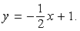
y = negative one half x, +, 1.

Example 2.9.2: Consider the quadratic function defined by 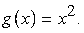
g of, x = x squared.
The graph of g is the parabola with the quadratic equation 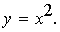 y = x squared.

The graph of both the linear equation 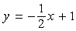 y = negative one half x, +, 1 and the quadratic equation 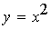 y = x squared are shown in Algebra Figure 9 below.

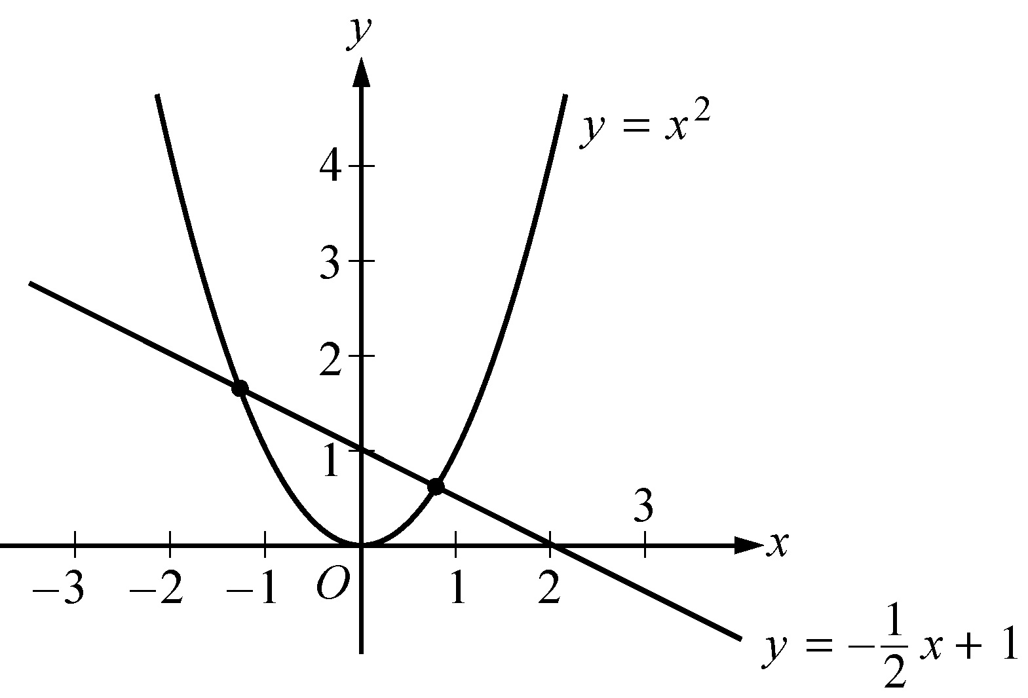
Algebra Figure 9

Begin skippable part of description of Algebra Figure 9.
The graph of the linear equation y = negative one half x, +, 1 is a line that slants downward as it goes from left to right, intersecting the y axis at 1, and the x axis at 2. The graph of the quadratic equation y = x squared is an upward facing parabola, whose vertex is at the origin.

End skippable part of figure description.

Note that the graphs f and g in Algebra Figure 9 above intersect at two points. These are the points at which g of, x = f of, x. We can find these points algebraically as follows.
Set g of, x = f of, x and get 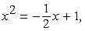 x squared, =, negative one half x, +, 1, which is equivalent to 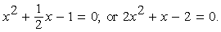
x squared, +, one half x, minus, 1, =, 0; or 2, x squared, +, x, minus 2, =, 0.
Then solve the equation 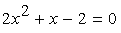 2, x squared, +, x, minus 2, =, 0 for x using the quadratic formula getting 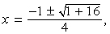 x = the fraction with numerator negative 1 plus or minus the square root of the quantity 1 + 16, and denominator 4,
which represents the x coordinates of the two solutions
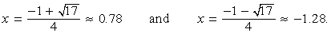
x = the fraction with numerator negative 1 plus the positive square root of 17, and denominator 4, which is approximately 0.78, and x = the fraction with numerator negative 1 minus the positive square root of 17, and denominator 4, which is approximately negative 1.28.
With these input values, the corresponding y coordinates can be found using either f or g:
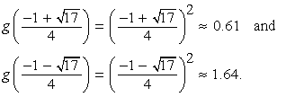
g of, the fraction with numerator negative 1 + the positive square root of 17 and denominator 4, =, open parenthesis, the fraction with numerator negative 1 + the positive square root of 17 and denominator 4, close parenthesis, squared, which is approximately 0.61, and
g of, the fraction with numerator negative 1 minus the positive square root of 17 and denominator 4, =, open parenthesis, the fraction with numerator negative 1 minus the positive square root of 17 and denominator 4, close parenthesis, squared, which is approximately 1.64.
Thus, the two intersection points can be approximated by
the point 0.78 comma 0.61 and the point negative 1.28 comma 1.64.

Example 2.9.3: Consider the absolute value function defined by h of, x = the absolute value of x. By using the definition of absolute value (see Chapter 1: Arithmetic, Section 1.5), h can be expressed as a piecewise defined function:

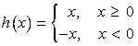
h of, x = x, for x greater than or equal to 0, and h of, x = negative x, for x less than 0
The graph of this function is V shaped and consists of two linear pieces, y = x and y = negative x, joined at the origin, as shown in Algebra Figure 10 below.

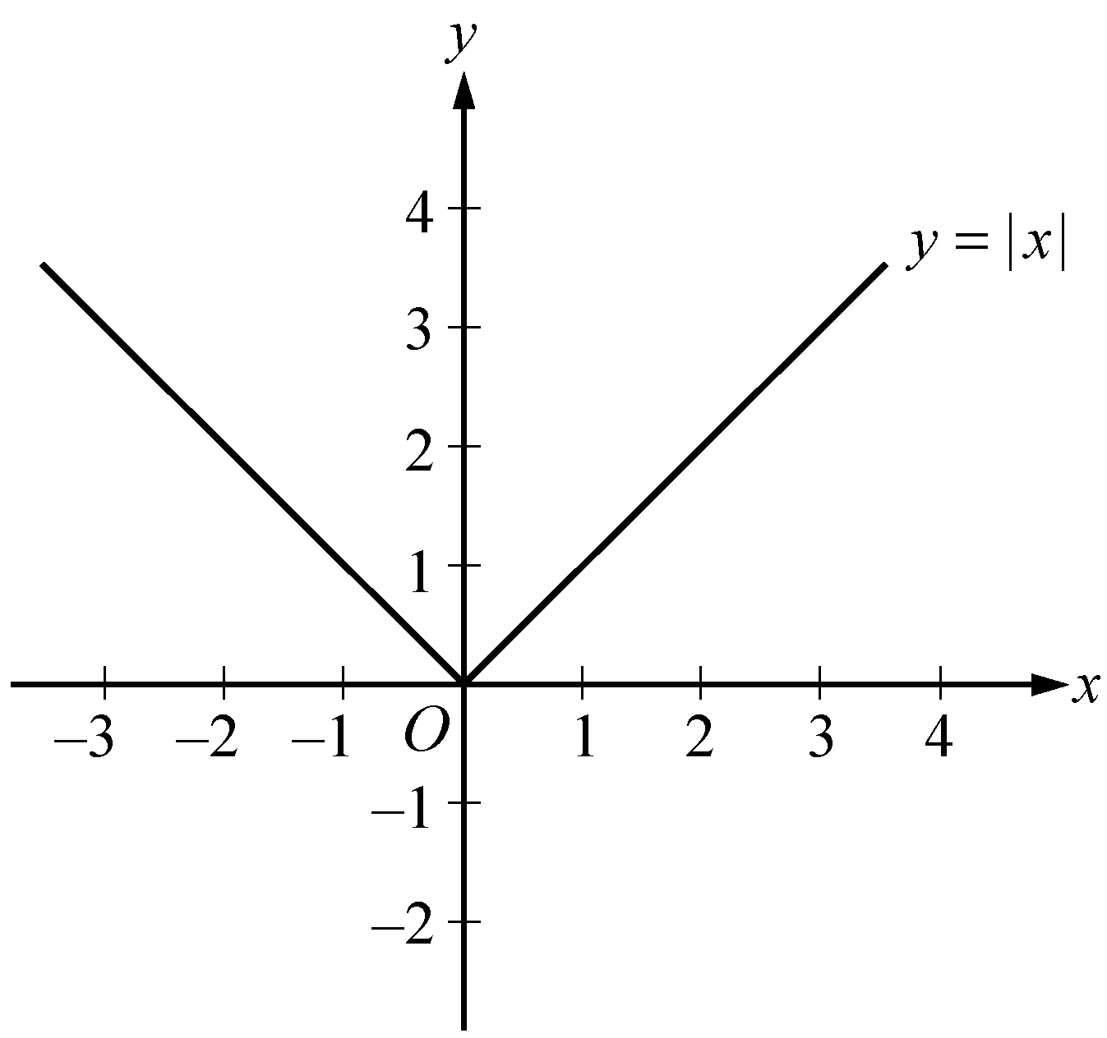
Algebra Figure 10

Example 2.9.4: This example is based on Algebra Figure 11 below, which is the graph of 2 parabolas.
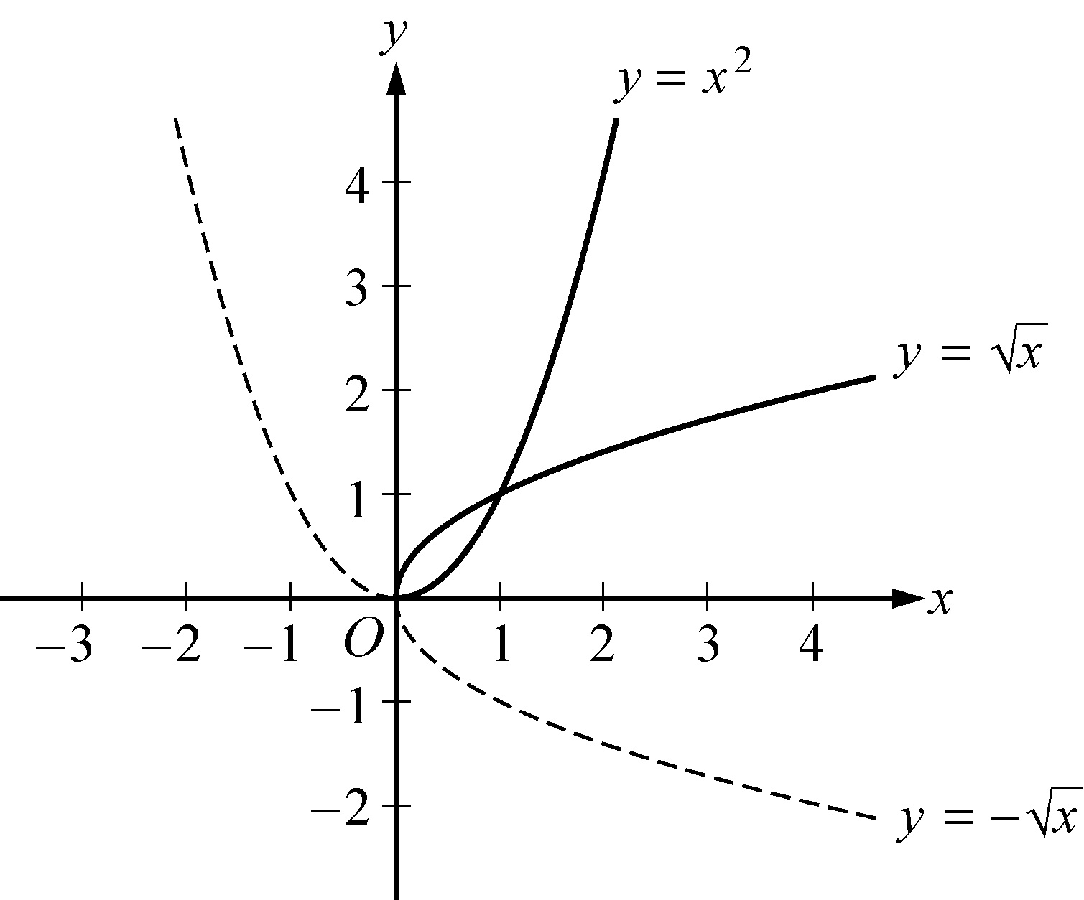
Algebra Figure 11
One of the parabolas is the upward facing parabola y = x squared and the other looks like the parabola 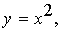 y = x squared, but instead of facing upward, it faces to the right. The vertex of both parabolas is at the origin.

Begin skippable part of description of Algebra Figure 11.
The half of the upward facing parabola to the right of the y axis is a solid curve, and the half to the left of the y axis is a dashed curve. The half of the right facing parabola above the x axis is a solid curve and the half below the x axis is a dashed curve.

End skippable part of figure description.

Consider the positive square root function defined by
j of, x = the positive square root of x, for x greater than or equal to 0.
The graph of this function is the upper half of the right facing parabola in Algebra Figure 11; that is, the solid part of the parabola, the part above the x axis. Also consider the negative square root function defined by
k of, x = the negative square root of x, for x greater than or equal to 0. The graph of this function is the bottom half of the right facing parabola; that is, the dashed part of the parabola, the part below the x axis.

The graphs of y = the positive square root of x and y = the negative square root of x are halves of a parabola because they are reflections of the right and left halves, respectively, of the parabola y = x squared about the line y = x. This follows from squaring both sides of the two square root equations to get y squared = x and then interchanging x and y to get y = x squared.

Also note that y = the negative square root of x is the reflection of y = the positive square root of x about the x axis. In general, for any function h, the graph of y = negative h of, x is the reflection of the graph of y = h of, x about the x axis.

Example 2.9.5: Consider the functions defined by 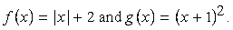 f of, x = the absolute value of x, +, 2 and g of, x = open parenthesis, x + 1, close parenthesis, squared.
These functions are related to the absolute value function absolute value of x and the quadratic function x squared, respectively, in simple ways.

The graph of f of, x = the absolute value of x, +, 2 is the graph of y = the absolute value of x shifted upward by 2 units, as shown in Algebra Figure 12 below.
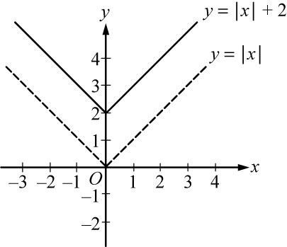
Algebra Figure 12

Begin skippable part of description of Algebra Figure 12.
Algebra Figure 12 shows the graph of y = the absolute value of x, +, 2 as a solid V shaped curve and the graph of y = the absolute value of x as a dashed V shaped curve.

End skippable part of figure description.
Similarly, the graph of the function k of, x = the absolute value of x, minus, 2 is the graph of y = the absolute value of x shifted downward by 5 units.

The graph of 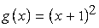 g of, x = open parenthesis, x + 1, close parenthesis, squared is the graph of y = x squared shifted to the left by 1 unit, as shown in Algebra Figure 13 below.
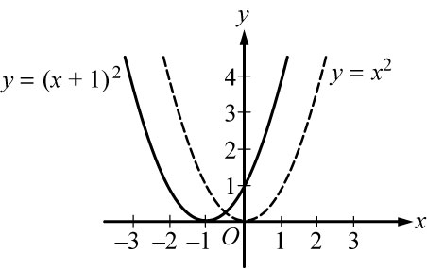
Algebra Figure 13

Begin skippable part of description of Algebra Figure 13.
Algebra Figure 13 shows the graph of 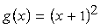 g of, x = open parenthesis, x + 1, close parenthesis, squared as a solid parabola and the graph of y = x squared as a dashed parabola.

End skippable part of figure description.

Similarly, the graph of the function 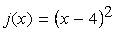 j of, x = open parenthesis, x minus 4, close parenthesis, squared is the graph of y = x squared shifted to the right by 4 units. To double check the direction of the shift, you can plot some corresponding values of the original function and the shifted function.

In general, for any function h of, x and any positive number c, the following are true.
The graph of h of, x, +, c is the graph of h of x shifted upward by c units.
The graph of h of, x, minus, c is the graph of h of x shifted downward by c units.
The graph of h of, the quantity, x + c is the graph of h of, x shifted to the left by c units.
The graph of h of, the quantity, x minus c is the graph of h of, x shifted to the right by c units.

Example 2.9.6: Consider the functions defined by 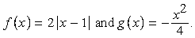
f of, x = 2 times the absolute value of the quantity x minus 1, and g of, x = negative x squared, over 4.
These functions are related to the absolute value function absolute value of x and the quadratic function x squared, respectively, in more complicated ways than in the preceding example.

The graph of f of, x = 2 times the absolute value of the quantity x minus 1, is the graph of y = the absolute value of x shifted to the right by 1 unit and then stretched, or dilated, vertically away from the x axis by a factor of 2, as shown in Algebra Figure 14 below.

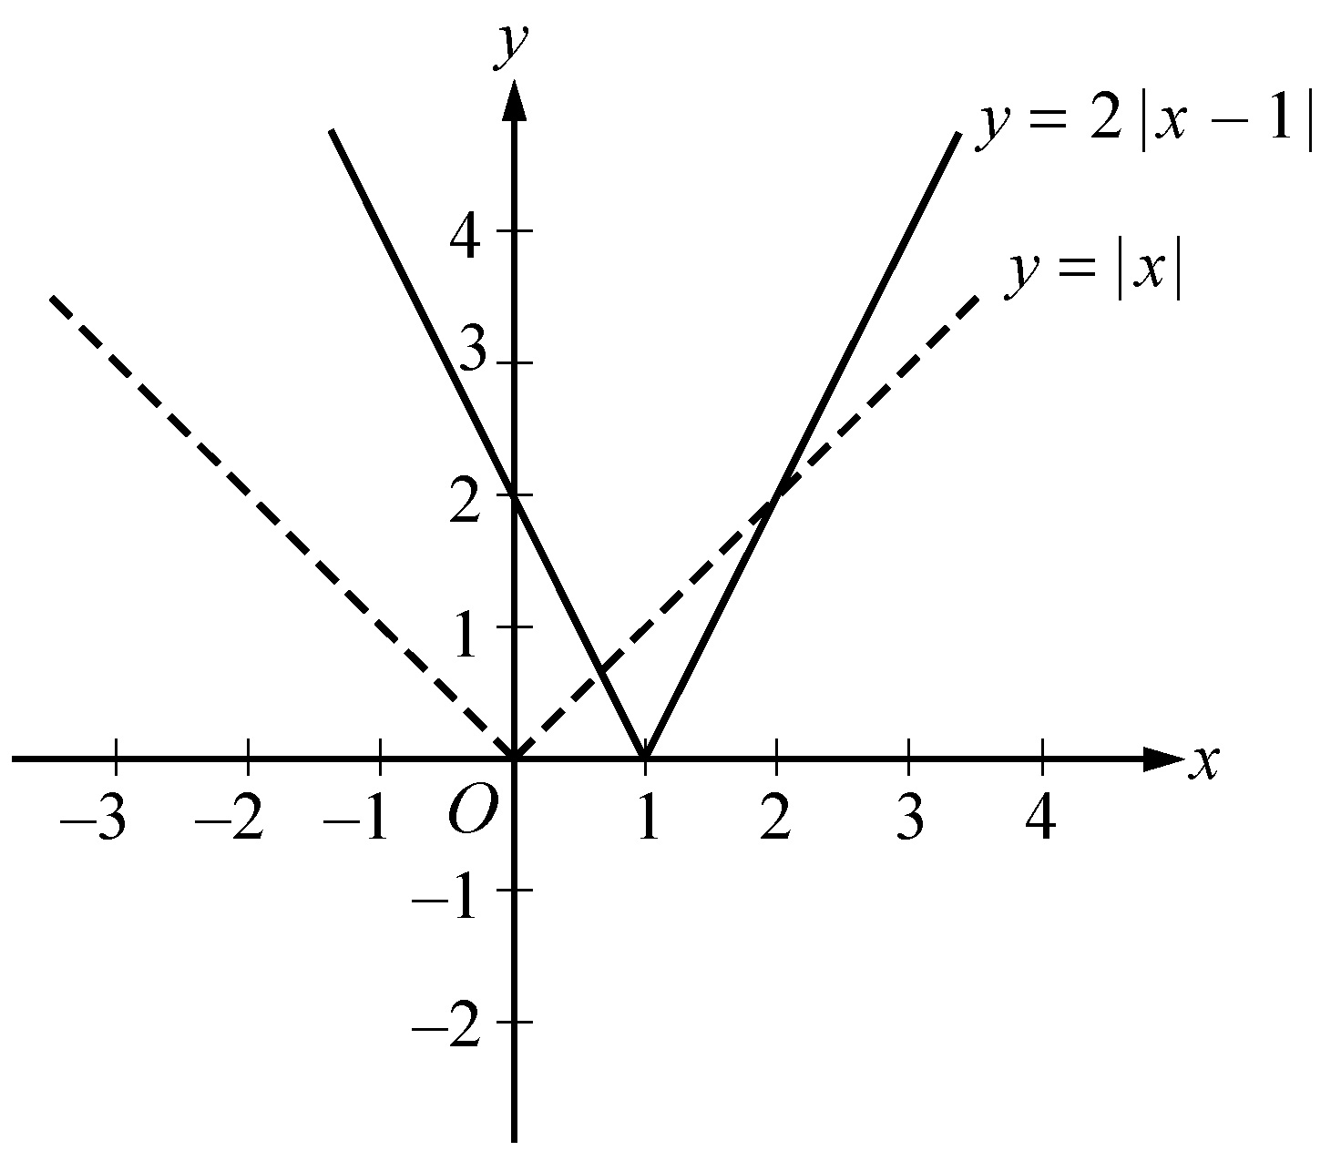
Algebra Figure 14

Begin skippable part of description of Algebra Figure 14.
Algebra Figure 14 shows the graph of f of, x = 2 times the absolute value of the quantity x minus 1 as a solid V shaped curve and the graph of y = the absolute value of x as a dashed V shaped curve. The bottom of the V in the graph of f of, x = 2 times the absolute value of the quantity x minus 1 is 1 unit to the right of the bottom of the V in the graph of y = the absolute value of x, and the V shape of the graph of f of, x = 2 times the absolute value of the quantity x minus 1 is narrower than the V shape of the graph of y = the absolute value of x.

End skippable part of figure description.

Similarly, the graph of the function 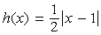 h of, x = one half times the absolute value of the quantity x minus 1 is the graph of y = the absolute value of x shifted to the right by 1 unit and then shrunk, or contracted, vertically toward the x axis by a factor of one half.

The graph of 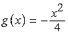 g of, x = negative x squared over 4 is the graph of y = x squared contracted vertically toward the x axis by a factor of one fourth and then reflected in the x axis, as shown in Algebra Figure 15 below.

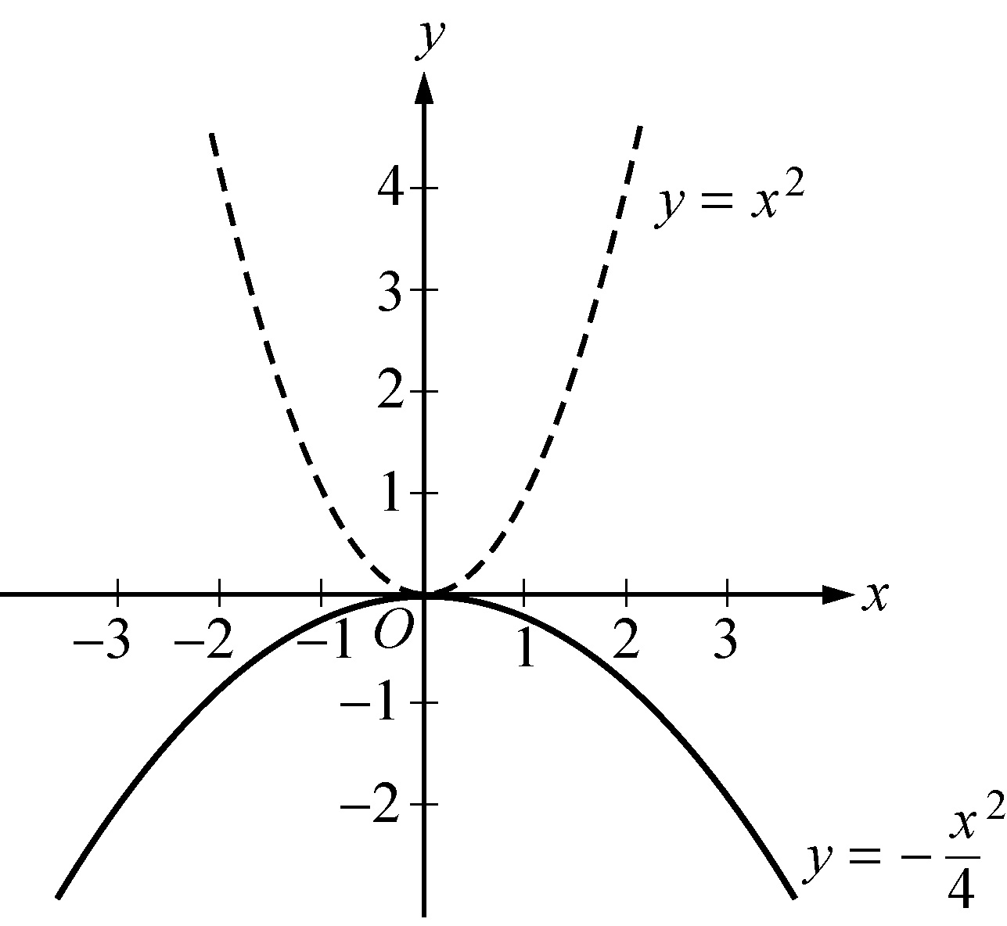
Algebra Figure 15

Begin skippable part of description of Algebra Figure 15.
Algebra Figure 15 shows the graph of g of, x = negative x squared over 4 as a solid parabola and the graph of y = x squared as a dashed parabola. The graph of g of, x = negative x squared over 4 has vertex at the origin, opens downward, and is wider than the parabola y = x squared.

End skippable part of figure description.

In general, for any function h of, x and any positive number c, the following are true.
The graph of c times h of, x is the graph of h of, x stretched vertically by a factor of c if c is greater than 1.
The graph of c times h of, x is the graph of h of, x shrunk vertically by a factor of c if 0 is less than c, which is less than 1.

Algebra Exercises

1. Find an algebraic expression to represent each of the following.
a. The square of y is subtracted from 5, and the result is multiplied by 37.
b. Three times x is squared, and the result is divided by 7.
c. The product of open parenthesis, x + 4, close parenthesis and y is added to 18.

2. Simplify each of the following algebraic expressions.
a. 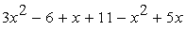 3, x squared, minus 6, +, x + 11, minus x squared, +, 5x
b. 3 times, open parenthesis, 5x, minus 1, close parenthesis, minus x, +, 4
c. 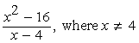 the expression with numerator x squared minus 16 and denominator x minus 4, where x is not equal to 4
d. open parenthesis, 2x, +, 5, close parenthesis, times, open parenthesis, 3x, minus 1, close parenthesis

3.
a. What is the value of 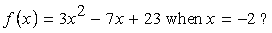 f of, x = 3, x squared, minus 7x, +, 23, when x is equal to negative 2 ?
b. What is the value of 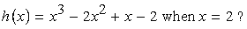 h of, x = x cubed, minus 2, x squared, +, x, minus 2, when x = 2 ?
c. What is the value of 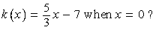 k of, x = 5 thirds x, minus 7, when x = 0 ?

4. If the function g is defined for all nonzero numbers y by 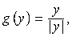 g of, y = y over the absolute value of y, find the value of each of the following.
a. g of, 2
b. g of, negative 2
c. g of, 2, minus, g of, negative 2

5. Use the rules of exponents to simplify the following.
a. 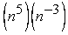 n to the power 5, times, n to the power negative 3
b. 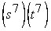 s to the power 7, times, t to the power 7
c. 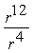 r to the power 12 over r to the power 4
d. 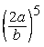 open parenthesis 2a over b, close parenthesis, to the power 5
e. 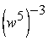 open parenthesis, w to the power 5, close parenthesis, to the power negative 3
f. 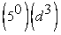 5 to the power 0, times, d to the power 3

g. 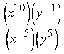
the expression with numerator x to the power 10 times y to the power negative 1, and denominator x to the power negative 5 times y to the power 5
h. 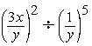
open parenthesis, 3x over y, close parenthesis, squared, divided by, open parenthesis, 1 over y, close parenthesis, to the power 5

6. Solve each of the following equations for x.
a. 5x, minus 7 = 28
b. 12 minus 5x = x + 30
c. 5 times, open parenthesis, x + 2, close parenthesis, = 1, minus, 3x
d. open parenthesis, x + 6, close parenthesis, times, open parenthesis, 2x, minus 1, close parenthesis, = 0
e. 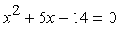 x squared, +, 5x, minus 14
f. 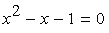 x squared, minus x, minus 1 = 0

7. Solve each of the following systems of equations for x and y.
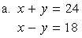
a. x + y = 24, and, x minus y = 18

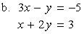
b. 3x minus y = negative 5, and, x + 2y = 3
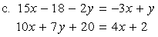
c. 15x minus 18 minus 2y = negative 3x, +, y, and, 10x, +, 7y, +, 20 = 4x, +, 2

8. Solve each of the following inequalities for x.
a. negative 3x is greater than 7 + x
b. 25x + 16 is greater than or equal to 10 minus x
c. 16 + x is greater than 8x, minus 12

9. For a given two digit positive integer, the tens digit is 5 more than the units digit. The sum of the digits is 11. Find the integer.

10. If the ratio of 2x to 5y is 3 to 4, what is the ratio of x to y ?

11. Kathleen’s weekly salary was increased by 8 percent to $237.60. What was her weekly salary before the increase?

12. A theater sells children’s tickets for half the adult ticket price. If 5 adult tickets and 8 children’s tickets cost a total of $27, what is the cost of an adult ticket?

13. Pat invested a total of $3,000. Part of the money was invested in a money market account that paid 10 percent simple annual interest, and the remainder of the money was invested in a fund that paid 8 percent simple annual interest. If the interest earned at the end of the first year from these investments was $256, how much did Pat invest at 10 percent and how much at 8 percent?

14. Two cars started from the same point and traveled on a straight course in opposite directions for exactly 2 hours, at which time they were 208 miles apart. If one car traveled, on average, 8 miles per hour faster than the other car, what was the average speed of each car for the 2 hour trip?

15. A group can charter a particular aircraft at a fixed total cost. If 36 people charter the aircraft rather than 40 people, then the cost per person is greater by $12.
a. What is the fixed total cost to charter the aircraft?
b. What is the cost per person if 40 people charter the aircraft?

16. An antiques dealer bought c antique chairs for a total of x dollars. The dealer sold each chair for y dollars.
a. Write an algebraic expression for the profit, P, earned from buying and selling the chairs.
b. Write an algebraic expression for the profit per chair.

17. Algebra Figure 16 below shows right triangle PQR in the x y plane. Find the following.
a. Coordinates of point Q
b. Lengths of line segment PQ, line segment QR, and line segment PR
c. Perimeter of triangle PQR
d. Area of triangle PQR
e. Slope, y intercept, and equation of the line passing through points P and R

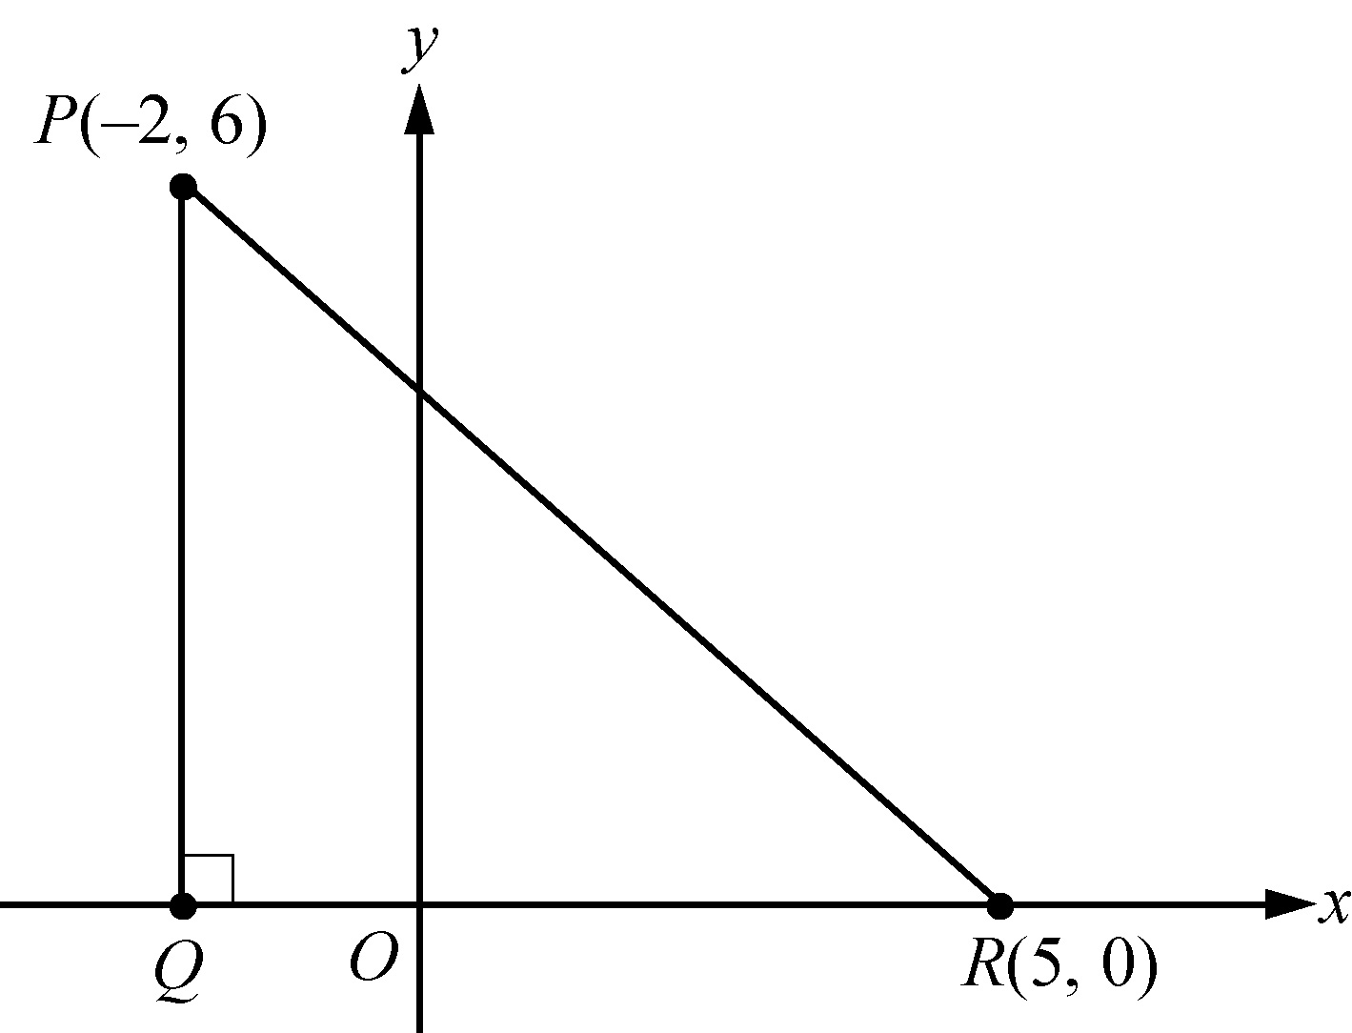
Algebra Figure 16

Begin skippable part of description of Algebra Figure 16.
The figure shows right triangle PQR in the x y plane. Vertex R lies on the x axis and has coordinates 5 comma 0. Vertex P lies in the second quadrant and has coordinates negative 2 comma 6. Vertex Q lies on the x axis directly below vertex P. Angle PQR is a right angle.
End skippable part of figure description.

18. In the x y plane, find the following.
a. Slope and y intercept of the line with equation 2y + x = 6
b. Equation of the line passing through the point 3 comma 2 with y intercept 1
c. The y intercept of a line with slope 3 that passes through the point negative 2 comma 1
d. The x intercepts of the graphs in parts a, b, and c

19. For the parabola 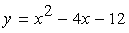 y = x squared, minus 4x, minus 12 in the x y plane, find the following.
a. The x intercepts
b. The y intercept
c. Coordinates of the vertex

20. For the circle 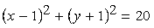 open parenthesis, x minus 1, close parenthesis, squared, +, open parenthesis, y + 1, close parenthesis, squared, =, 20
in the x y plane, find the following.
a. Coordinates of the center
b. Radius
c. Area

21. For each of the following functions, give the domain and a description of the graph y = f of, x in the x y plane, including its shape, and the x and y intercepts.
a. f of, x = negative 4
b. f of, x = 100 minus 900x
c. 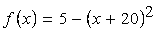 f of, x = 5 minus, open parenthesis, x + 20, close parenthesis, squared
d. f of, x = the positive square root of the quantity x + 2
e. f of, x = x + the absolute value of x

Answers to Algebra Exercises

1.
a. 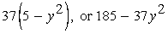
37 times, open parenthesis, 5 minus, y squared, close parenthesis, or 185, minus, 37, y squared
b. 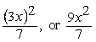
the fraction, open parenthesis, 3x, close parenthesis, squared, over 7, or the fraction, 9, x squared over 7
c.
18 +, open parenthesis, x + 4, close parenthesis, times y, or, 18 + x y + 4y

2.
a. 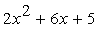 2, x squared, + 6x, + 5
b. 14x + 1
c. x + 4
d. 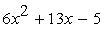 6, x squared, + 13x, minus 5
3.
a. 49
b. 0
c. negative 7

4.
a. 1
b. negative 1
c. 2

5.
a. n squared
b. 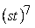 open parenthesis, st, close parenthesis, to the power 7
c. r to the power 8
d. 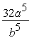 the fraction 32, a to the power 5, over, b to the power 5
e. 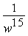 1 over, w to the power 15
f. d cubed
g. 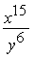 the fraction x to the power 15, over, y to the power 6
h. 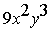 9, x squared, y cubed

6.
a. 7
b. negative 3
c. negative 9 over 8
d. the two solutions are 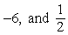 negative 6, and one half
e. the two solutions are negative 7 and 2
f. the two solutions are 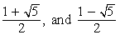
the fraction with numerator 1 + the positive square root of 5, and denominator 2, and
the fraction with numerator 1 minus the positive square root of 5, and denominator 2

7.
a. x = 21; y = 3
b. x = negative 1, y = 2
c. 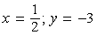 x = one half; y = negative 3

8.
a. 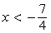 x is less than negative 7 over 4
b. 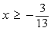 x is greater than or equal to negative 3 over 13
c. x is less than 4

9. 83

10. 15 to 8

11. $220

12. $3

13. $800 at 10% and $2,200 at 8%

14. 48 miles per hour and 56 miles per hour

15.
a. $4,320
b. $108

16.
a. P = c y, minus x
b. 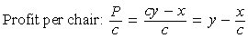
Profit per chair: P over c, =, the fraction with numerator c y minus x, and denominator c, which is equal to y minus the fraction x over c

17.
a. The coordinates of point Q are negative 2 comma 0
b. The length of PQ is 6, the length of QR is 7, and the length of PR is the positive square root of 85.
c. 13 + the positive square root of 85
d. 21
e. Slope: 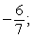 negative 6 over 7; y intercept: 30 over 7
equation of line: 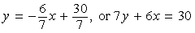
y = negative 6 sevenths x, +, 30 over 7, or 7y + 6x = 30

18.
a. Slope: 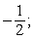 negative one half; y intercept: 3
b. 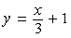 y = x over 3, +, 1
c. 7
d. 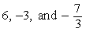 6, negative 3, and negative 7 over 3

19.
a. x = negative 2, and x = 6
b. y = negative 12
c. coordinates 2 comma negative 16

20.
a. coordinates 1 comma negative 1
b. the positive square root of 20
c. 20 pi

21.
a. Domain: the set of all real numbers. The graph is a horizontal line with y intercept negative 4 and no x intercept.
b. Domain: the set of all real numbers. The graph is a line with slope negative 900, y intercept 100, and x intercept 1 ninth.
c. Domain: the set of all real numbers. The graph is a parabola opening downward with vertex at negative 20 comma 5, line of symmetry x = negative 20, y intercept negative 395 and x intercepts negative 20 plus or minus the positive square root of 5.
d. Domain: the set of numbers greater than or equal to negative 2. The graph is half a parabola opening to the right with vertex at negative 2 comma 0, x intercept negative 2, and y intercept the positive square root of 2.
e. Domain: the set of all real numbers. The graph is two half lines joined at the origin: one half line is the negative x axis and the other is a line starting at the origin with slope 2. Every nonpositive number is an x intercept, and the y intercept is 0. The function is equal to the following piecewise defined function
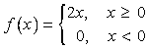
f of, x = 2x, for x greater than or equal to 0, and f of, x = 0 for x less than 0

