GRADUATE RECORD EXAMINATIONS®

Math Review
Chapter 3: Geometry

Copyright © 2010 by Educational Testing Service. All rights reserved. ETS, the ETS logo, GRADUATE RECORD EXAMINATIONS, and GRE are registered trademarks of Educational Testing Service (ETS) in the United States and other countries.

The GRE® Math Review consists of 4 chapters: Arithmetic, Algebra, Geometry, and Data Analysis. This is the accessible electronic format (Word) edition of the Geometry Chapter of the Math Review. Downloadable versions of large print (PDF) and accessible electronic format (Word) of each of the 4 chapters of the Math Review, as well as a Large Print Figure supplement for each chapter are available from the GRE® website. Other downloadable practice and test familiarization materials in large print and accessible electronic formats are also available. Tactile figure supplements for the 4 chapters of the Math Review, along with additional accessible practice and test familiarization materials in other formats, are available from E T S Disability Services Monday to Friday 8:30 a m to 5 p m New York time, at 1-6 0 9-7 7 1-7 7 8 0, or 1-8 6 6-3 8 7-8 6 0 2 (toll free for test takers in the United States, U S Territories and Canada), or via email at stassd@ets.org.

The mathematical content covered in this edition of the Math Review is the same as the content covered in the standard edition of the Math Review. However, there are differences in the presentation of some of the material. These differences are the result of adaptations made for presentation of the material in accessible formats. There are also slight differences between the various accessible formats, also as a result of specific adaptations made for each format.

Information for screen reader users:
This document has been created to be accessible to individuals who use screen readers. You may wish to consult the manual or help system for your screen reader to learn how best to take advantage of the features implemented in this document. Please consult the separate document, GRE Screen Reader Instructions.doc, for important details.

Figures
The Math Review includes figures. In accessible electronic format (Word) editions, figures appear on screen. Following each figure on screen is text describing that figure. Readers using visual presentations of the figures may choose to skip parts of the text describing the figure that begin with “Begin skippable part of description of …” and end with “End skippable figure description.”

Mathematical Equations and Expressions
The Math Review includes mathematical equations and expressions. In accessible electronic format (Word) editions some of the mathematical equations and expressions are presented as graphics. In cases where a mathematical equation or expression is presented as a graphic, a verbal presentation is also given and the verbal presentation comes directly after the graphic presentation. The verbal presentation is in green font to assist readers in telling the two presentation modes apart. Readers using audio alone can safely ignore the graphical presentations, and readers using visual presentations may ignore the verbal presentations.

Table of Contents

Overview of the Math Review 5
Overview of this Chapter 5
3.1 Lines and Angles 6
3.2 Polygons 11
3.3 Triangles 13
3.4 Quadrilaterals 21
3.5 Circles 26
3.6 Three Dimensional Figures 34
Geometry Exercises 39
Answers to Geometry Exercises 52

Overview of the Math Review

The Math Review consists of 4 chapters: Arithmetic, Algebra, Geometry, and Data Analysis.

Each of the 4 chapters in the Math Review will familiarize you with the mathematical skills and concepts that are important to understand in order to solve problems and reason quantitatively on the Quantitative Reasoning measure of the GRE® revised General Test.

The material in the Math Review includes many definitions, properties, and examples, as well as a set of exercises with answers at the end of each chapter. Note, however that this review is not intended to be all inclusive. There may be some concepts on the test that are not explicitly presented in this review. If any topics in this review seem especially unfamiliar or are covered too briefly, we encourage you to consult appropriate mathematics texts for a more detailed treatment.

Overview of this Chapter

The review of geometry begins with lines and angles and progresses to other plane figures, such as polygons, triangles, quadrilaterals, and circles. The chapter ends with some basic three dimensional figures. Coordinate geometry is covered in the Algebra chapter.

3.1 Lines and Angles

Plane geometry is devoted primarily to the properties and relations of plane figures, such as angles, triangles, other polygons, and circles. The terms “point”, “line”, and “plane” are familiar intuitive concepts. A point has no size and is the simplest geometric figure. All geometric figures consist of points. A line is understood to be a straight line that extends in both directions without end. A plane can be thought of as a floor or a tabletop, except that a plane extends in all directions without end and has no thickness.

Given any two points on a line, a line segment is the part of the line that contains the two points and all the points between them. The two points are called endpoints. Line segments that have equal lengths are called congruent line segments. The point that divides a line segment into two congruent line segments is called the midpoint of the line segment.

In Geometry Figure 1 below, A, B, C, and D are points on line l.

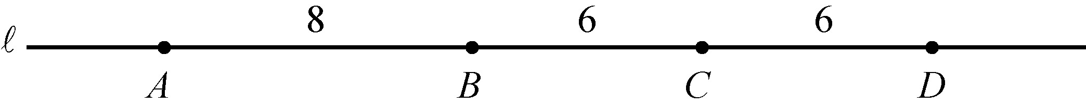
Geometry Figure 1

Line segment AB consists of points A and B and all the points on the line between A and B. According to Geometry Figure 1 above, the lengths of line segments AB, BC, and CD are 8, 6, and 6, respectively. Hence, line segments BC and CD are congruent. Since C is halfway between B and D, point C is the midpoint of line segment BD.

Sometimes the notation AB denotes line segment AB, and sometimes it denotes the length of line segment AB. The meaning of the notation can be determined from the context.

When two lines intersect at a point, they form four angles. Each angle has a vertex at the point of intersection of the two lines. For example, in Geometry Figure 2 below, lines l sub 1 and l sub 2 intersect at point P, forming the four angles APC, CPB, BPD, and DPA.

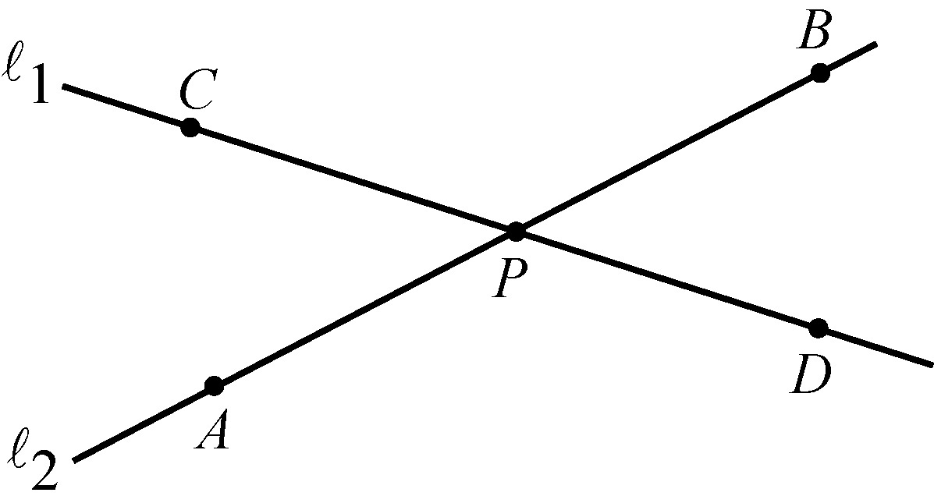
Geometry Figure 2

The first and the third of the angles, that is, angles APC and BPD, are called opposite angles, also known as vertical angles. The second and fourth of the angles, that is angles CPB and DPA are also opposite angles. Opposite angles have equal measures, and angles that have equal measures are called congruent angles. Hence, opposite angles are congruent. The sum of the measures of the four angles is 360º.

Sometimes the angle symbol is used instead of the word “angle”. For example, angle APC can be written as the angle symbol followed by APC.

Two lines that intersect to form four congruent angles are called perpendicular lines. Each of the four angles has a measure of 90º. An angle with a measure of 90º is called a right angle. Geometry Figure 3 below shows two lines, l sub 1 and l sub 2, that are perpendicular, denoted by l sub 1, followed by the perpendicular symbol, followed by l sub 2.

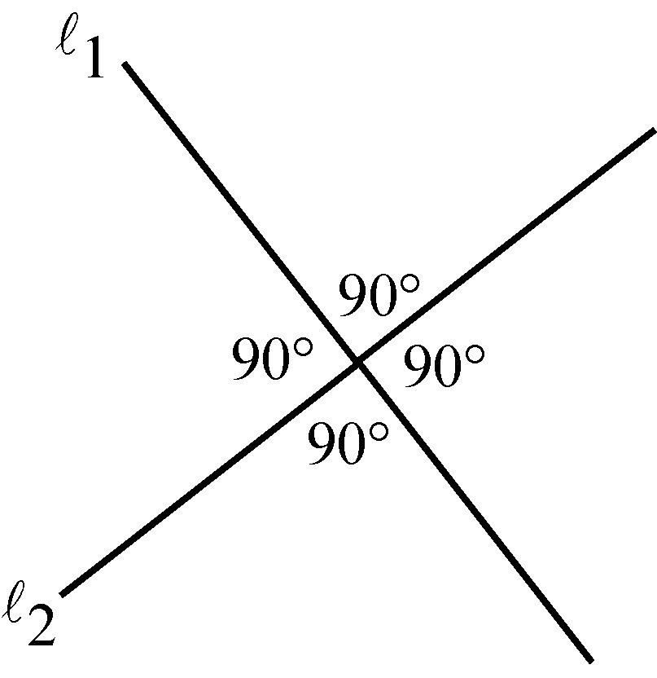
Geometry Figure 3

A common way to indicate that an angle is a right angle is to draw a small square at the vertex of the angle, as shown in Geometry Figure 4 below, where P O N is a right angle.

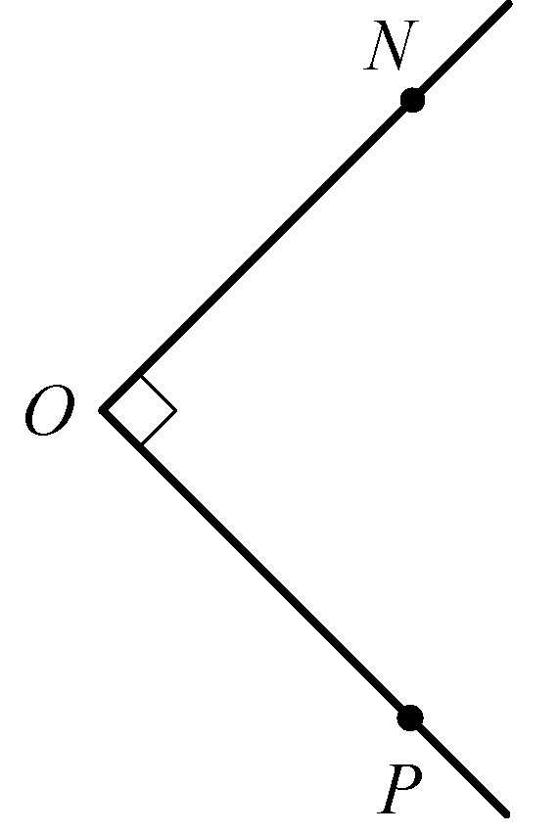
Geometry Figure 4

An angle with measure less than 90º is called an acute angle, and an angle with measure between 90º and 180º is called an obtuse angle.

Two lines in the same plane that do not intersect are called parallel lines. Geometry Figure 5 below shows two lines, l sub 1 and l sub 2, that are parallel, denoted by l sub 1, followed by the parallel symbol, followed by l sub 2. The two lines are intersected by a third line, l sub 3, forming eight angles.

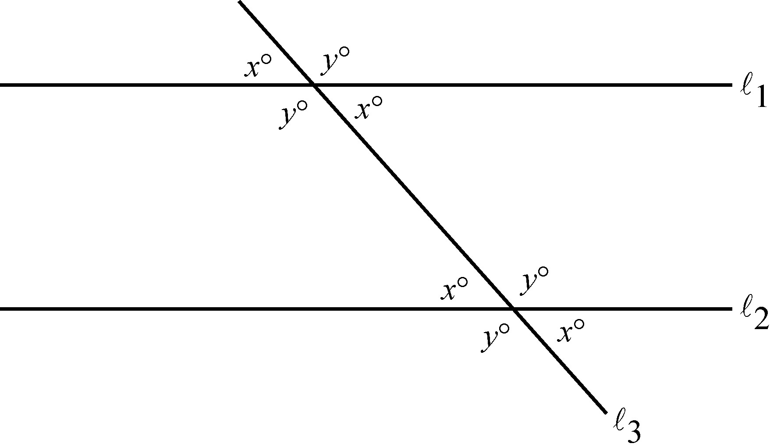
Geometry Figure 5

Begin skippable part of description of Geometry Figure 5.
There are eight labeled angles in Geometry Figure 5, four at the intersection of l sub 1 and l sub 3, and four at the intersection of l sub 2 and l sub 3. The four angles at each intersection, from the upper left angle, going clockwise, are labeled xº, yº, xº, and yº.

End skippable part of figure description.

Note that four of the eight angles in Geometry Figure 5 have the measure xº, and the remaining four angles have the measure yº, where x + y = 180.

3.2 Polygons

A polygon is a closed figure formed by three or more line segments, called sides. Each side is joined to two other sides at its endpoints, and the endpoints are called vertices. In this discussion, the term “polygon” means “convex polygon”, that is, a polygon in which the measure of each interior angle is less than 180°. Geometry Figure 6 below contains examples of a triangle, a quadrilateral, and a pentagon, all of which are convex.

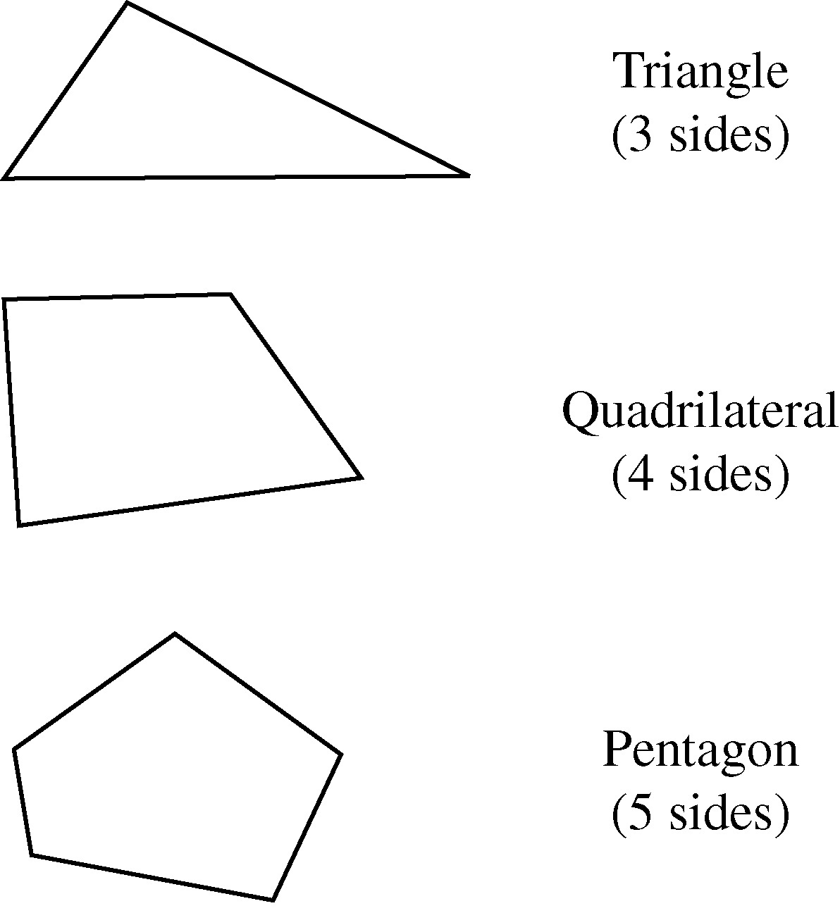
Geometry Figure 6

The simplest polygon is a triangle. Note that a quadrilateral can be divided into 2 triangles by drawing a diagonal; and a pentagon can be divided into 3 triangles by selecting one of the vertices and drawing 2 line segments connecting that vertex to the two nonadjacent vertices, as shown in Geometry Figure 7 below.

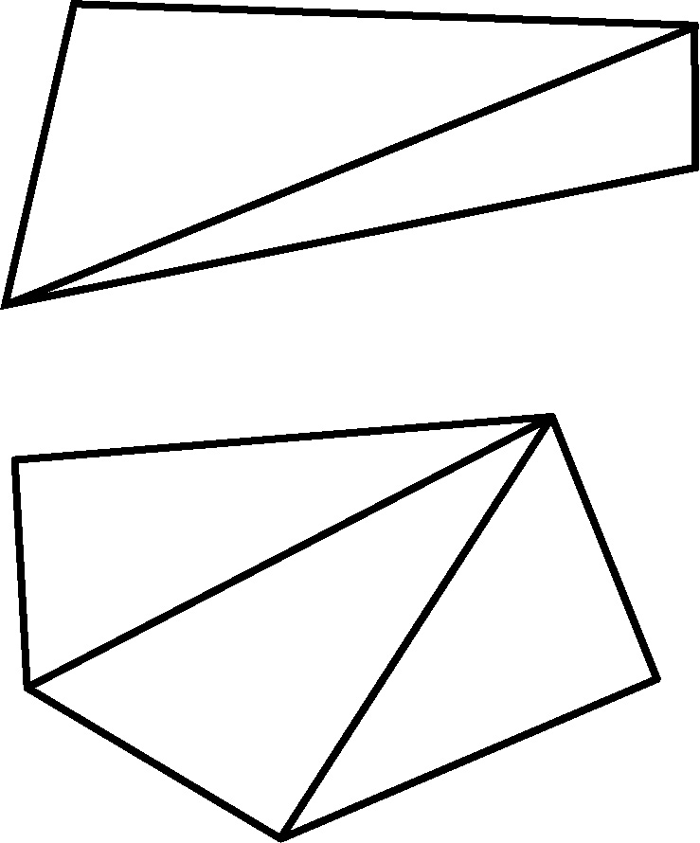
Geometry Figure 7

If a polygon has n sides, it can be divided into n minus 2 triangles. Since the sum of the measures of the interior angles of a triangle is 180º, it follows that the sum of the measures of the interior angles of an n sided polygon is open parenthesis, n minus 2, close parenthesis, times 180°. For example, since a quadrilateral has 4 sides, the sum of the measures of the interior angles for a quadrilateral is open parenthesis, 4 minus 2, close parenthesis, times 180° = 360°; and since a hexagon has 6 sides, the sum of the measures of the interior angles for a hexagon is open parenthesis, 6 minus 2, close parenthesis, times 180° = 720°.

A polygon in which all sides are congruent and all interior angles are congruent is called a regular polygon. For example, since an octagon has 8 sides, the sum of the measures of the interior angles of an octagon is open parenthesis, 8 minus 2, close parenthesis, times 180° = 1,080°. Therefore, in a regular octagon the measure of each angle is 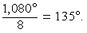 1,080° over 8 = 135°.

The perimeter of a polygon is the sum of the lengths of its sides. The area of a polygon refers to the area of the region enclosed by the polygon.

In the next two sections, we will look at some basic properties of triangles and quadrilaterals.

3.3 Triangles

Every triangle has three sides and three interior angles. The measures of the interior angles add up to 180°. The length of each side must be less than the sum of the lengths of the other two sides. For example, the sides of a triangle could not have the lengths 4, 7, and 12 because 12 is greater than 4 + 7.

The following are 3 types of special triangles.

Type 1: A triangle with three congruent sides is called an equilateral triangle. The measures of the three interior angles of such a triangle are also equal, and each measure is 60º.

Type 2: A triangle with at least two congruent sides is called an isosceles triangle. If a triangle has two congruent sides, then the angles opposite the two sides are congruent. The converse is also true. For example, in triangle ABC in Geometry Figure 8 below, the measure of angle A is 50º, the measure of angle C is 50º, and the measure of angle B is xº. Since both angle A and angle C have measure 50º, it follows that the length of AB is equal to the length of BC. Also, since the sum of the 3 angles of a triangle is 180º, it follows that 50 + 50 + x = 180, and the measure of angle B is 80º.

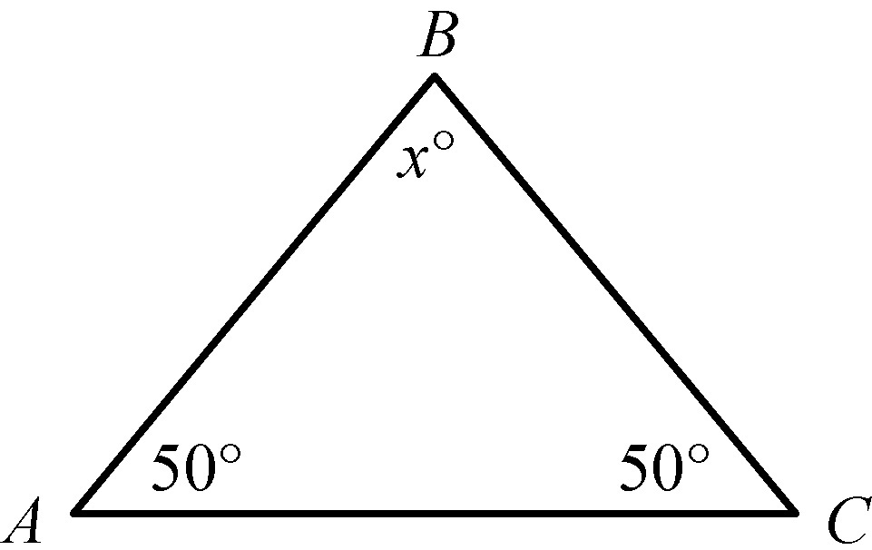
Geometry Figure 8

Type 3: A triangle with an interior right angle is called a right triangle. The side opposite the right angle is called the hypotenuse; the other two sides are called legs.

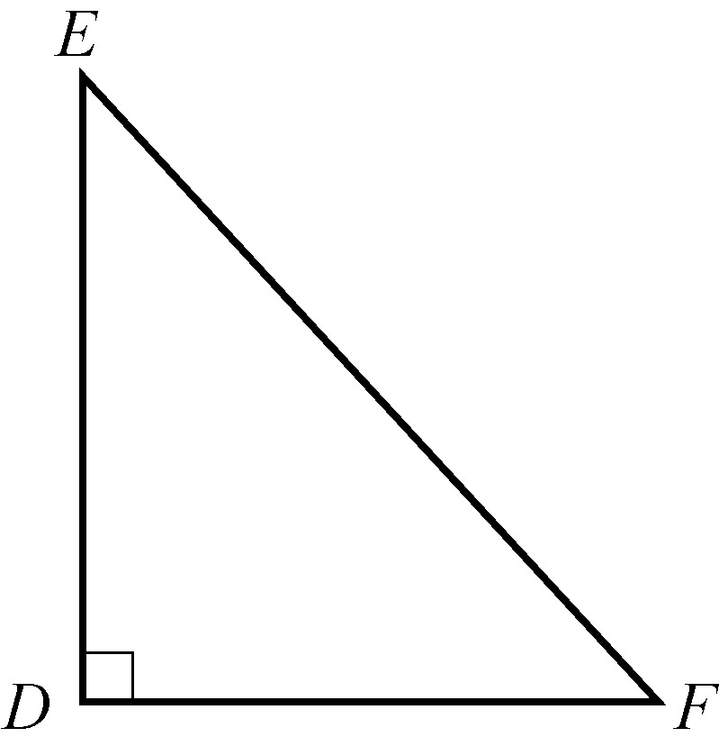
Geometry Figure 9

In right triangle D E F in Geometry Figure 9 above, side E F is the side opposite right angle D, therefore E F is the hypotenuse and D E and D F are legs. The Pythagorean theorem states that in a right triangle, the square of the length of the hypotenuse is equal to the sum of the squares of the lengths of the legs. Thus, for triangle D E F in Geometry Figure 9 above,

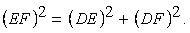 the length of E F squared = the length of D E squared, +, the length of D F squared .

This relationship can be used to find the length of one side of a right triangle if the lengths of the other two sides are known. For example, consider a right triangle with hypotenuse of length 8, a leg of length 5, and another leg of unknown length x, as shown in Geometry Figure 10 below.

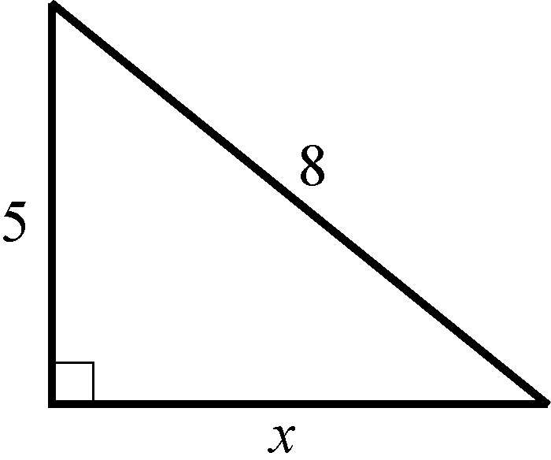
Geometry Figure 10

By the Pythagorean theorem 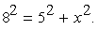 8 squared = 5 squared, +, x squared.
Therefore 64 = 25, +, x squared and 39 = x squared.
Since 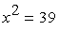 x squared = 39 and x must be positive, it follows that x = the positive square root of 39, or approximately 6.2.

The Pythagorean theorem can be used to determine the ratios of the sides of two special right triangles. One special right triangle is an isosceles right triangle, as shown in Geometry Figure 11 below.

.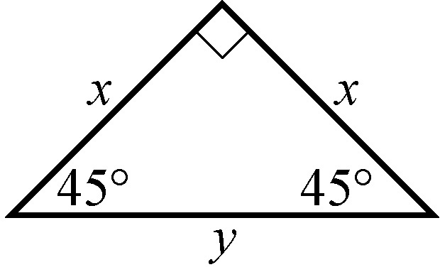
Geometry Figure 11

In Geometry Figure 11, the hypotenuse of the right triangle is of length y, both legs are of length x, and the angles opposite the legs are both 45 degree angles.
Applying the Pythagorean theorem to the isosceles right triangle in Geometry Figure 11 shows that the lengths of its sides are in the ratio 1 to 1 to the positive square root of 2, as follows.
By the Pythagorean theorem, 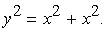 y squared = x squared + x squared.
Therefore 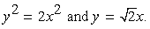 y squared = 2, x squared and y = the positive square root of 2, times x. So the lengths of the sides are in the ratio x to x, to the positive square root of 2, times x, which is the same as the ratio 1 to 1 to the positive square root of 2.

The other special right triangle is a 30º- 60º- 90º right triangle, which is half of an equilateral triangle, as shown in Geometry Figure 12 below.

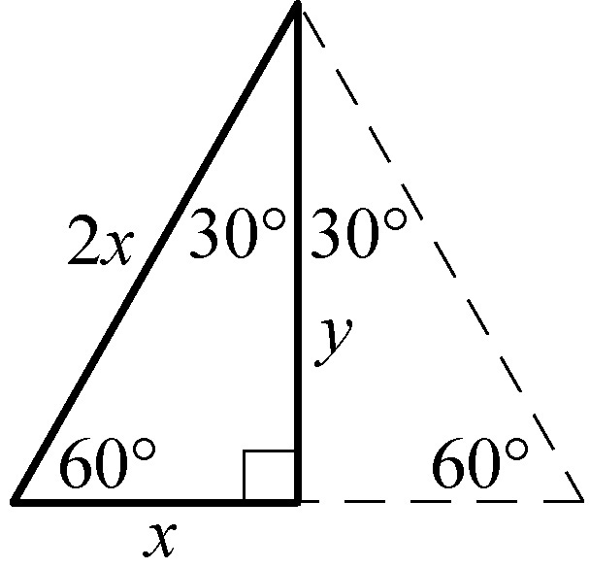
Geometry Figure 12

Begin skippable part of description of Geometry Figure 12.
One of the sides of the equilateral triangle is horizontal and the other two sides meet at a vertex of the triangle that lies above the horizontal side. A perpendicular line from the vertex to the horizontal side of the triangle divides the equilateral triangle into two congruent right triangles. Each right triangle has a horizontal leg of length x, a vertical leg of length y and a hypotenuse of length 2x. The angle opposite the vertical leg has measure 60 degrees, and the angle opposite the horizontal leg has measure 30 degrees.

End skippable part of figure description.

Note that the length of the horizontal side, x, is one half the length of the hypotenuse, 2x. Applying the Pythagorean theorem to the 30º- 60º- 90º right triangle shows that the lengths of its sides are in the ratio 1 to the positive square root of 3 to 2 as follows.

By the Pythagorean theorem 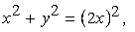 x squared + y squared = open parenthesis, 2x, close parenthesis, squared, which simplifies to 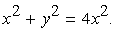 x squared + y squared = 4, x squared.
Subtracting x squared from both sides gives 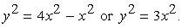 y squared = 4, x squared, minus x squared, or y squared = 3, x squared. Therefore, y = the positive square root of 3, times x.
Hence, the ratio of the lengths of the three sides of a 30º- 60º- 90º right triangle is x to the positive square root of 3, times x, to 2x, which is the same as the ratio 1 to the positive square root of 3, to 2.

The area A of a triangle equals one half the product of the length of a base and the height corresponding to the base, or 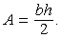 A = bh, over 2. Geometry Figure 13 below shows a triangle: the horizontal base of the triangle is denoted by b and the corresponding vertical height is denoted by h.

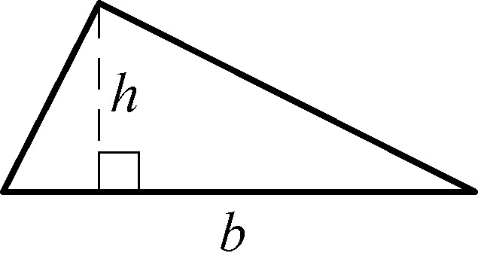
Geometry Figure 13

Any side of a triangle can be used as a base; the height that corresponds to the base is the perpendicular line segment from the opposite vertex to the base (or an extension of the base). The examples in Geometry Figure 14 below show three different configurations of a base and the corresponding height.

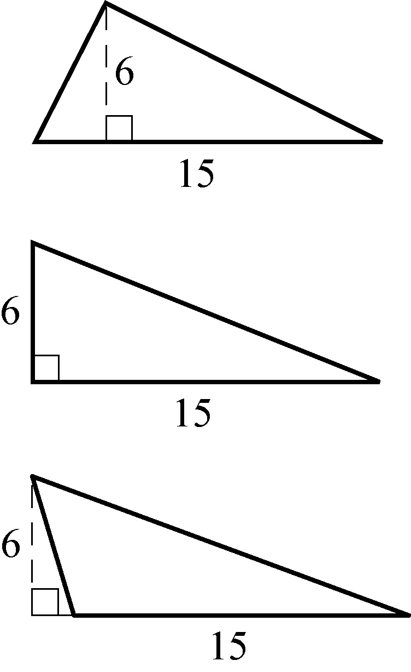
Geometry Figure 14

Begin skippable part of description of Geometry Figure 14.
In all three triangles the base is a horizontal line segment of length 15, and the height is a vertical line segment of length 6. In the first triangle, the angle at the left of the horizontal base is an acute angle and the height goes to the base. In the second triangle, the angle at the left of the horizontal base is a right angle and the height is the vertical side of the right triangle. In the third triangle, the angle at the left of the horizontal base is an obtuse angle and the height goes to an extension of the base.

End skippable part of figure description.

In all three triangles in Geometry Figure 14 above, the area is 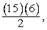 15 times 6, over 2, or 45.

Two triangles that have the same shape and size are called congruent triangles. More precisely, two triangles are congruent if their vertices can be matched up so that the corresponding angles and the corresponding sides are congruent.

The following three propositions can be used to determine whether two triangles are congruent by comparing only some of their sides and angles.

Proposition 1: If the three sides of one triangle are congruent to the three sides of another triangle, then the triangles are congruent.

Proposition 2: If two sides and the included angle of one triangle are congruent to two sides and the included angle of another triangle, then the triangles are congruent.

Proposition 3: If two angles and the included side of one triangle are congruent to two angles and the included side of another triangle, then the triangles are congruent.

Two triangles that have the same shape but not necessarily the same size are called similar triangles. More precisely, two triangles are similar if their vertices can be matched up so that the corresponding angles are congruent or, equivalently, the lengths of corresponding sides have the same ratio, called the scale factor of similarity. For example, all 30º-60º-90º right triangles, are similar triangles, though they may differ in size.

When we say that triangles ABC and D E F are similar, it is assumed that angles A and D are congruent, angles B and E are congruent, and angles C and F are congruent, as shown in Geometry Figure 15 below. Also sides AB, BC, and AC in triangle ABC correspond to sides D E, E F, and DF in triangle D E F, respectively. In other words, the order of the letters indicates the correspondences.

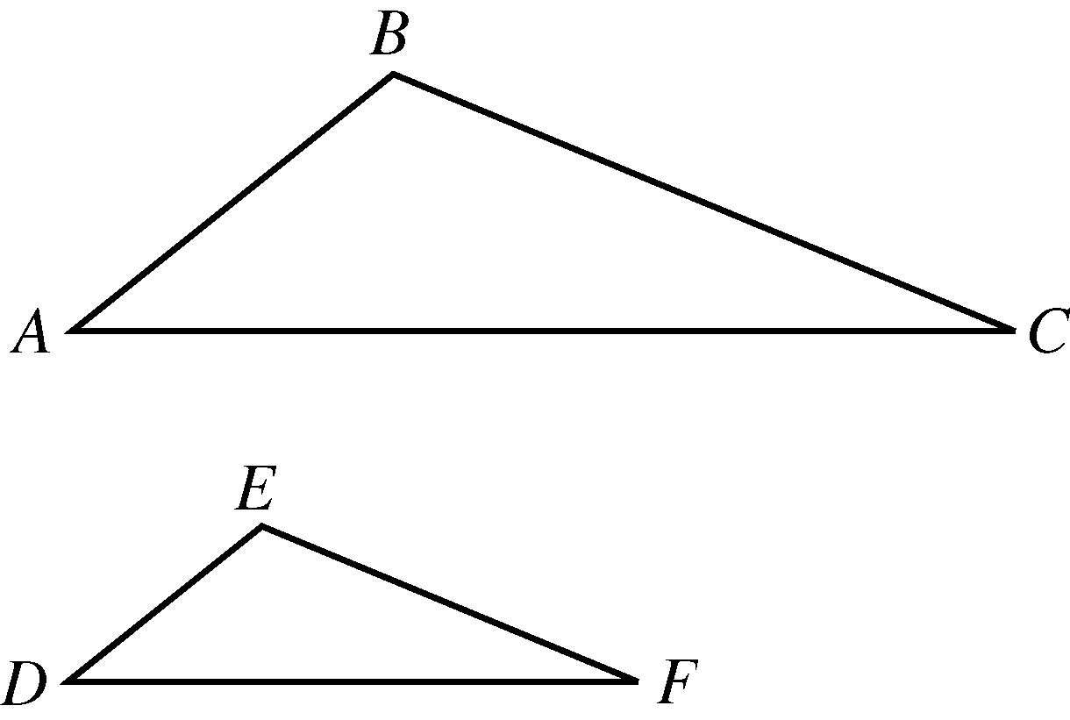
Geometry Figure 15

Since triangles ABC and D E F are similar, we have 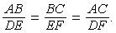 AB over D E = BC over E F = AC over DF. By cross multiplication, we can obtain other proportions, such as 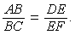 AB over BC = D E over E F.

3.4 Quadrilaterals

Every quadrilateral has four sides and four interior angles. The measures of the interior angles add up to 360°. The following are four special types of quadrilaterals.

Type 1: A quadrilateral with four right angles is called a rectangle. Opposite sides of a rectangle are parallel and congruent, and the two diagonals are also congruent.

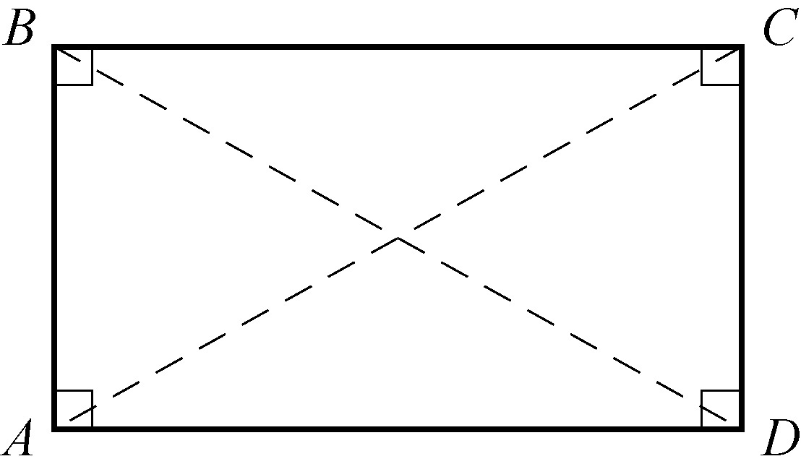
Geometry Figure 16

Geometry Figure 16 above shows rectangle ABCD.
In rectangle ABCD, opposite sides AD and BC are parallel and congruent,
opposite sides AB and DC are parallel and congruent, and
diagonal AC is congruent to diagonal BD.

Type 2: A rectangle with four congruent sides is called a square.

Type 3: A quadrilateral in which both pairs of opposite sides are parallel is called a parallelogram. In a parallelogram, opposite sides are congruent and opposite angles are congruent.

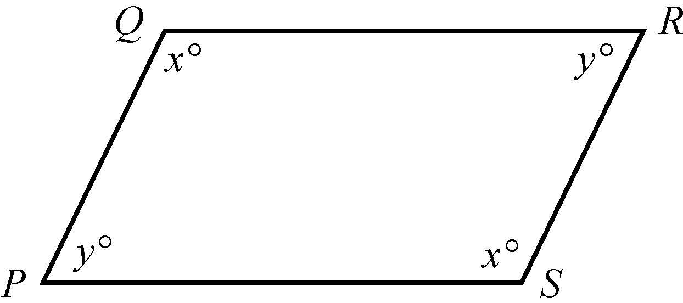
Geometry Figure 17

Geometry Figure 17 above shows parallelogram PQRS.
In parallelogram PQRS,
opposite sides PQ and SR are parallel and congruent,
opposite sides QR and PS are parallel and congruent,
opposite angles Q and S are congruent, and
opposite angles P and R are congruent.
In the figure angles Q and S are both labeled xº, and angles P and R are both labeled yº.

Type 4: A quadrilateral in which two opposite sides are parallel is called a trapezoid.

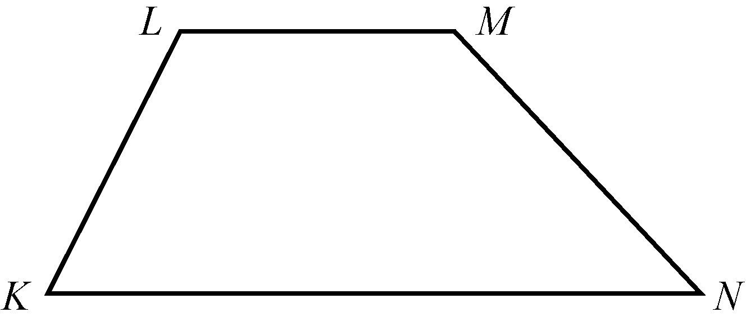
Geometry Figure 18

Geometry Figure 18 above shows trapezoid KLMN. In trapezoid KLMN, horizontal side KN is parallel to horizontal side LM.

For all parallelograms, including rectangles and squares, the area A equals the product of the length of a base b and the corresponding height h; that is,

A = bh.

Any side can be used as a base. The height corresponding to the base is the perpendicular line segment from any point of a base to the opposite side (or an extension of that side). In Geometry Figure 19 below are examples of finding the areas of a rectangle and a parallelogram.

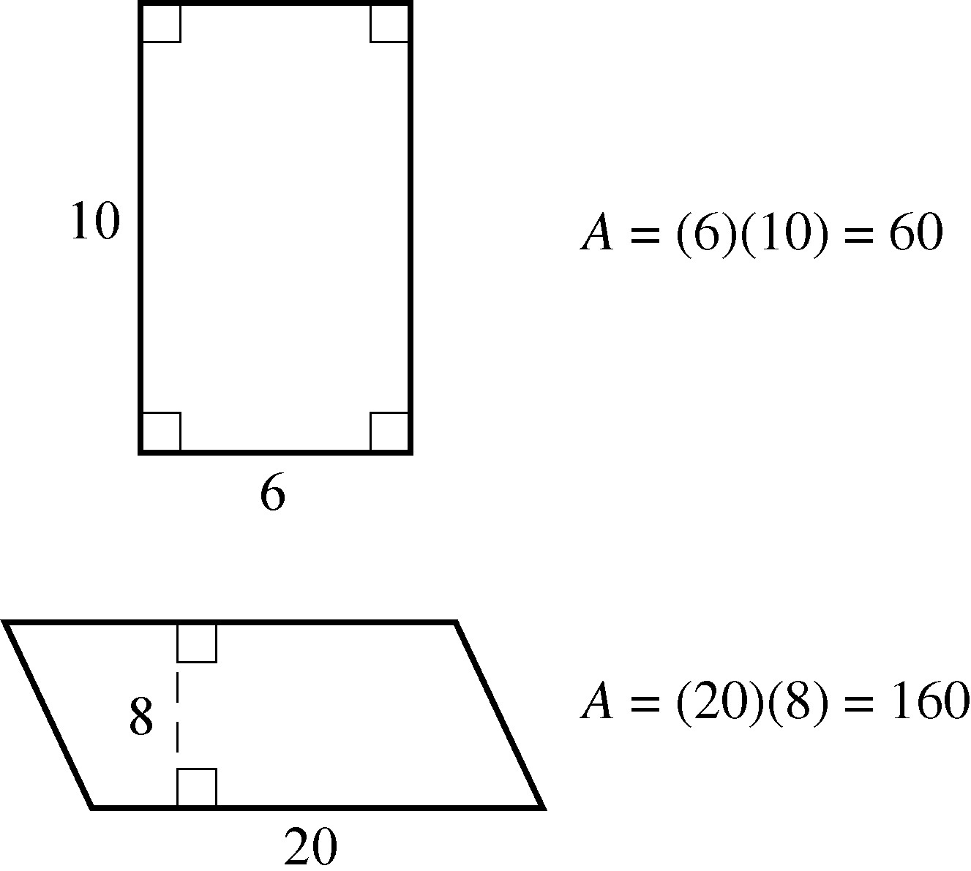
Geometry Figure 19

Begin skippable part of description of Geometry Figure 19.
The first figure is a rectangle with length 10 and width 6. The area of the rectangle is 6 times 10, or 60.
The second figure is a parallelogram with a pair of parallel sides of length 20, and height of length 8. The area of the parallelogram is 20 times 8, or 160.

End skippable part of figure description.

The area A of a trapezoid equals half the product of the sum of the lengths of the two parallel sides b sub 1 and b sub 2 and the corresponding height h; that is,

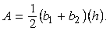 A = 1 half times, open parenthesis, b sub 1 + b sub 2, close parenthesis, times h.

For example, for the trapezoid in Geometry Figure 20 below with bases of length 10 and 18 and a height of 7.5, the area is

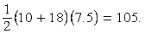1 half times, open parenthesis, 10 + 18, close parenthesis, times 7.5 = 105.

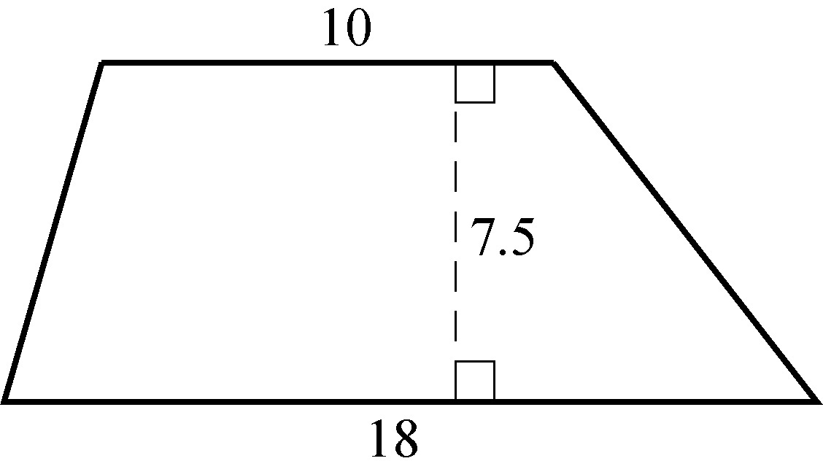
Geometry Figure 20

3.5 Circles

Given a point O in a plane and a positive number r, the set of points in the plane that are a distance of r units from O is called a circle. The point O is called the center of the circle and the distance r is called the radius of the circle. The diameter of the circle is twice the radius. Two circles with equal radii are called congruent circles.

Any line segment joining two points on the circle is called a chord. The terms “radius” and “diameter” can also refer to line segments: A radius is any line segment joining a point on the circle and the center of the circle, and a diameter is a chord that passes through the center of the circle. In Geometry Figure 21 below, O is the center of the circle, r is the radius, PQ is a chord, and ST is a diameter.

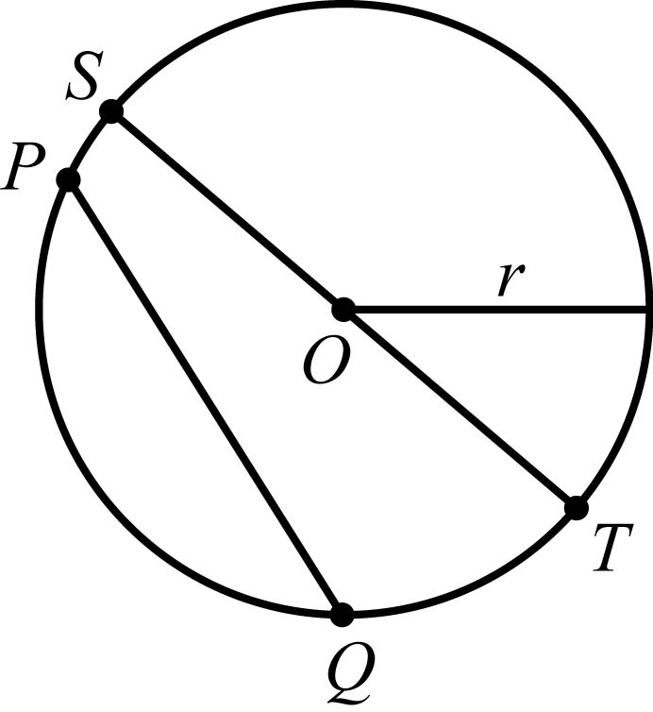
Geometry Figure 21

The distance around a circle is called the circumference of the circle, which is analogous to the perimeter of a polygon. The ratio of the circumference C to the diameter d is the same for all circles and is denoted by the Greek letter pi; that is,

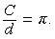 C over d = pi.

The value of pi is approximately 3.14 and can also be approximated by the fraction 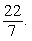 22 over 7. If r is the radius of a circle, then 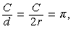 C over d = C over 2r = pi, and so the circumference is related to the radius as follows.

C = 2 pi r

For example, if a circle has a radius of 5.2, then its circumference is

2 times pi times 5.2 = 10.4 times pi, which is approximately 10.4 times 3.14,

which is approximately 32.7.

Given any two points on a circle, an arc is the part of the circle containing the two points and all the points between them. Two points on a circle are always the endpoints of two arcs. It is customary to identify an arc by three points to avoid ambiguity. In Geometry Figure 22 below, there are 4 points on a circle. Going clockwise around the circle the four points are A, B, C, and D. There are two different arcs between points A and C: arc ABC is the shorter arc between A and C, and arc ADC is the longer arc between A and C.

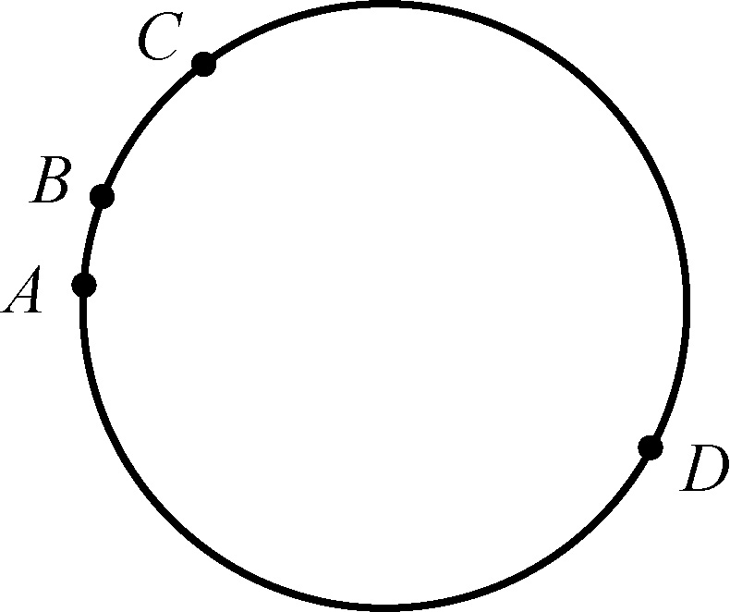
Geometry Figure 22

A central angle of a circle is an angle with its vertex at the center of the circle. The measure of an arc is the measure of its central angle, which is the angle formed by two radii that connect the center of the circle to the two endpoints of the arc. An entire circle is considered to be an arc with measure 360°.
In Geometry Figure 23 below, there are 3 points on a circle: points A, B, and C.
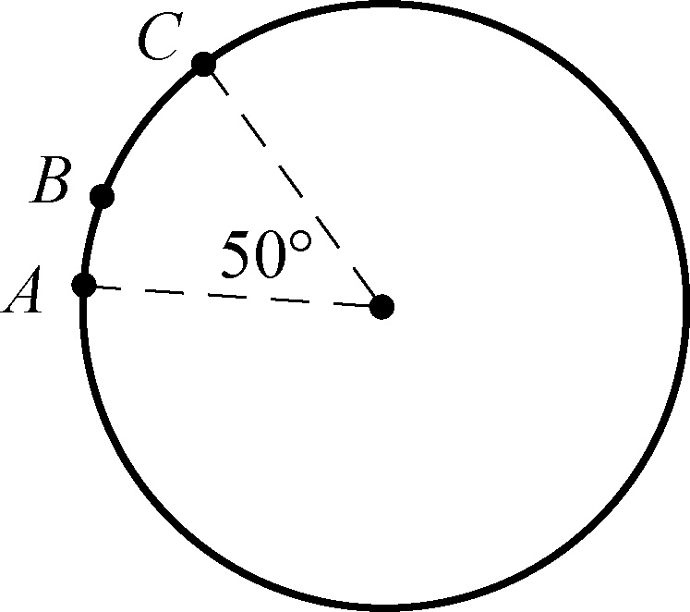
Geometry Figure 23

Begin skippable part of description of Geometry Figure 23.
There are also two radii, one from the center of the circle to point A and the other from the center to point C. The smaller of the two central angles associated with these two radii, that is the central angle associated with arc ABC, measures 50°.

End skippable part of figure description.

In Geometry Figure 23, the measure of the shorter arc between points A and C, that is arc ABC, is 50°; and the measure of the longer arc between points A and C is 310°.
In addition to the information given in the figure, it is also given that the radius of the circle is 5.

To find the length of an arc of a circle, note that the ratio of the length of an arc to the circumference is equal to the ratio of the degree measure of the arc to 360°. For example, since the radius of the circle in Geometry Figure 23 is 5, the circumference of the circle is 10 pi. Therefore,

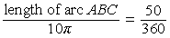 the length of arc ABC over 10 pi = 50 over 360
and

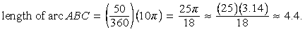 the length of arc ABC = the fraction 50 over 360, times 10 pi = 25 pi over 18, which is approximately 25 times 3.14 over 18, which is approximately 4.4.

The area of a circle with radius r is equal to pi r squared. For example, the area of a circle with radius 5 is pi, times 5 squared = 25 pi.

A sector of a circle is a region bounded by an arc of the circle and two radii. In the circle in Geometry Figure 23 above, the region bounded by arc ABC and the two radii is a sector with central angle 50º. Just as in the case of the length of an arc, the ratio of the area of a sector of a circle to the area of the entire circle is equal to the ratio of the degree measure of its arc to 360º. Therefore, if S represents the area of the sector with central angle 50º, then

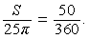 S over 25 pi = 50 over 360.

and

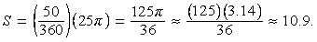 S = 50 over 360, times 25 pi = 125 pi over 36, which is approximately 125 times 3.14 over 36, which is approximately 10.9.

A tangent to a circle is a line that intersects the circle at exactly one point, called the point of tangency. If a line is tangent to a circle, then a radius drawn to the point of tangency is perpendicular to the tangent line. Geometry Figure 24 below shows a circle, a line tangent to the circle at point P, and a radius drawn to point P. The converse is also true; that is, if a line is perpendicular to a radius at its endpoint on the circle, then the line is a tangent to the circle at that endpoint.

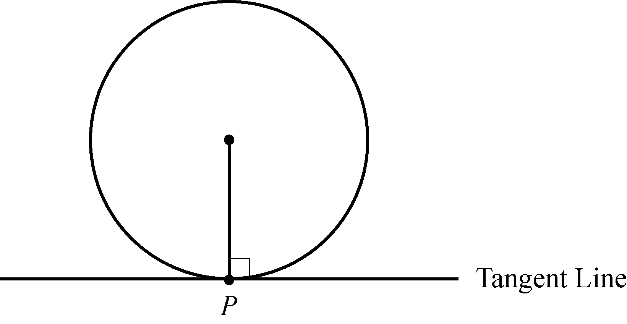
Geometry Figure 24

A polygon is inscribed in a circle if all its vertices lie on the circle, or equivalently, the circle is circumscribed about the polygon.

Geometry Figure 25 below shows triangle RST inscribed in a circle with center O. The center of the circle is inside the triangle.

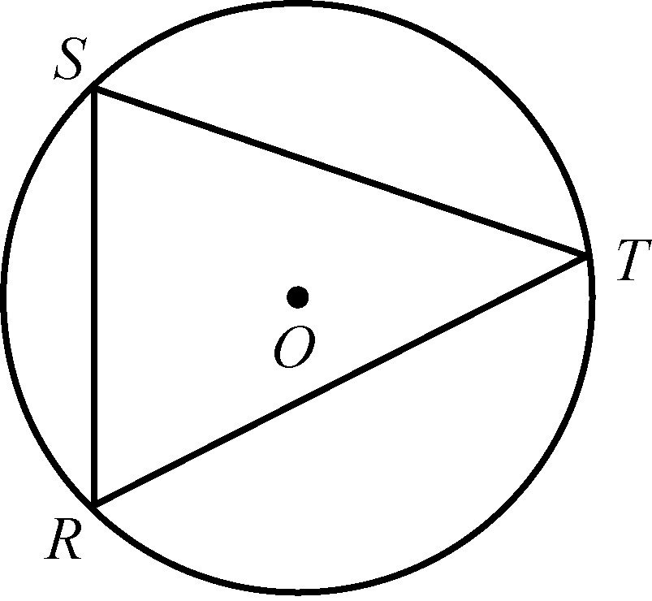
Geometry Figure 25

If one side of an inscribed triangle is a diameter of the circle, then the triangle is a right triangle. Conversely, if an inscribed triangle is a right triangle, then one of its sides is a diameter of the circle.

Geometry Figure 26 below shows right triangle X Y Z inscribed in a circle with center W. In triangle X Y Z, side XZ is a diameter of the circle and angle Y is a right angle.

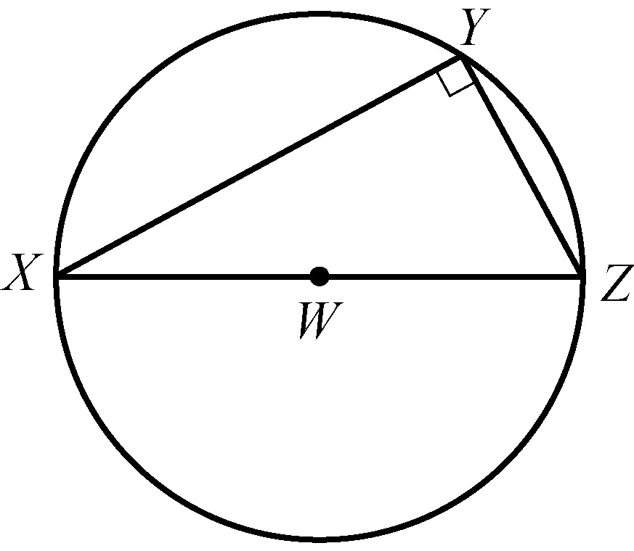
Geometry Figure 26

A polygon is circumscribed about a circle if each side of the polygon is tangent to the circle, or equivalently, the circle is inscribed in the polygon. Geometry Figure 27 below shows quadrilateral ABCD circumscribed about a circle with center O.

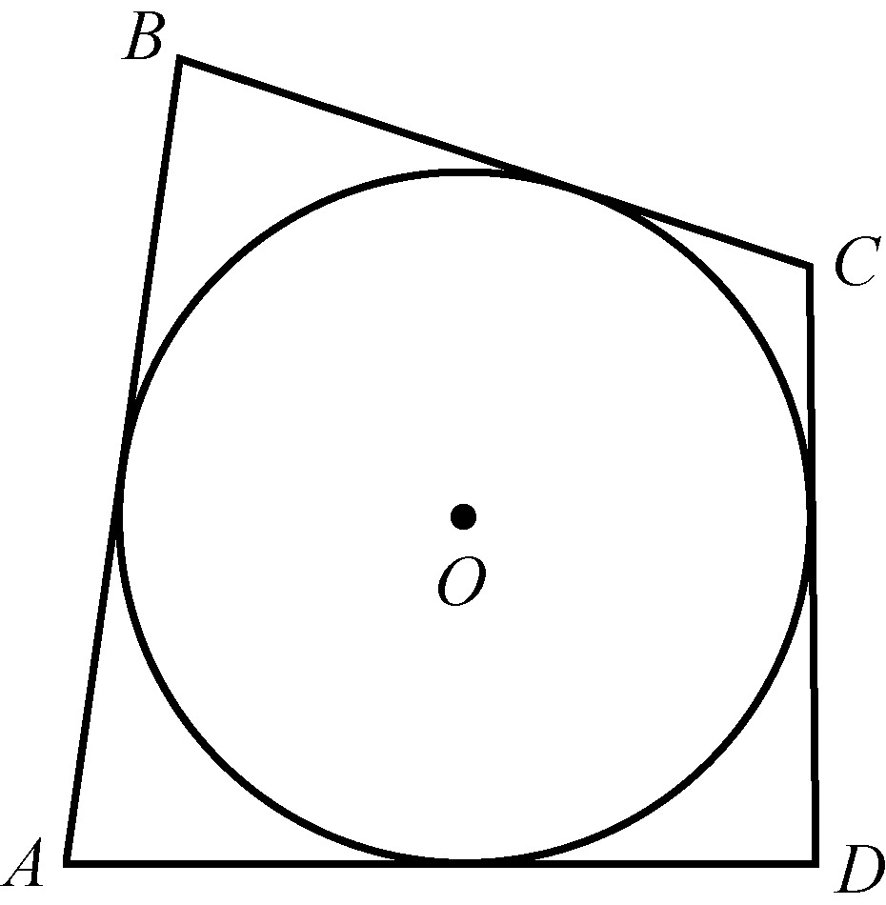
Geometry Figure 27

Two or more circles with the same center are called concentric circles, as shown in Geometry Figure 28 below.

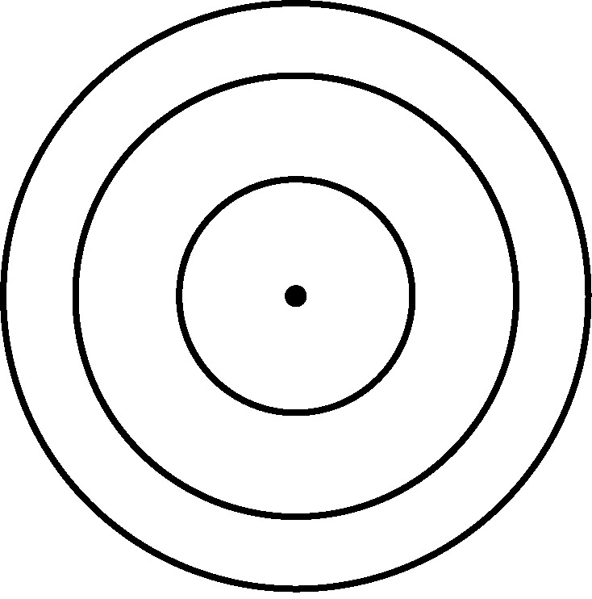
Geometry Figure 28

3.6 Three Dimensional Figures

Basic three dimensional figures include rectangular solids, cubes, cylinders, spheres, pyramids, and cones. In this section, we look at some properties of rectangular solids and right circular cylinders.

A rectangular solid has six rectangular surfaces called faces, as shown in Geometry Figure 29 below. Adjacent faces are perpendicular to each other. Each line segment that is the intersection of two faces is called an edge, and each point at which the edges intersect is called a vertex. There are 12 edges and 8 vertices. The dimensions of a rectangular solid are the length l the width w, and the height h.

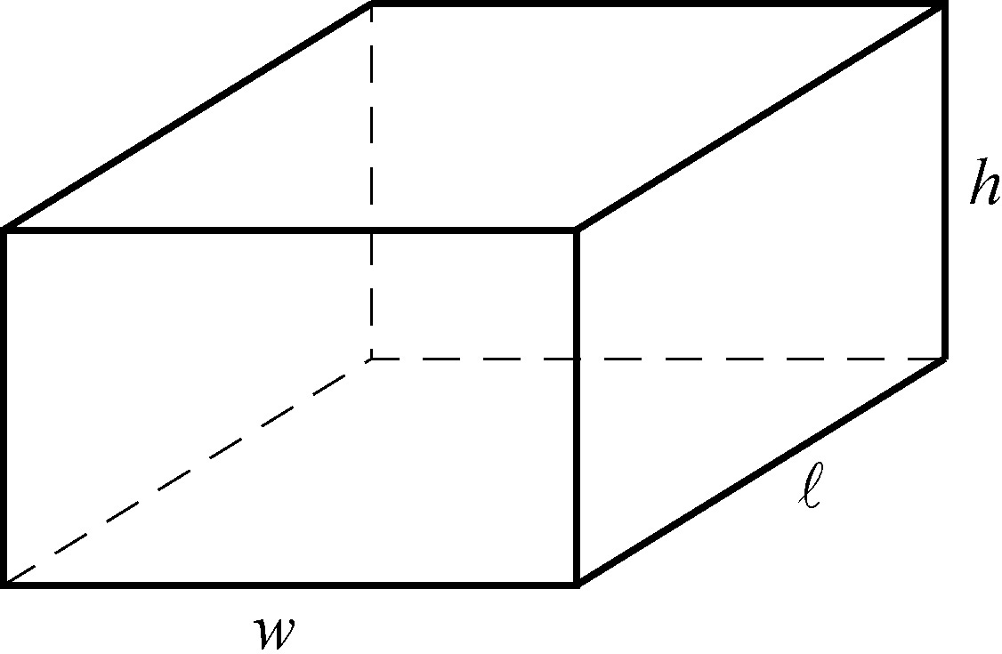
Geometry Figure 29

A rectangular solid with six square faces is called a cube, in which case l = w = h.

The volume V of a rectangular solid is the product of its three dimensions, or

V = l times w times h.

The surface area A of a rectangular solid is the sum of the areas of the six faces, or

A = 2 times, open parenthesis, l w + l h + w h, close parenthesis.

For example, if a rectangular solid has length 8.5, width 5, and height 10, then its volume is

V = 8.5 times 5 times 10 = 425

and its surface area is

A = 2 times, open parenthesis, 8.5 times 5, + 8.5 times 10, +, 5 times 10, close parenthesis, = 355.

A circular cylinder consists of two bases that are congruent circles and a lateral surface made of all line segments that join points on the two circles and that are parallel to the line segment joining the centers of the two circles. The latter line segment is called the axis of the cylinder. A right circular cylinder is a circular cylinder whose axis is perpendicular to its bases.

The right circular cylinder shown in Geometry Figure 30 below has circular bases with centers P and Q. Line segment PQ is the axis of the cylinder and is perpendicular to both bases. The length of PQ is called the height of the cylinder.

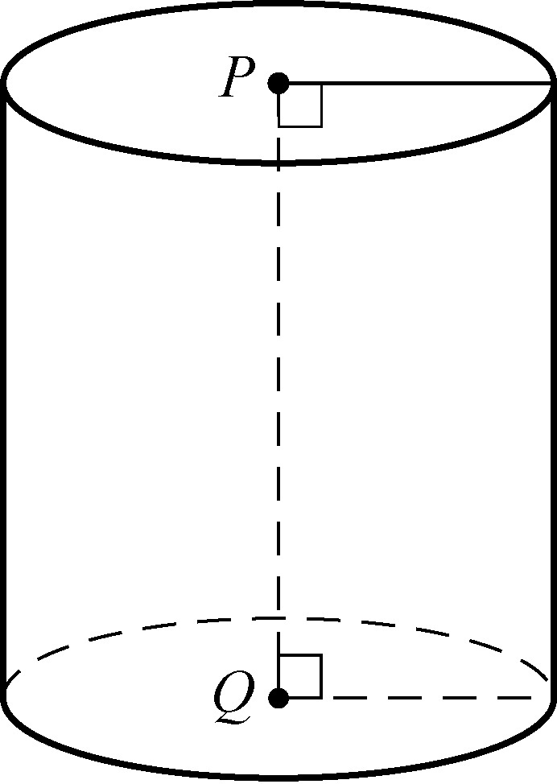
Geometry Figure 30

The volume V of a right circular cylinder that has height h and a base with radius r is the product of the height and the area of the base, or

V = pi times r squared times h.

The surface area A of a right circular cylinder is the sum of the areas of the two bases and the lateral area, or

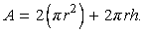 A = 2 times pi r squared, + , 2 times pi times r times h.

For example, if a right circular cylinder has height 6.5 and a base with radius 3, then its volume is

V = pi times, 3 squared, times 6.5 = 58.5 pi

and its surface area is

A = 2 times pi times, 3 squared ,+, 2 times pi times 3 times 6.5 = 57 pi.
Geometry Exercises

1. Exercise 1 is based on Geometry Figure 31 below.

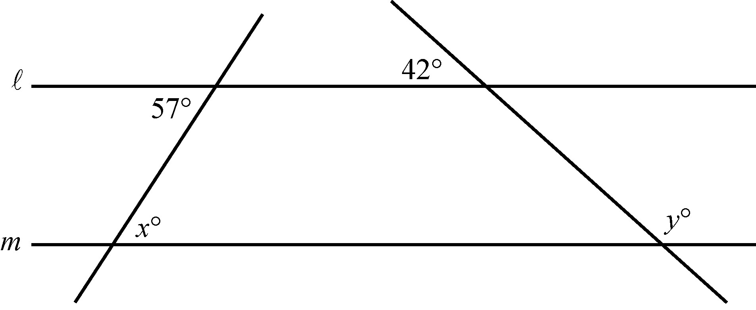
Geometry Figure 31

In Geometry Figure 31 there are four lines. Two of the lines are horizontal, and two are slanted. Each of the slanted lines cuts through both of the horizontal lines.
The horizontal lines, which are labeled l and m, are parallel.

Begin skippable part of description of Geometry Figure 31.
Line l is above line m. The first of the slanted lines begins at the lower left of the figure and slants upward and to the right, crossing both horizontal lines. The second slanted line begins at the lower right of the figure and slants upward and to the left, crossing both horizontal lines. In the figure, the two slanted lines do not cross each other, but if the lines were extended upward they would cross at a point above the two horizontal lines.
At each of the 4 points where one of the slanted lines crosses one of the horizontal lines there are 4 angles formed. For each of these points the degree measure of one of the 4 angles is given.
At the point where the first slanted line crosses the lower horizontal line, the upper right angle measures x degrees.
At the point where the first slanted line crosses the upper horizontal line, the lower left angle measures 57 degrees.
At the point where the second slanted line crosses the lower horizontal line, the upper right angle measures y degrees.
At the point where the second slanted line crosses the upper horizontal line, the upper left angle measures 42 degrees.
End skippable part of figure description.

Find the values of x and y.

2. Exercise 2 is based on Geometry Figure 32 below.

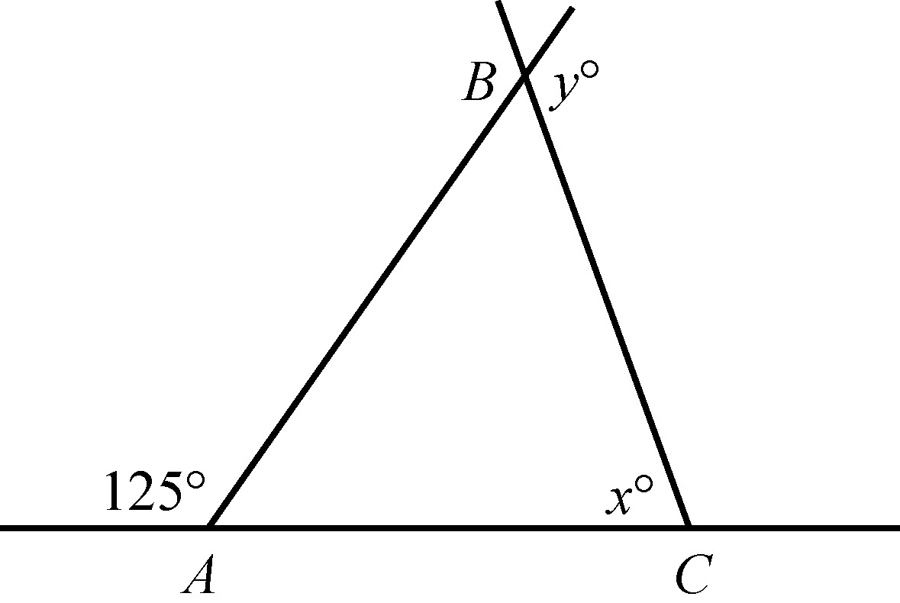
Geometry Figure 32

In Geometry Figure 32 there is a horizontal line passing through points A and C, and two half lines, AB and CB, that extend upward from points A and C, respectively, intersecting at point B to form triangle ABC. In triangle ABC, the length of side AC is equal to the length of side BC.

Begin skippable part of description of Geometry Figure 32.
On horizontal line AC, point A lies to the left of point C.
The half line AB begins at point A and slants upward and to the right.
The half line CB begins at point C and slants upward and to the left.
The two half lines intersect at point B, forming 4 angles there.
Of these 4 angles, 2 lie to the right of half line AB. One of these angles is interior angle B of triangle ABC. The other is supplementary to interior angle B and measures y degrees.
Interior angle C of triangle ABC measures x degrees.
There are 2 angles that have vertex A and lie above horizontal line AC. One of these angles is interior angle A of triangle ABC. The other is supplementary to, and to the left of, interior angle A and measures 125 degrees.
End skippable part of figure description.

Find the values of x and y.

3. Exercise 3 is based on Geometry Figure 33 below.

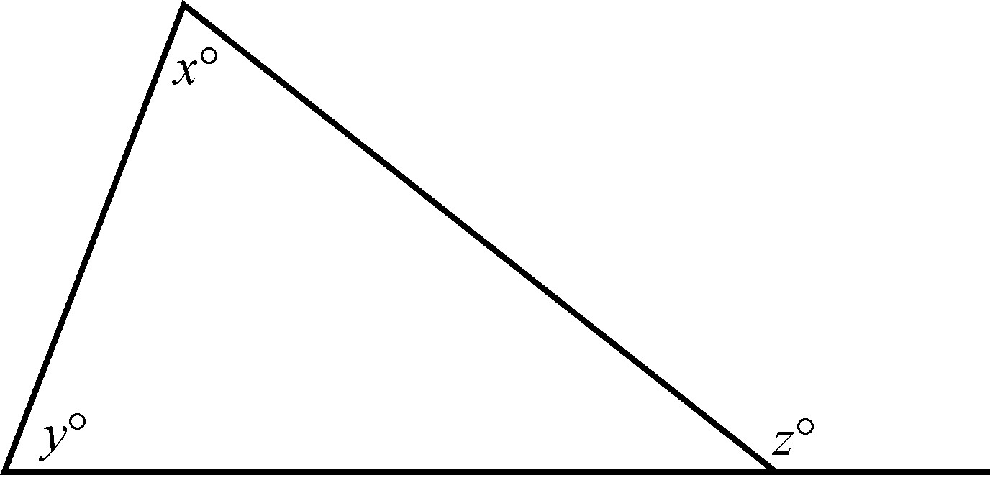
Geometry Figure 33

Geometry Figure 33 shows a triangle. One side of the triangle lies on a horizontal line segment and the other two sides intersect above the horizontal side.

Begin skippable part of description of Geometry Figure 33.
The horizontal line segment extends past the rightmost vertex of the triangle. In the triangle, the angle at the top vertex is labeled x°, the angle at the lower left vertex is labeled y°, and the angle at the lower right vertex is not labeled. There is an angle that is both adjacent to the unlabeled angle at the lower right vertex and above the extension of the horizontal side. This angle measures z°.

End skippable part of figure description.

In Geometry Figure 33, what is the relationship between x, y, and z ?

4. What is the sum of the measures of the interior angles of a decagon (10 sided polygon)?

5. If the polygon in exercise 4 is regular, what is the measure of each interior angle?

6. The lengths of two sides of an isosceles triangle are 15 and 22, respectively. What are the possible values of the perimeter?

7. Triangles PQR and X Y Z are similar. If PQ = 6, PR = 4, and X Y = 9, what is the length of side XZ ? (Note that there is no figure accompanying this exercise).

8. Exercise 8 is based on Geometry Figure 34 below.

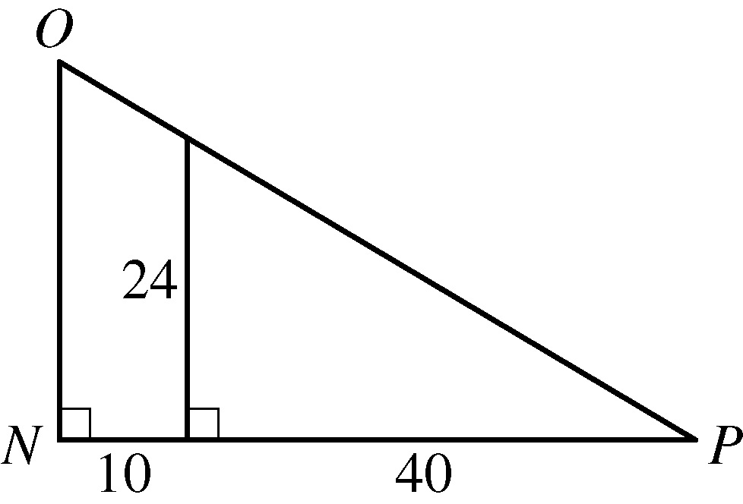
Geometry Figure 34

Geometry Figure 34 shows right triangle N O P, where the right angle is at vertex N. Horizontal leg NP is at the bottom of the figure, and vertical leg N O is on the left side of the figure. To the right of vertical leg N O is a vertical line segment that partitions right triangle N O P into a smaller right triangle and a quadrilateral.

Begin skippable part of description of Geometry Figure 34.
The vertical line segment, which is a leg of the smaller triangle is of length 24. Horizontal leg NP of triangle N O P consists of two line segments, one of the sides of the quadrilateral and the horizontal leg of the smaller triangle, which are of lengths 10 and 40, respectively.
End skippable part of figure description.

In Geometry Figure 34, what are the lengths of sides N O and O P of triangle N O P ?
9. Exercise 9 is based on Geometry Figure 35 below.
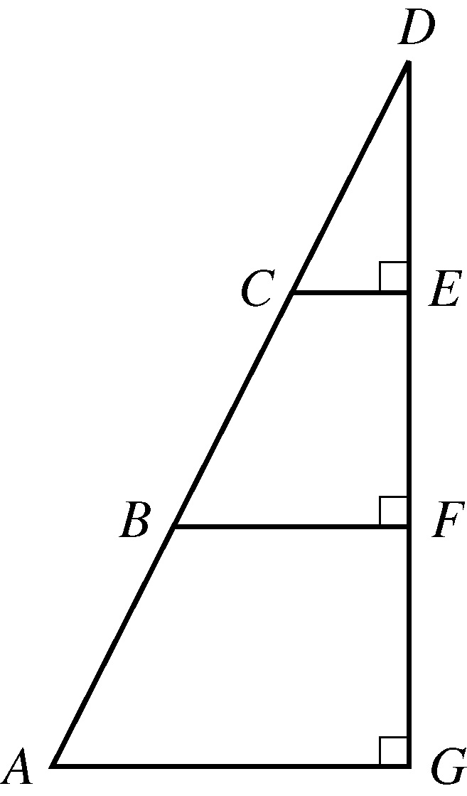
Geometry Figure 35

Geometry Figure 35 shows right triangle ADG. In the triangle, the right angle is at vertex G, horizontal leg A G is at the bottom of the figure and vertical leg GD is on the right side of the figure. Two additional horizontal line segments partition triangle ADG into three regions: a smaller right triangle, and two quadrilaterals.
Begin skippable part of description of Geometry Figure 35.
The additional line segments are C E and BF, where C E lies above BF. Horizontal line segment C E is the bottom side of the smaller right triangle, CDE. The endpoints of the additional line segments are positioned on the sides of right triangle ADG as follows: endpoints C and B lie on the hypotenuse AD, dividing it into 3 parts, AB, BC, and CD; and endpoints E and F lie on vertical leg DG, dividing it into 3 parts: GF, F E, and E D.

End skippable part of figure description.

In Geometry Figure 35, the length of AB = the length of BC = the length of CD. If the area of triangle CDE is 42, what is the area of triangle ADG ?

10. Exercise 10 is based on Geometry Figure 36 below.

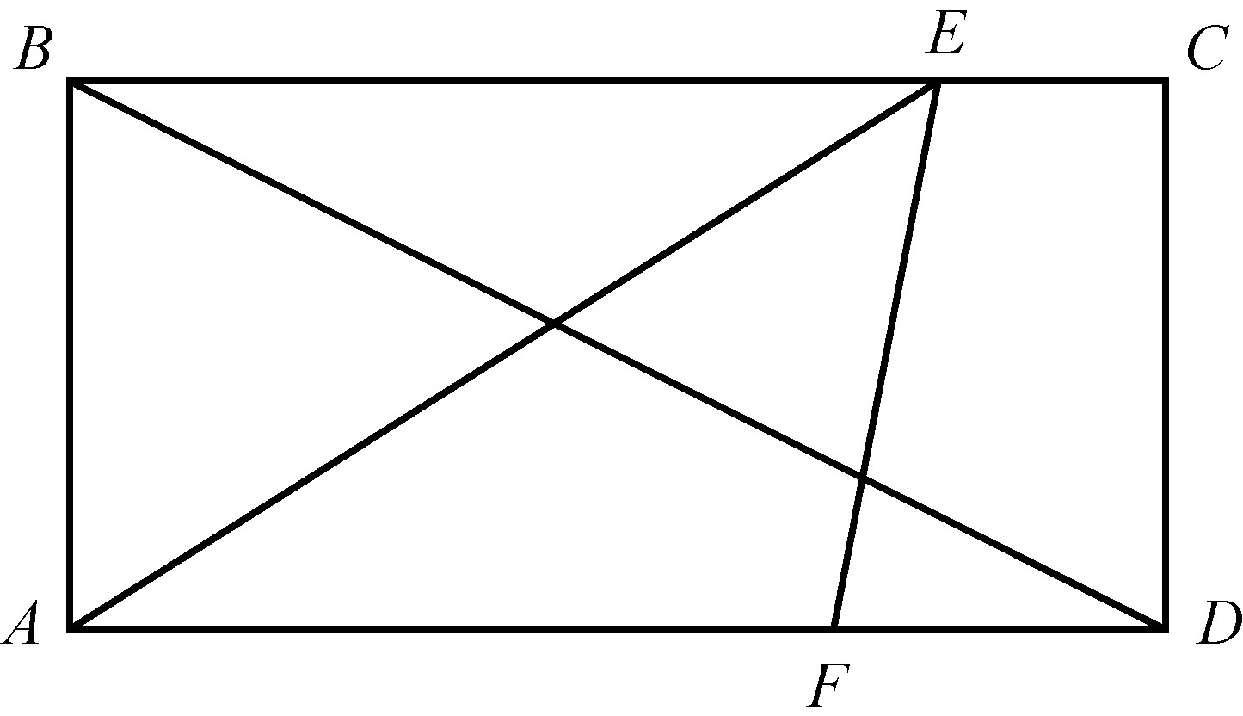
Geometry Figure 36

Geometry Figure 36 shows rectangle ABCD, along with 3 additional line segments in the rectangle.

Begin skippable part of description of Geometry Figure 36.
In rectangle ABCD, two of the sides are vertical, and two are horizontal. Vertex A is the lower left vertex; B is the upper left vertex; C is the upper right vertex; and D is the lower right vertex.
The three additional line segments are as follows:
Diagonal BD extends from the upper left vertex B to the lower right vertex D.
Line segment AE extends from the lower left vertex A to point E on the upper horizontal side BC.
Line segment E F extends from point E on the upper horizontal side BC to point F on the lower horizontal side AD.

End skippable part of figure description.

In Geometry Figure 36, ABCD is a rectangle, the length of side AB is 5, the length of line segment A F is 7, and the length of line segment FD is 3. Find the following.
a. Area of rectangle ABCD
b. Area of triangle A E F
c. Length of side BD
d. Perimeter of rectangle ABCD

11. Exercise 11 is based on Geometry Figure 37 below.

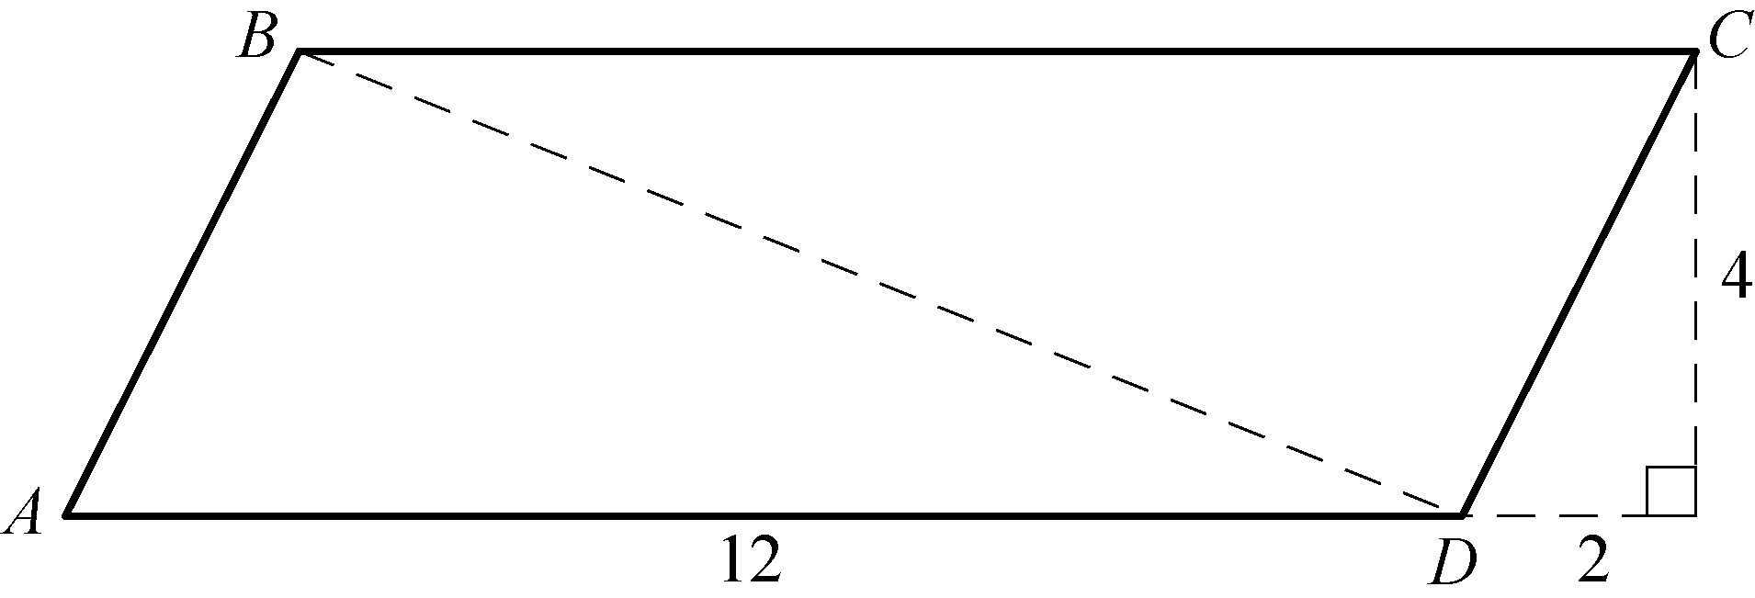
Geometry Figure 37

Geometry Figure 37 shows parallelogram ABCD, along with three additional dashed line segments.

Begin skippable part of description of Geometry Figure 37.
Parallelogram ABCD has two horizontal bases and two sides that slant upwards and to the right. Vertex A is the lower left vertex, vertex B is the upper left vertex, vertex C is the upper right vertex, and vertex D is the lower left vertex. The length of the lower base, AD, is 12.
There are three additional line segments, all of which are drawn as dashed lines. The additional line segments are.
A diagonal extending from upper left vertex B to lower right vertex D,
an extension of base AD to the right of vertex D,
and a vertical line segment from upper right vertex C to the horizontal extension of base AD.
The extension of base AD, the vertical line segment, and side CD form a right triangle. The length of the vertical side of the right triangle is 4, and the length of the horizontal side of the right triangle is 2.

End skippable part of figure description.

In parallelogram ABCD in Geometry Figure 37, find the following.
a. Area of ABCD
b. Perimeter of ABCD
c. Length of diagonal BD

12. Exercise 12 is based on Geometry Figure 38 below.

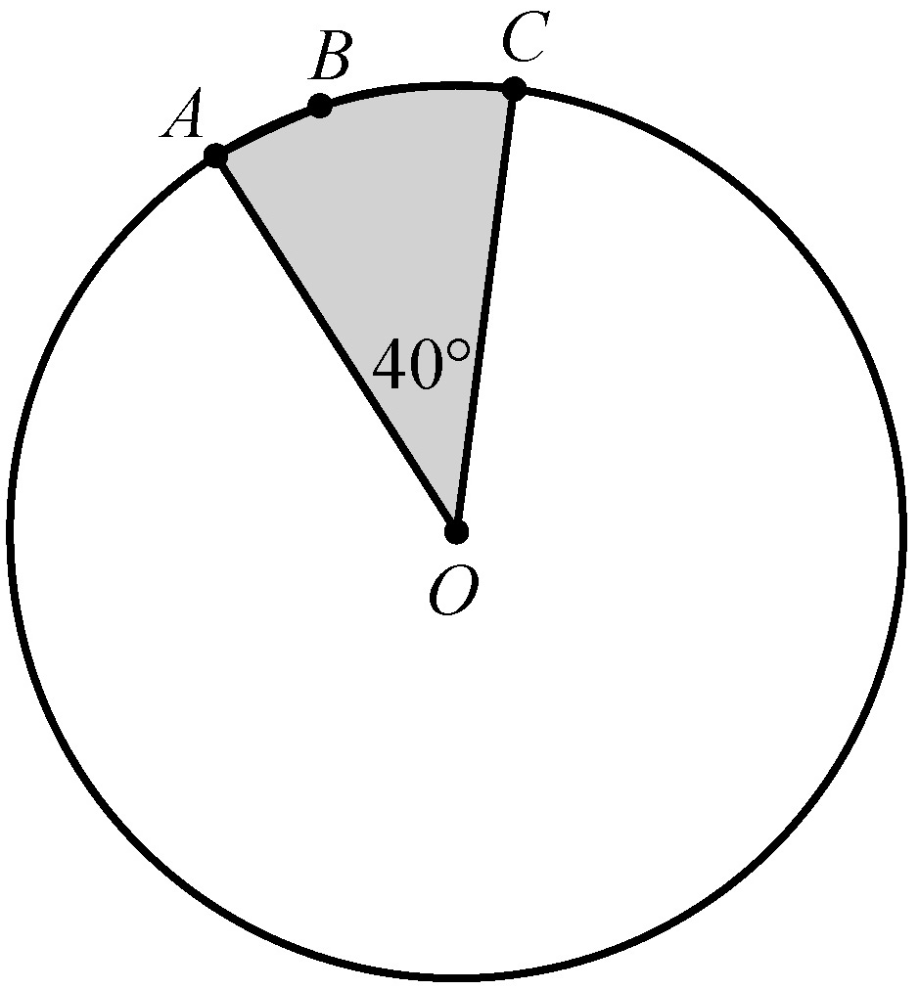
Geometry Figure 38

Begin skippable part of description of Geometry Figure 38.
Geometry Figure 38 shows a circle with center O. Points A, B, and C lie on the circle. The sector of the circle bounded by radii AO, C O, and arc ABC is shaded, and the measure of angle A O C is 40 degrees.

End skippable part of figure description.

In Geometry Figure 38, the circle with center O has radius 4. Find the following.
a. Circumference of the circle
b. Length of arc ABC
c. Area of the shaded region

13. Exercise 13 is based on Geometry Figure 39 below.

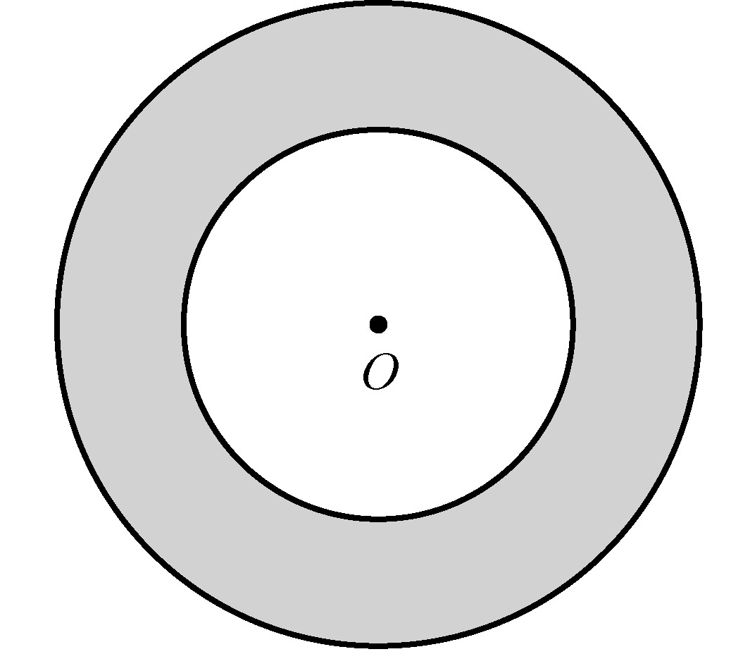
Geometry Figure 39

Geometry Figure 39 shows two concentric circles, each with center O. The region between the two concentric circles is shaded. Given that the larger circle has radius 12 and the smaller circle has radius 7, find the following.
a. Circumference of the larger circle
b. Area of the smaller circle
c. Area of the shaded region

14. Exercise 14 is based on Geometry Figure 40 below, which is a rectangular solid.

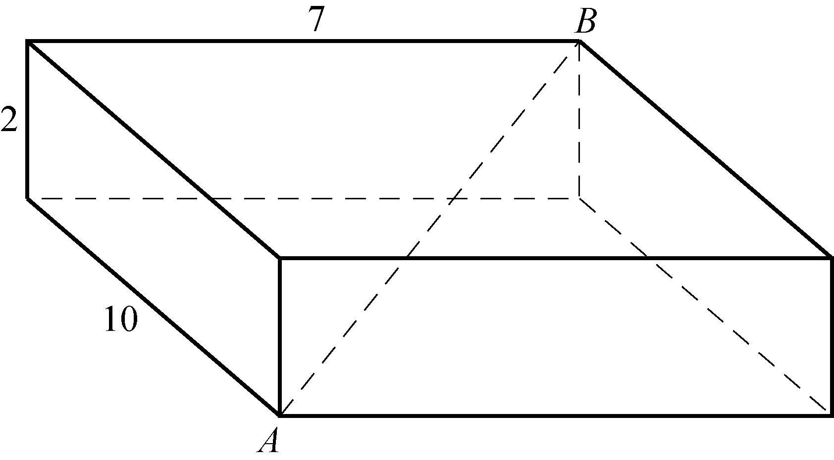
Geometry Figure 40

Begin skippable part of description of Geometry Figure 40.
Geometry Figure 40 shows a rectangular solid with base of length 10 and width 7; and with height of length 2.
Vertex A is at the lower left corner of the bottom base, and vertex B is at upper right corner of the top base. Diagonal AB goes through the interior of the rectangular solid.

End skippable part of figure description.

For the rectangular solid in Geometry Figure 40, find the following.
a. Surface area of the solid
b. Length of diagonal AB

Answers to Geometry Exercises

1. x = 57 and y = 138

2. x = 70 and y = 125

3. z = x + y

4. 1,440º

5. 144º

6. 52 and 59

7. 6

8. The length of side N O is 30 and the length of side OP is
10 times the positive square root of 34
9. 378

10.
a. 50
b. 17.5
c. 5 times the positive square root of 5
d. 30

11.
a. 48
b. 24, + 4 times the positive square root of 5
c. 2 times the positive square root of 29

12.
a. 8 pi
b. 8 pi over 9
c. 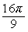 16 pi over 9

13.
a. 24 pi
b. 49 pi
c. 95 pi

14.
a. 208
b. 3 times the positive square root of 17

